**Setup Cloudera Cluster on AWS EC2 instances**

Create an account for aws services on <https://aws.amazon.com/console/>

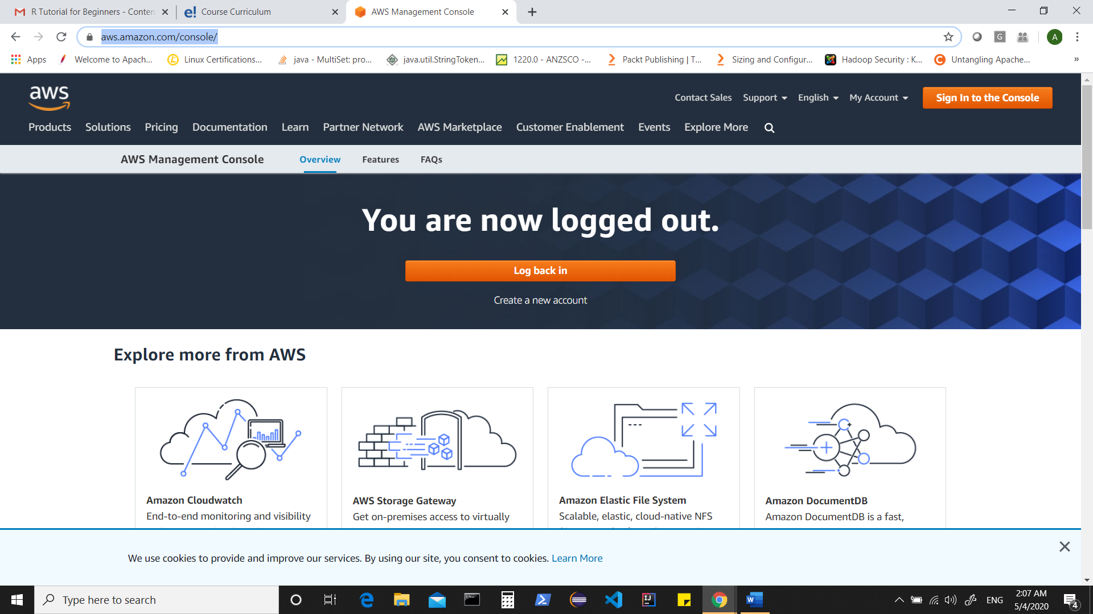

& sign into console

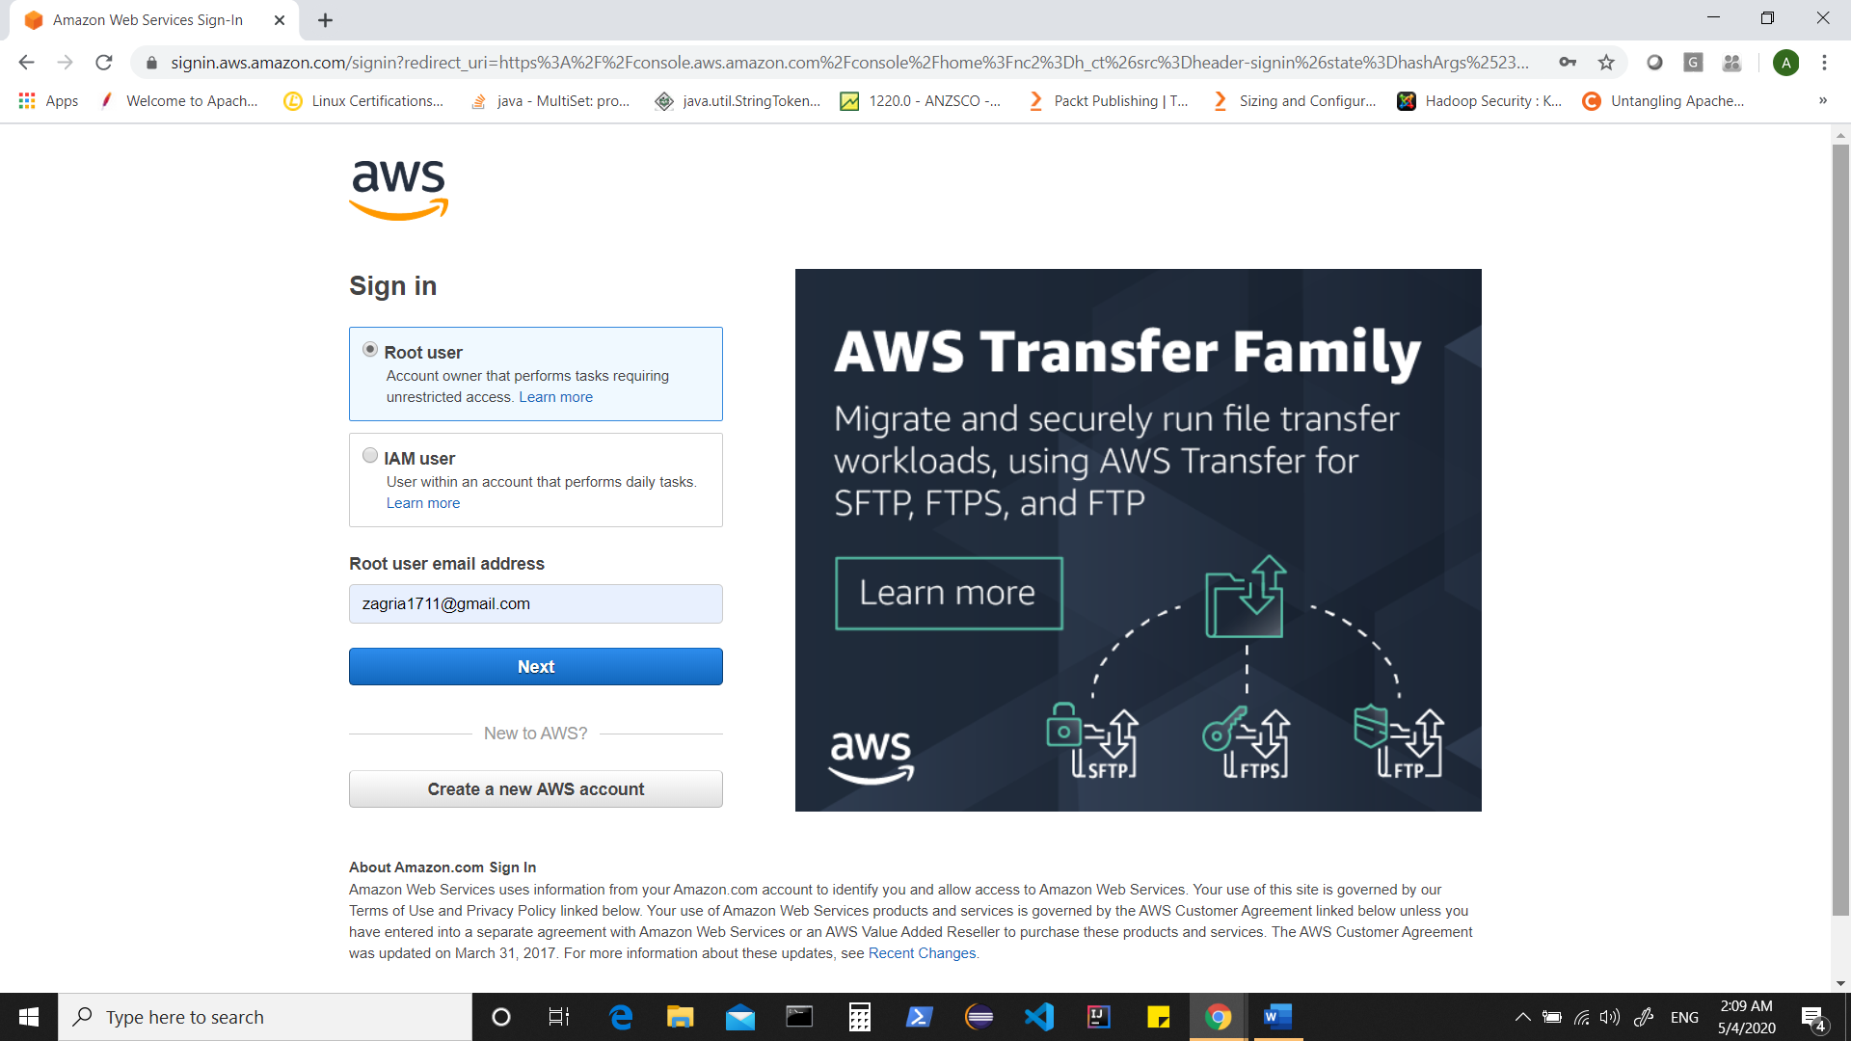

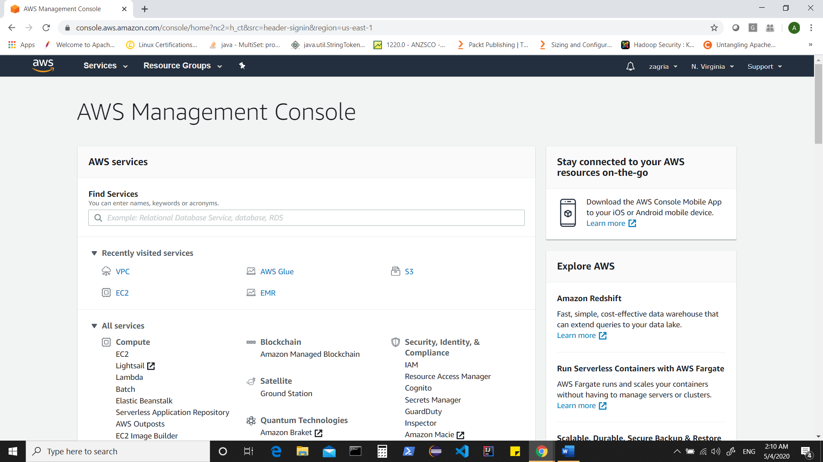

Create Default VPC (if not existing)

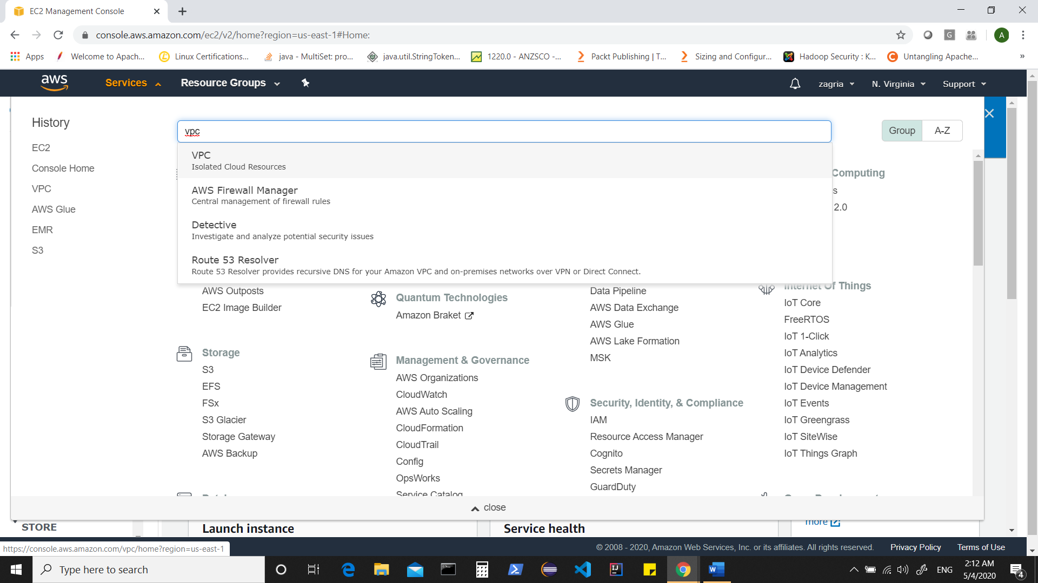

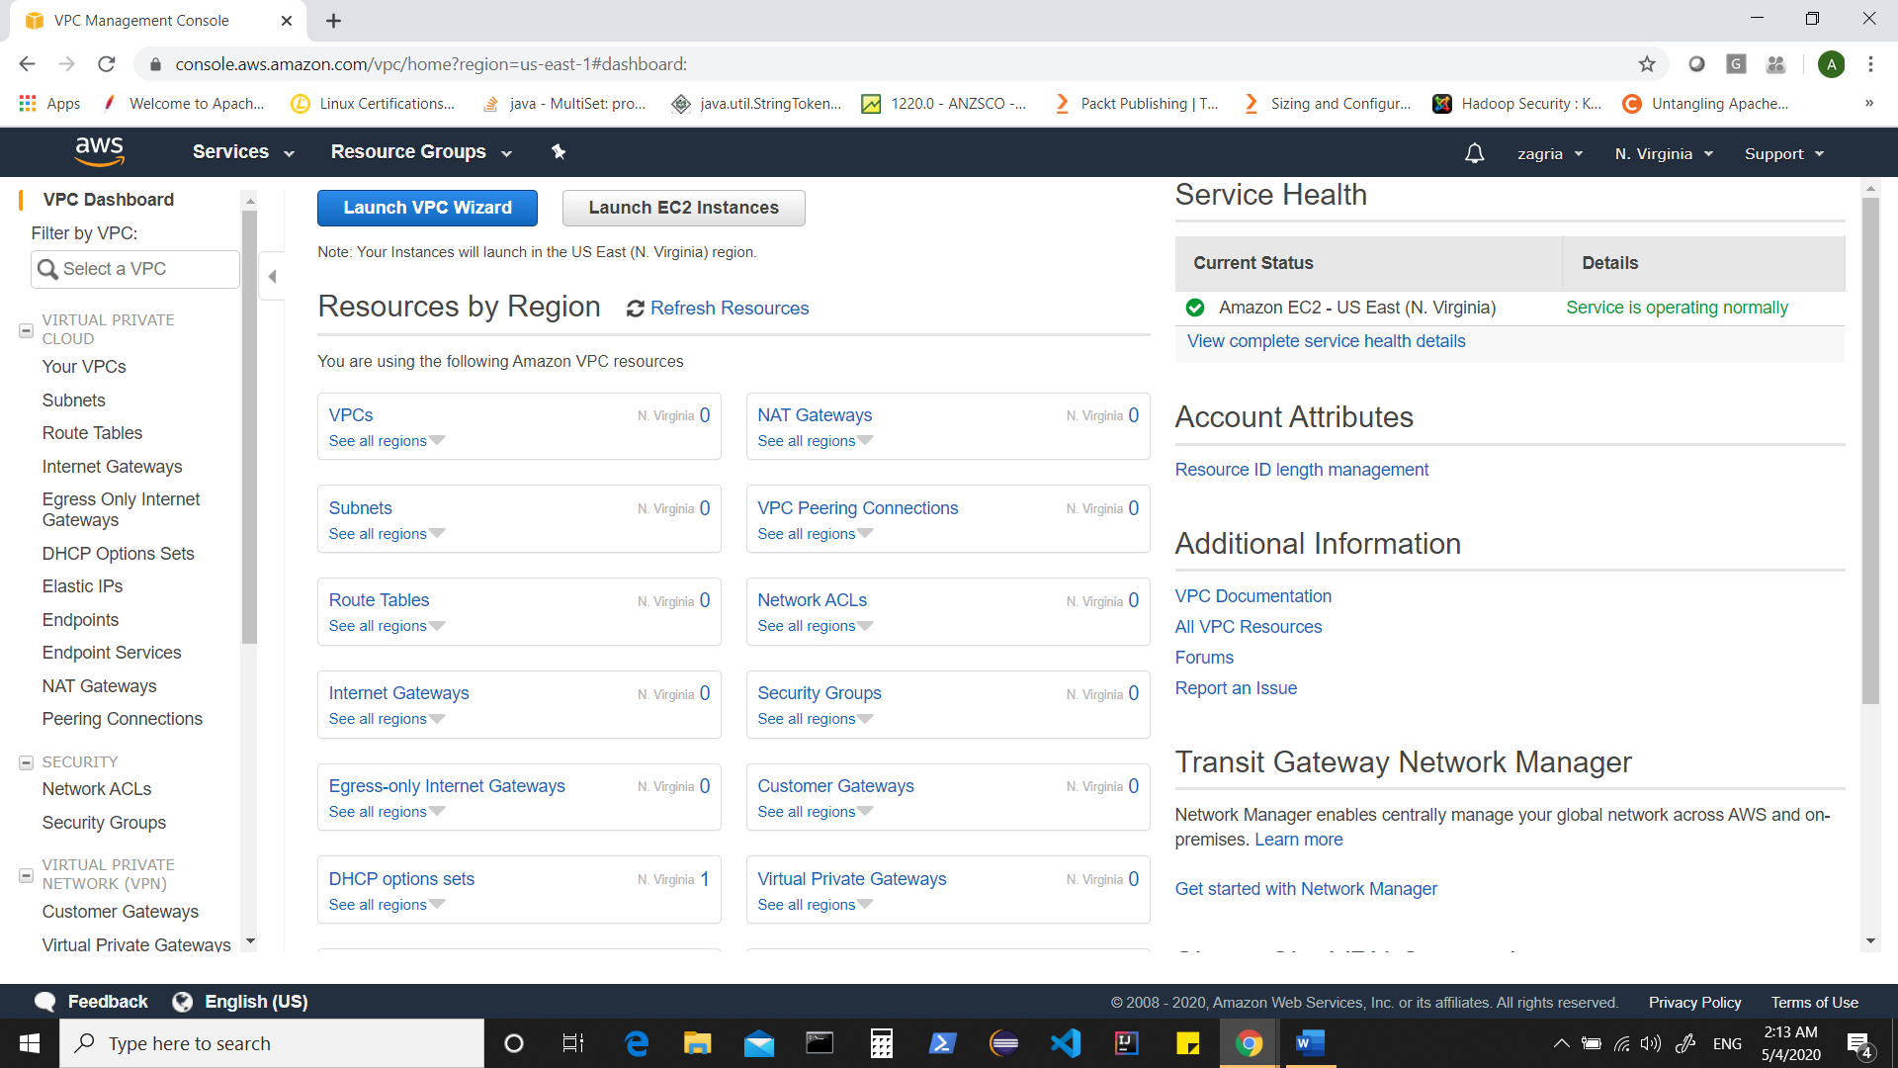

Click on VPCs

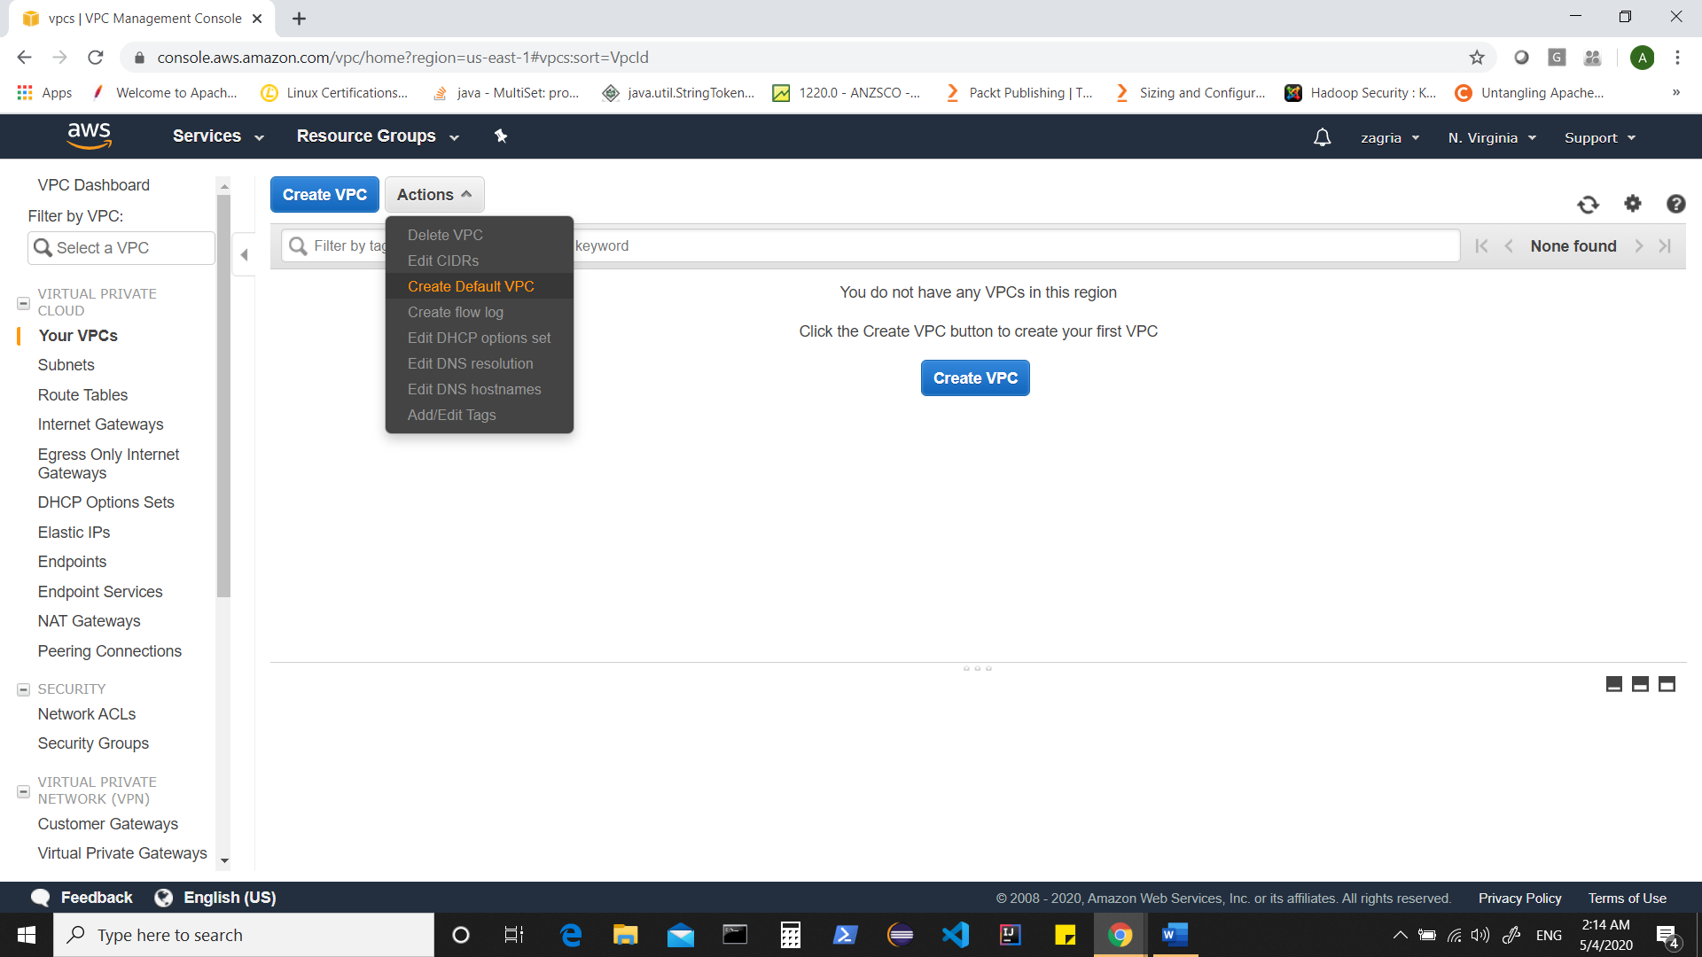

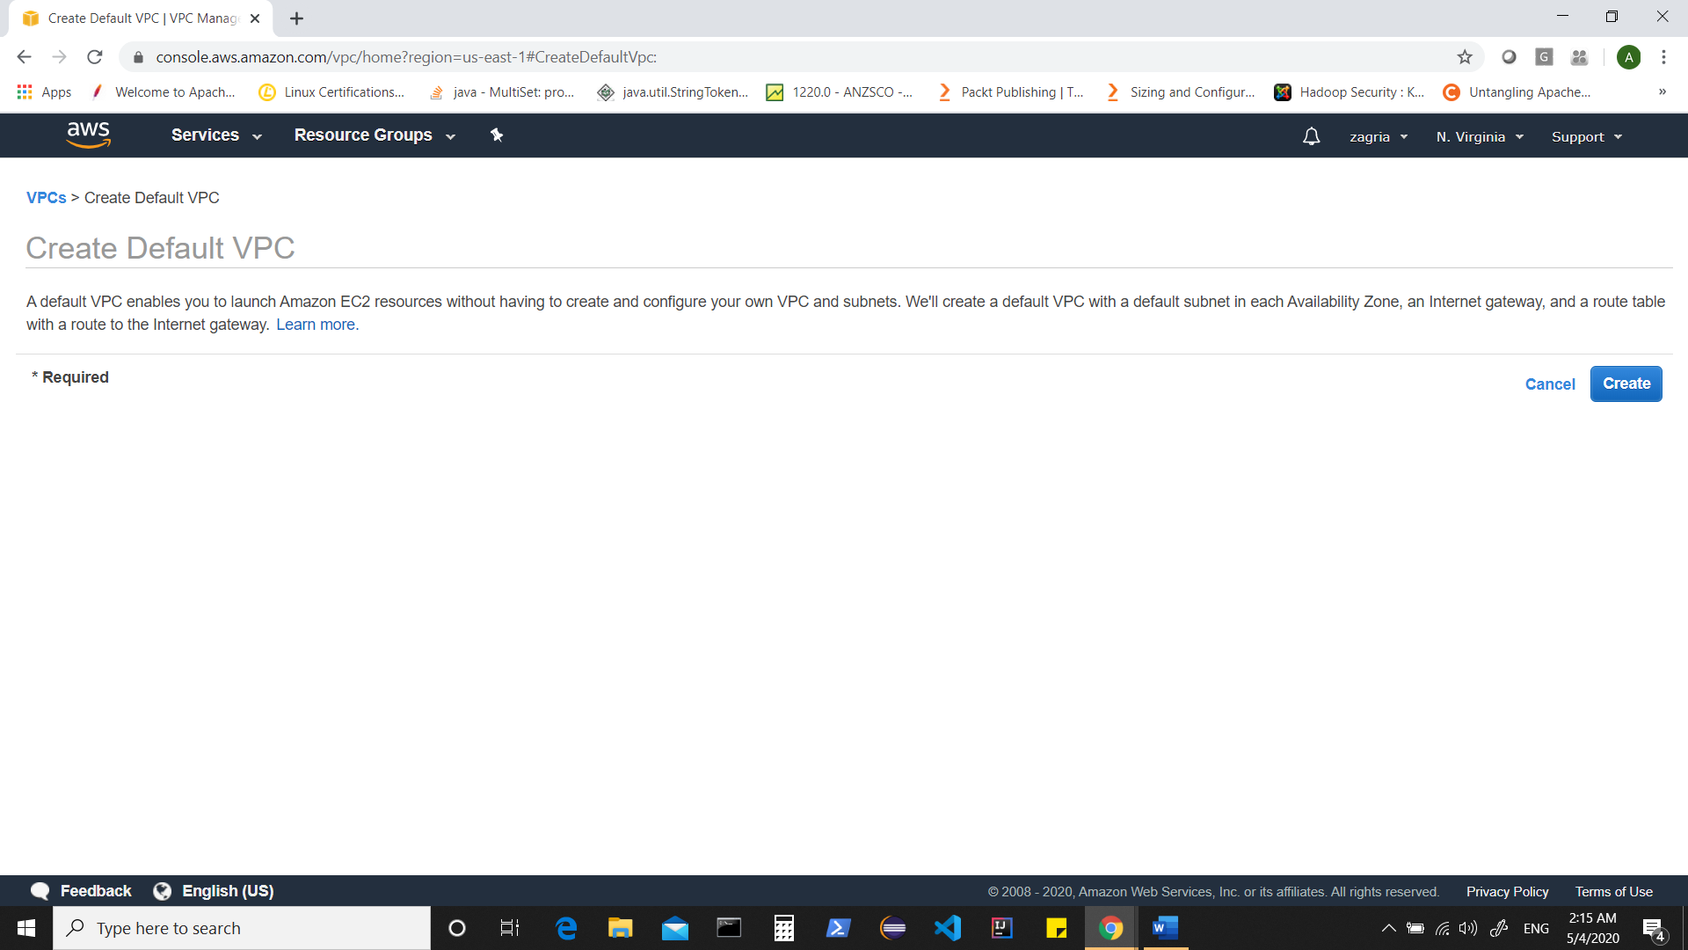

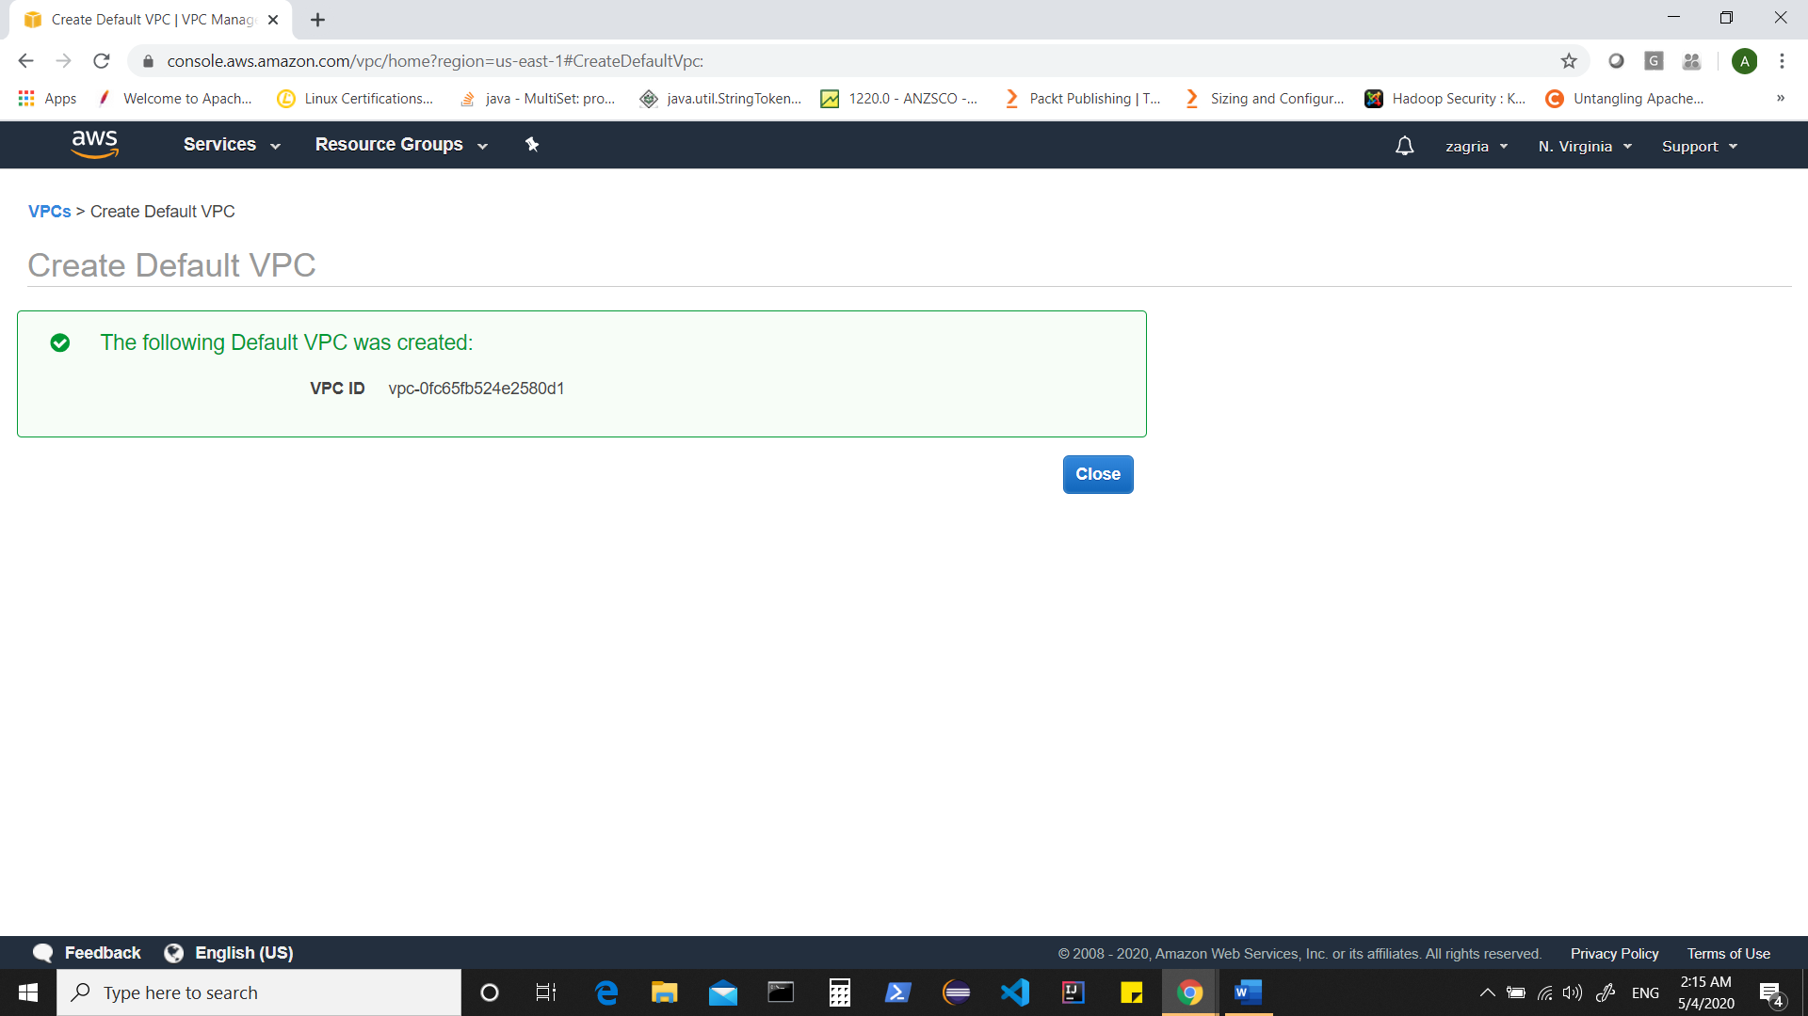

Now Create a Key Pair which will be used to access your instances .(Once created i.e. xyx.pem download it)

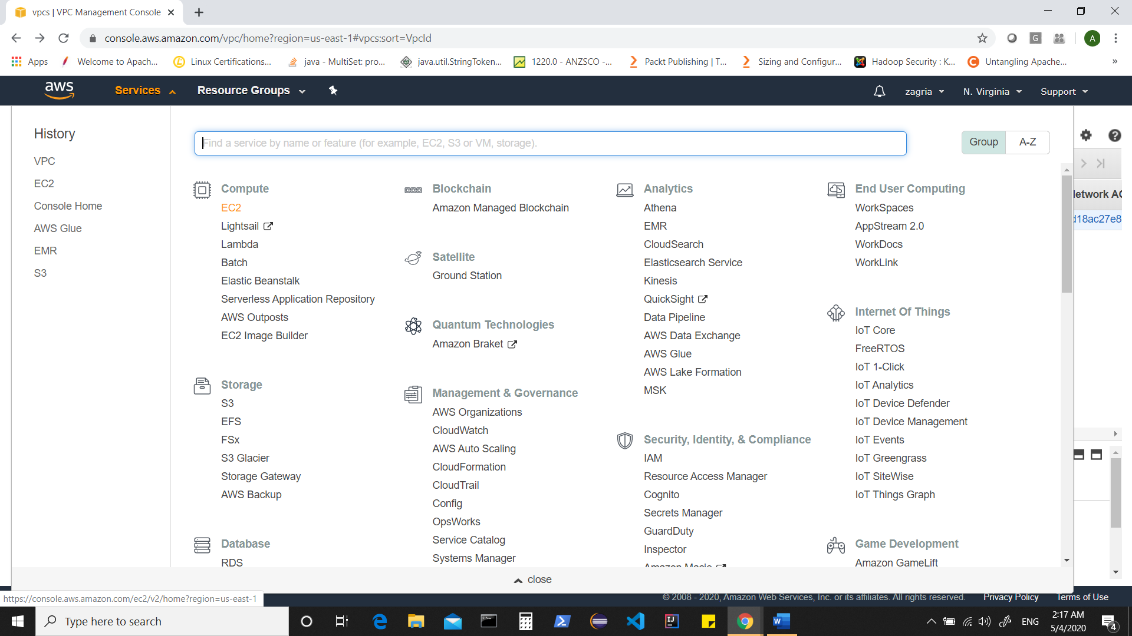

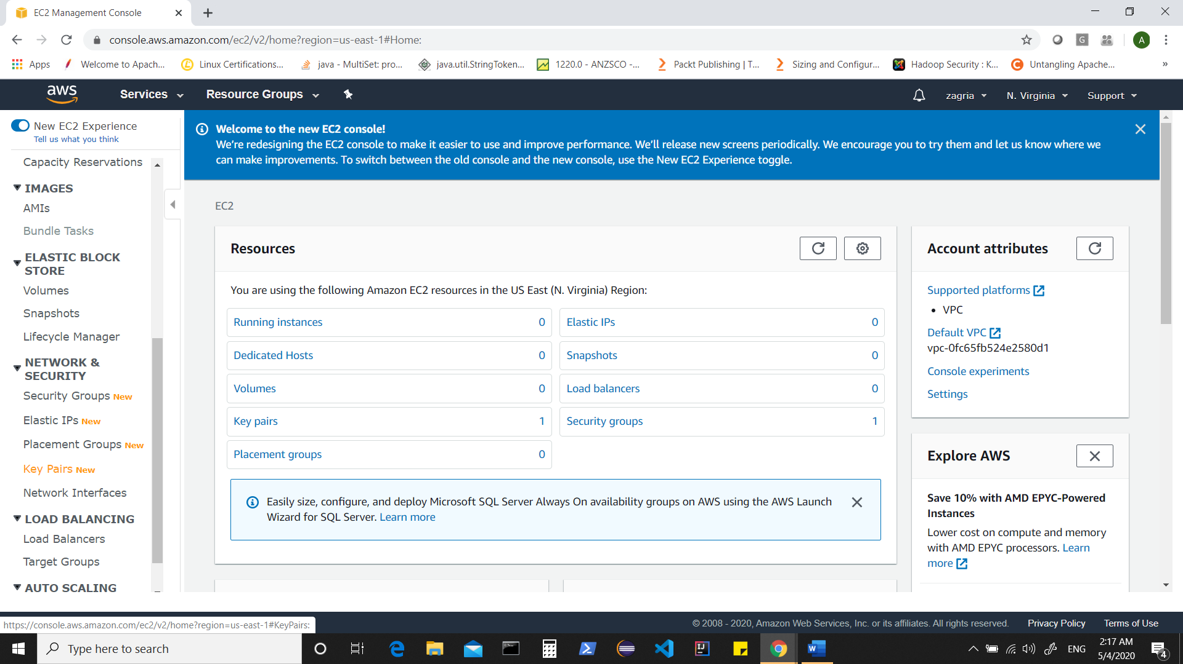

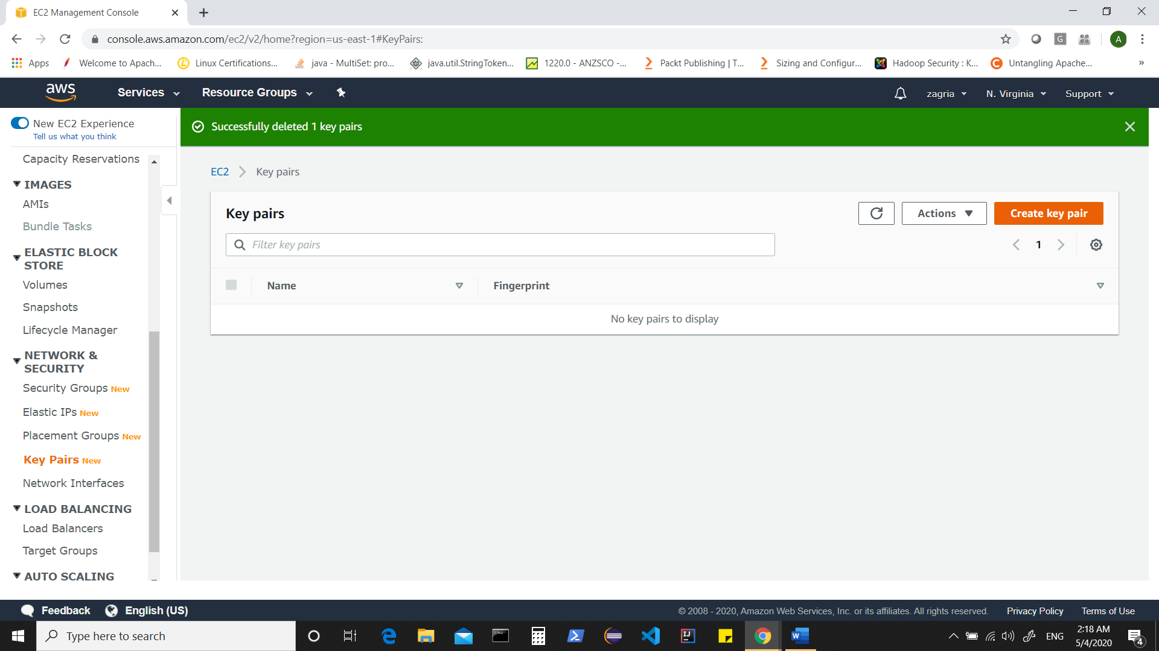

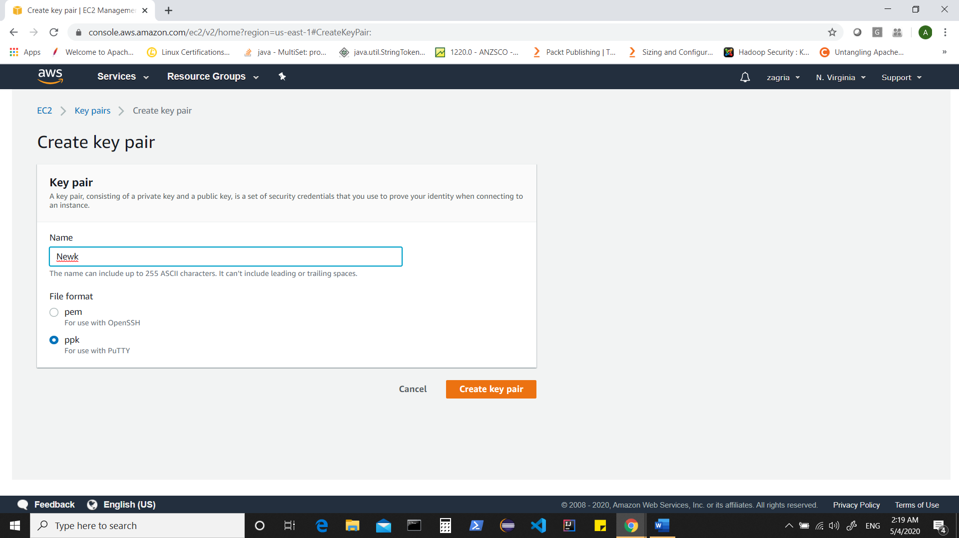

Or

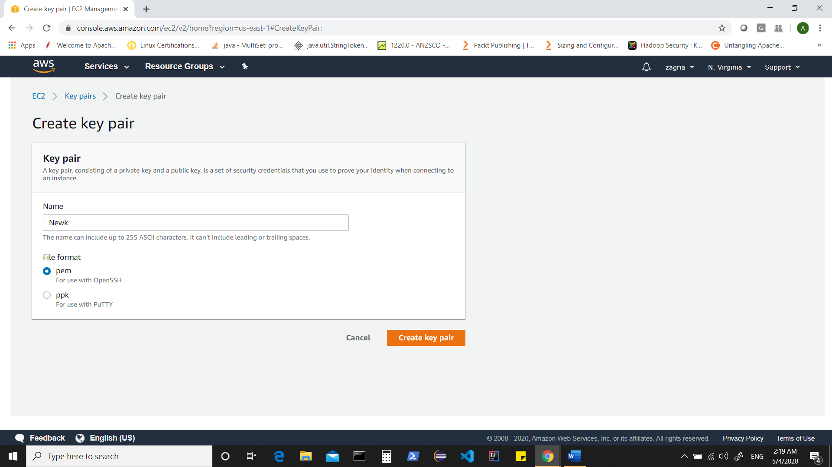

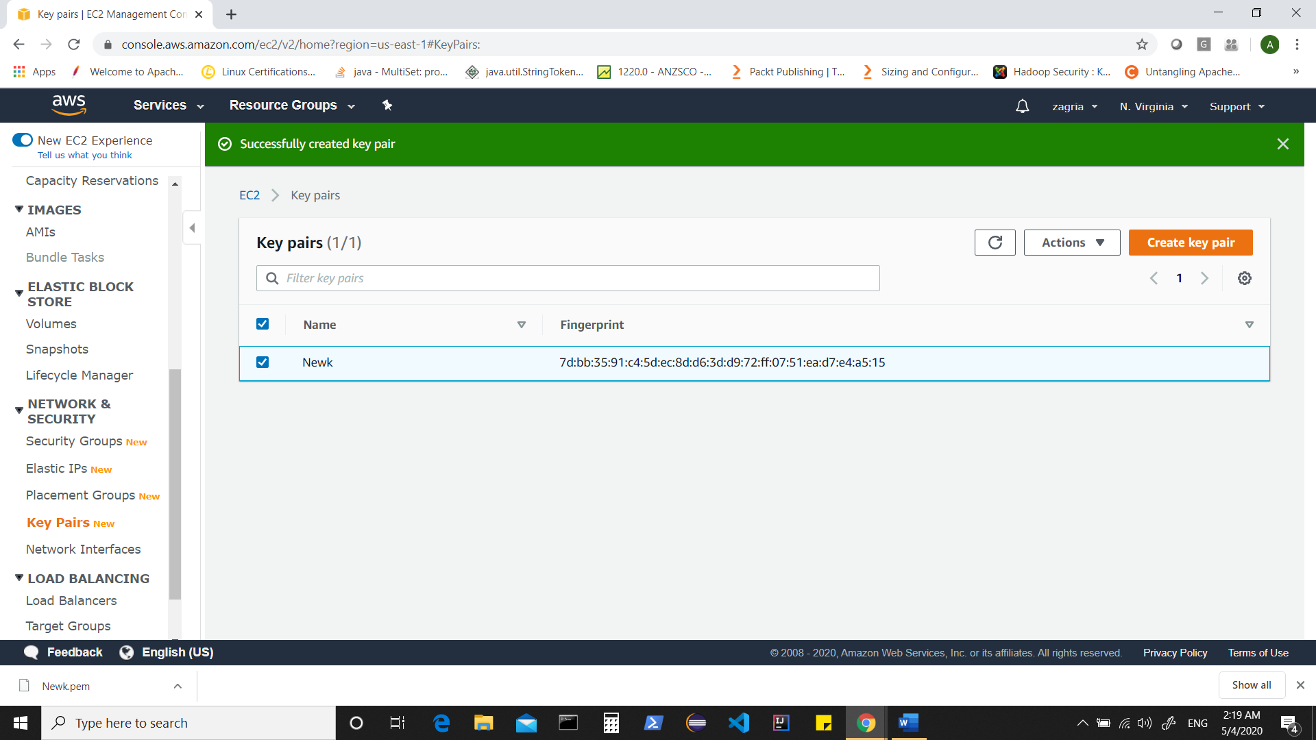

Now Create a Security Group which will allow incoming and outgoing traffic for your instances.

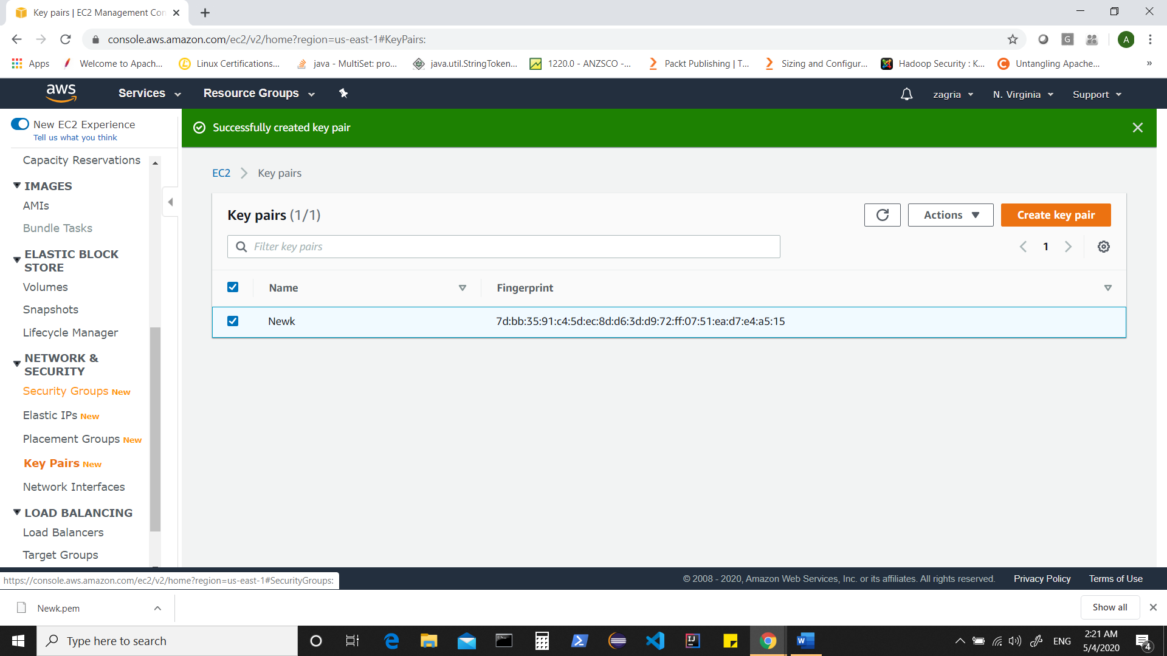

Click on “create security group”

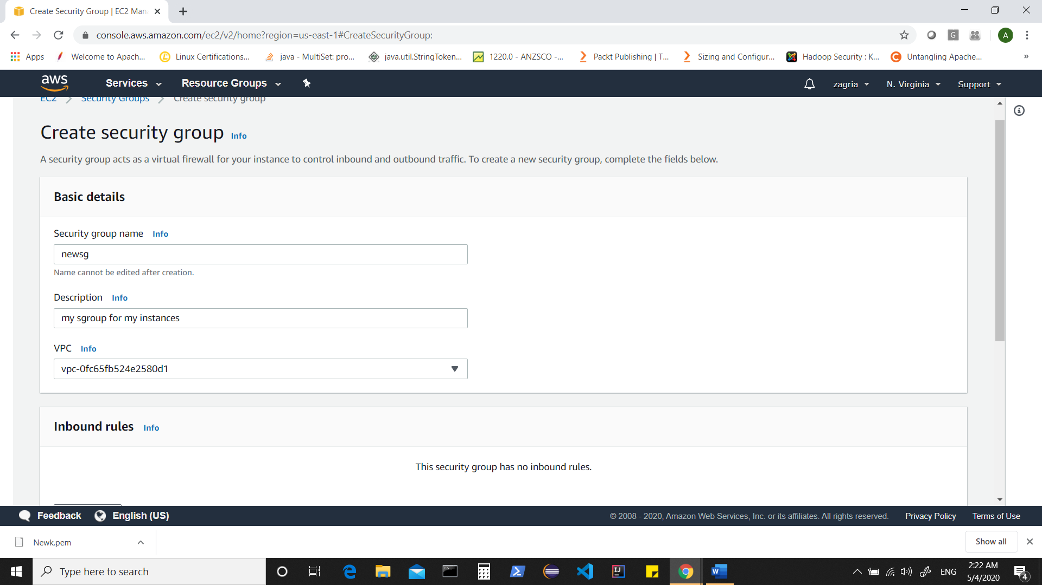

Add rules for ‘Inbound rules’

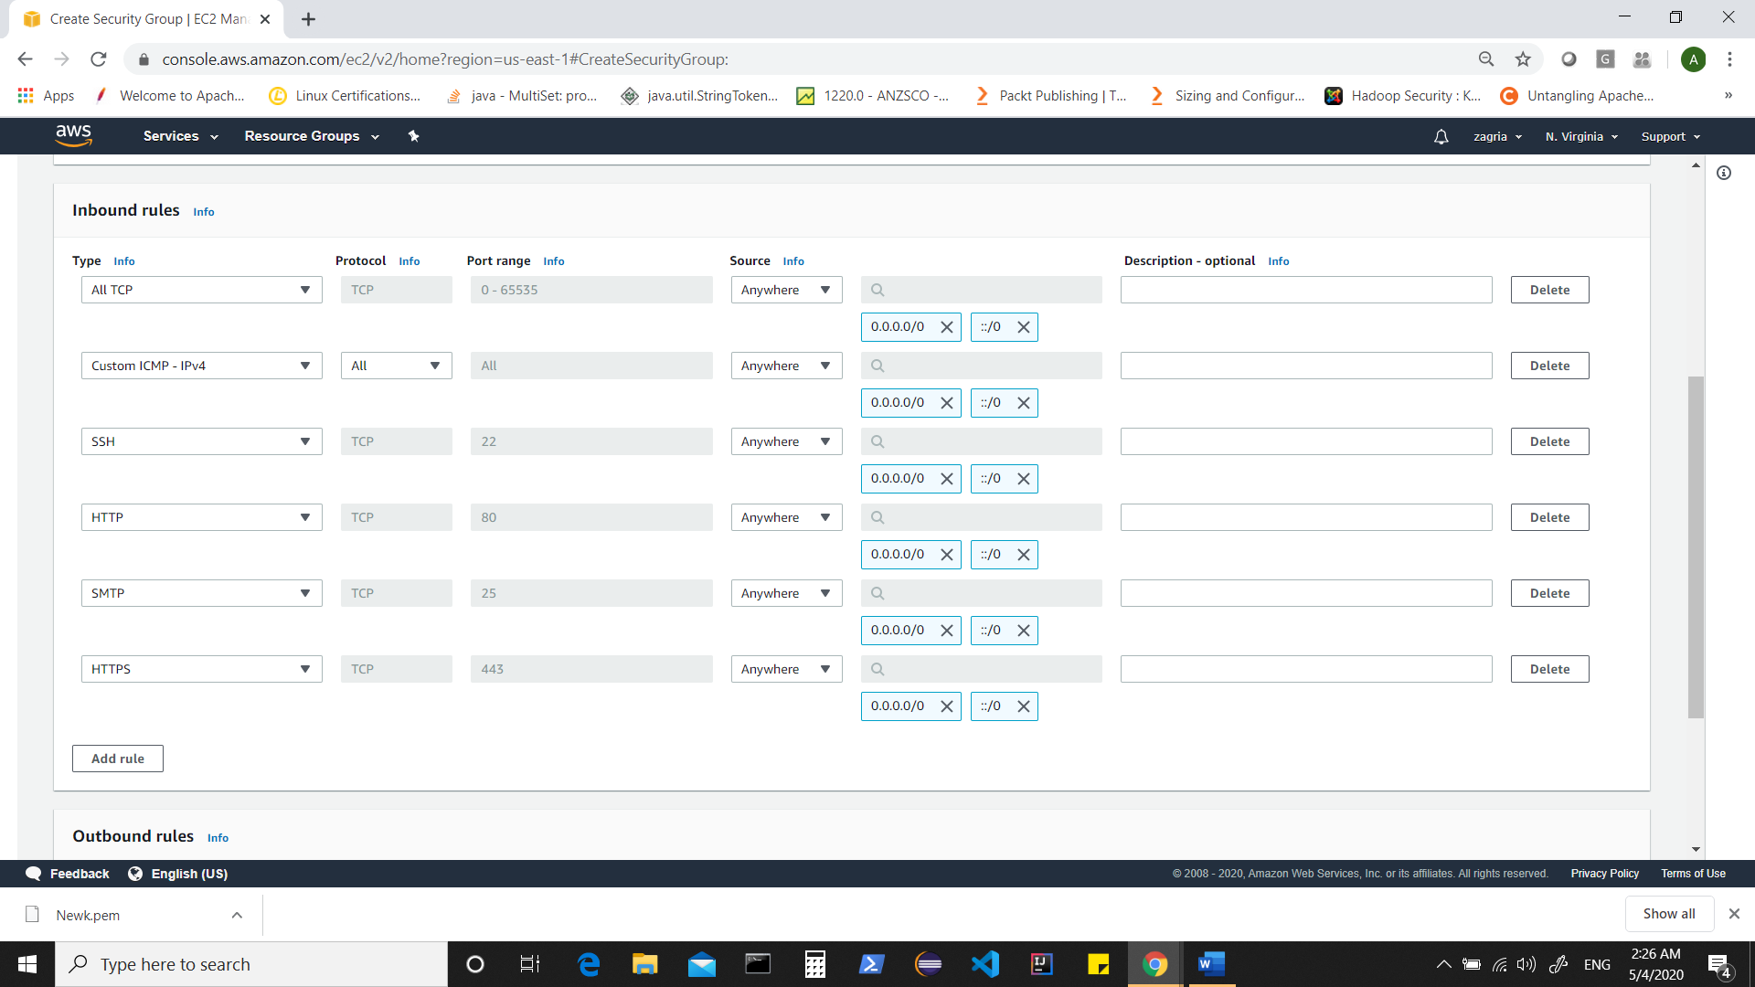

Here I have specified ‘anywhere’ for source which should be changed to ‘my ip’,’security group’ or other specifications.

Add rules for outbound

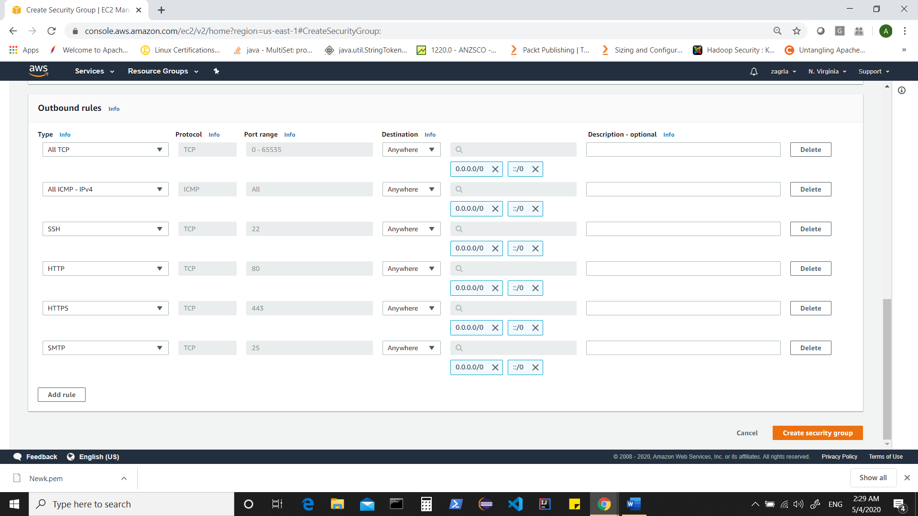

Now let’s create instances

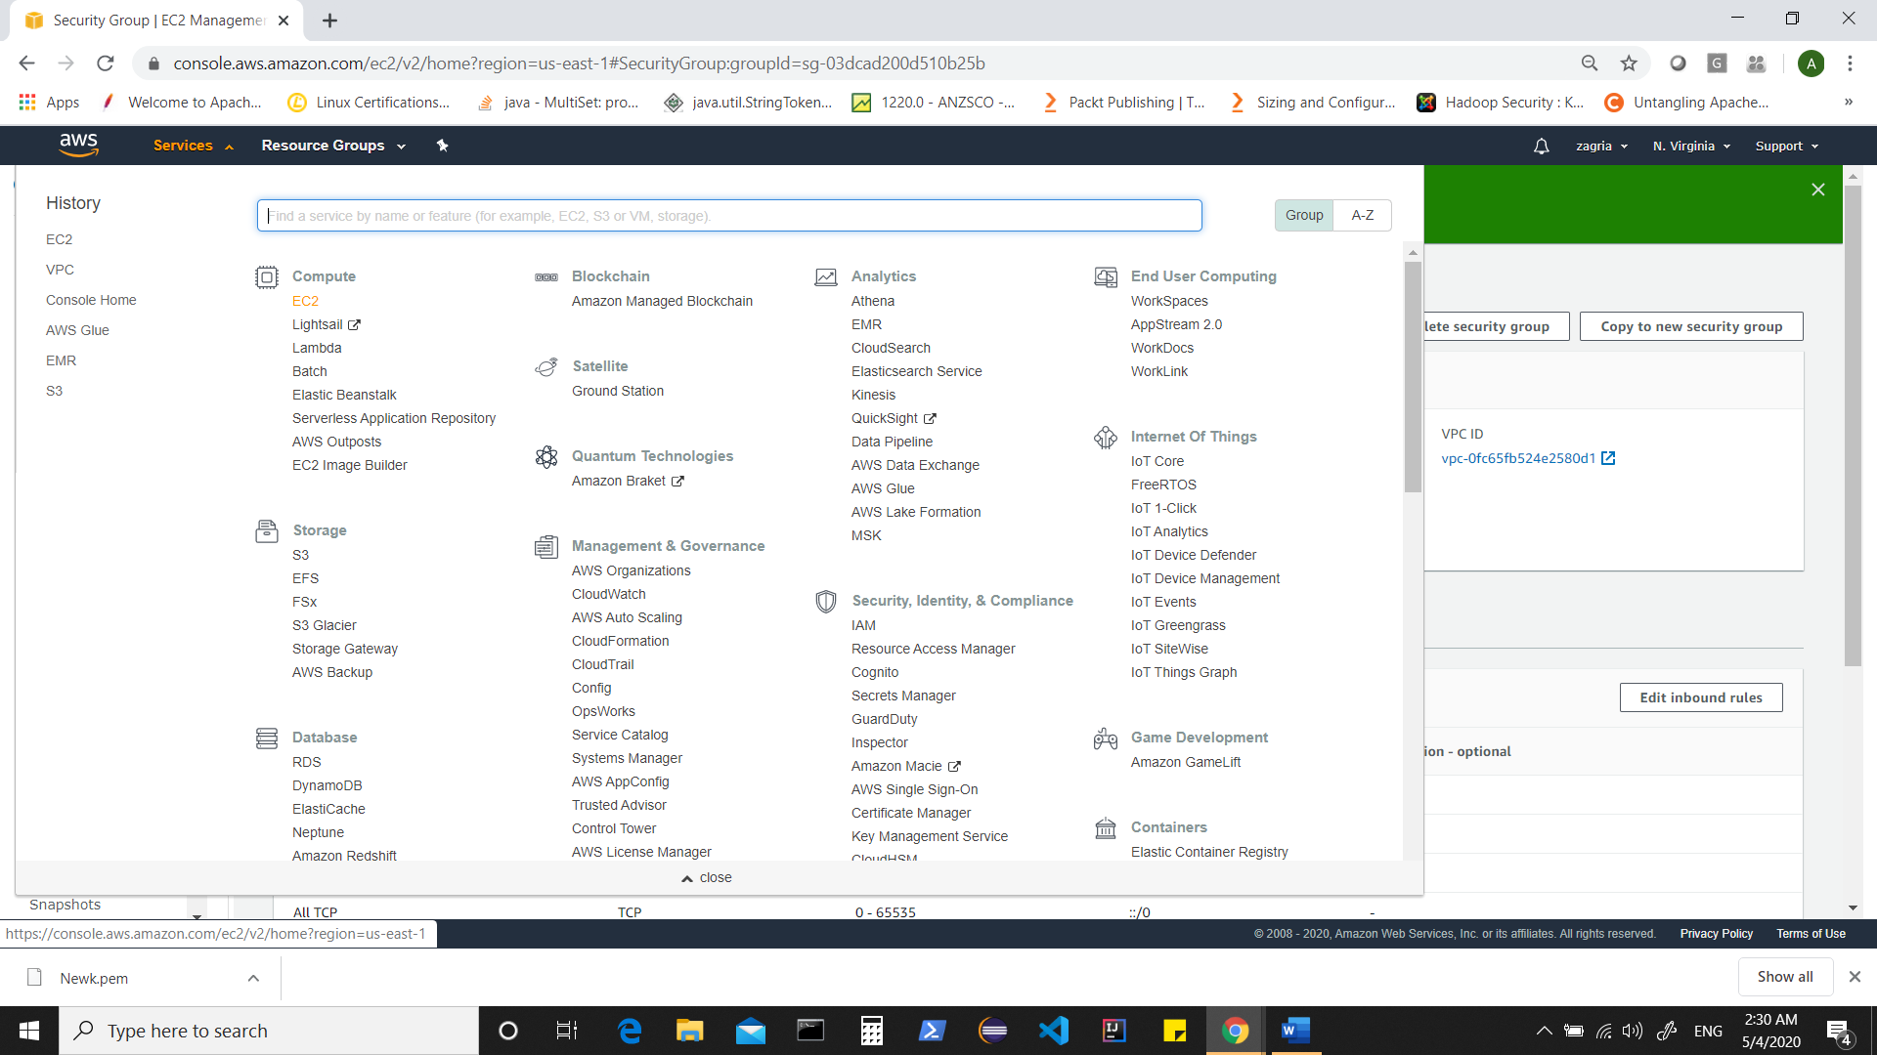

Click on Launch Instance

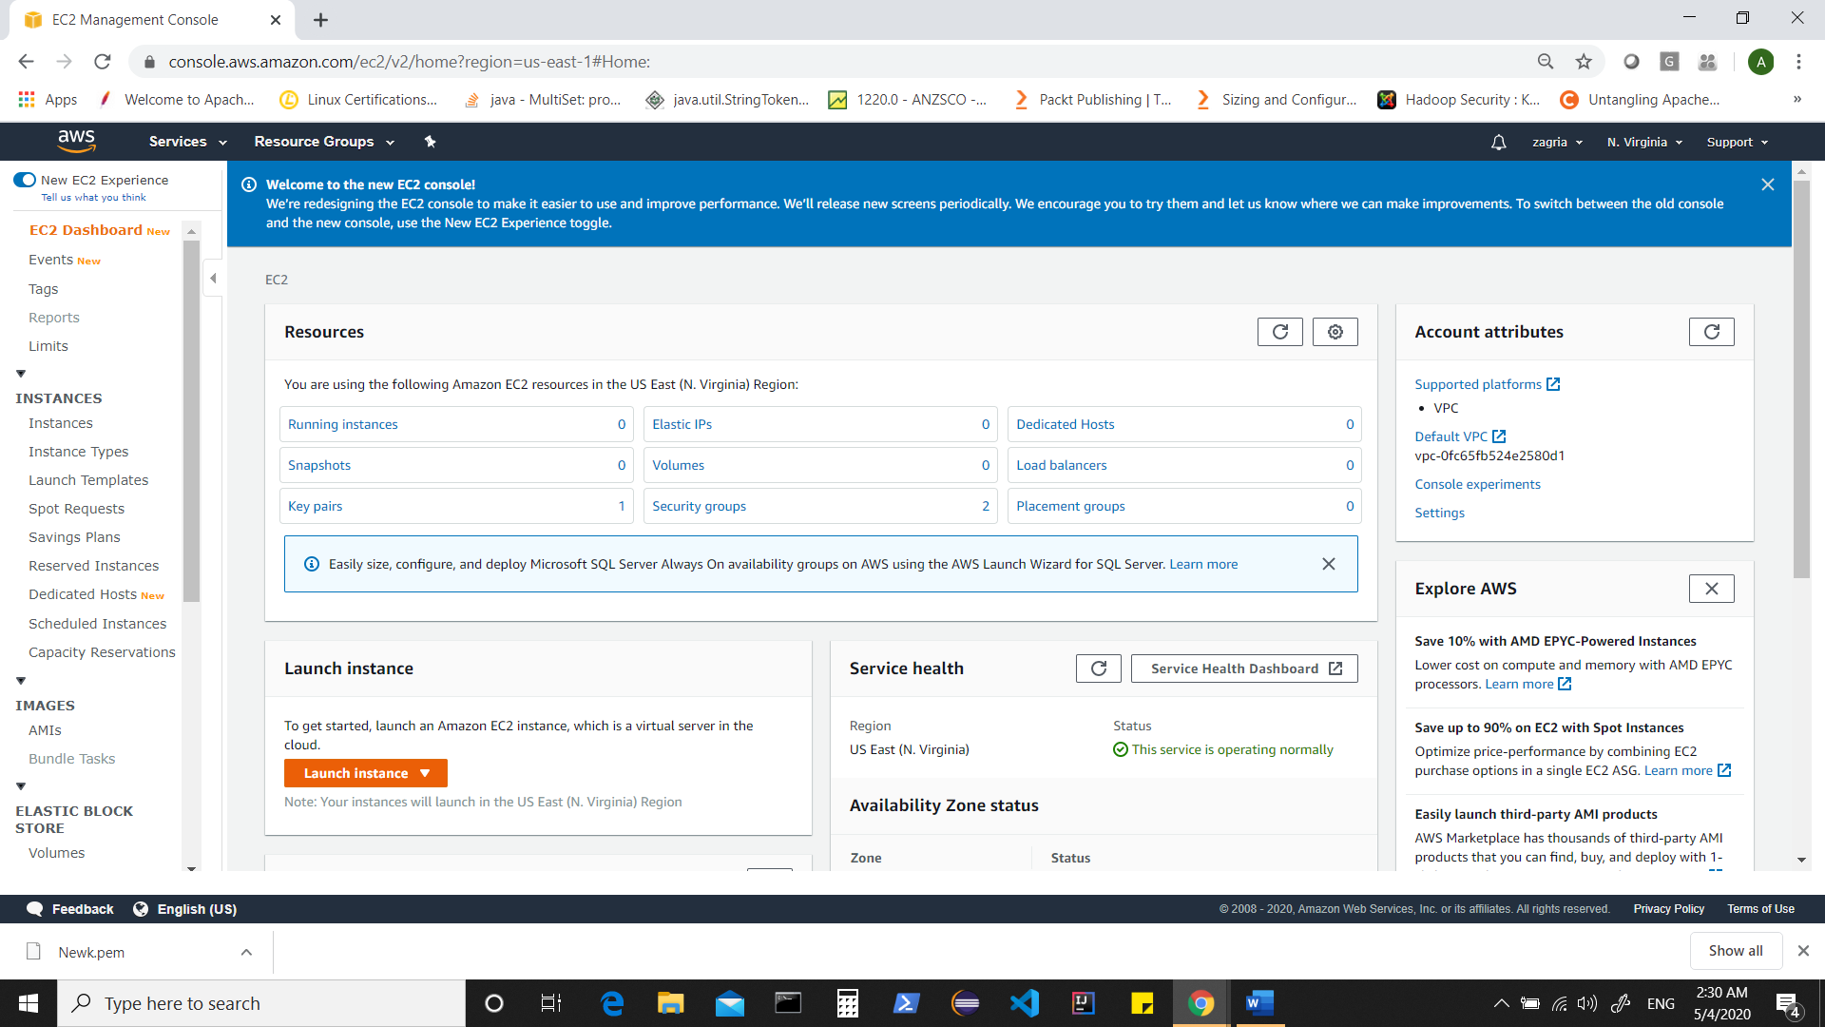

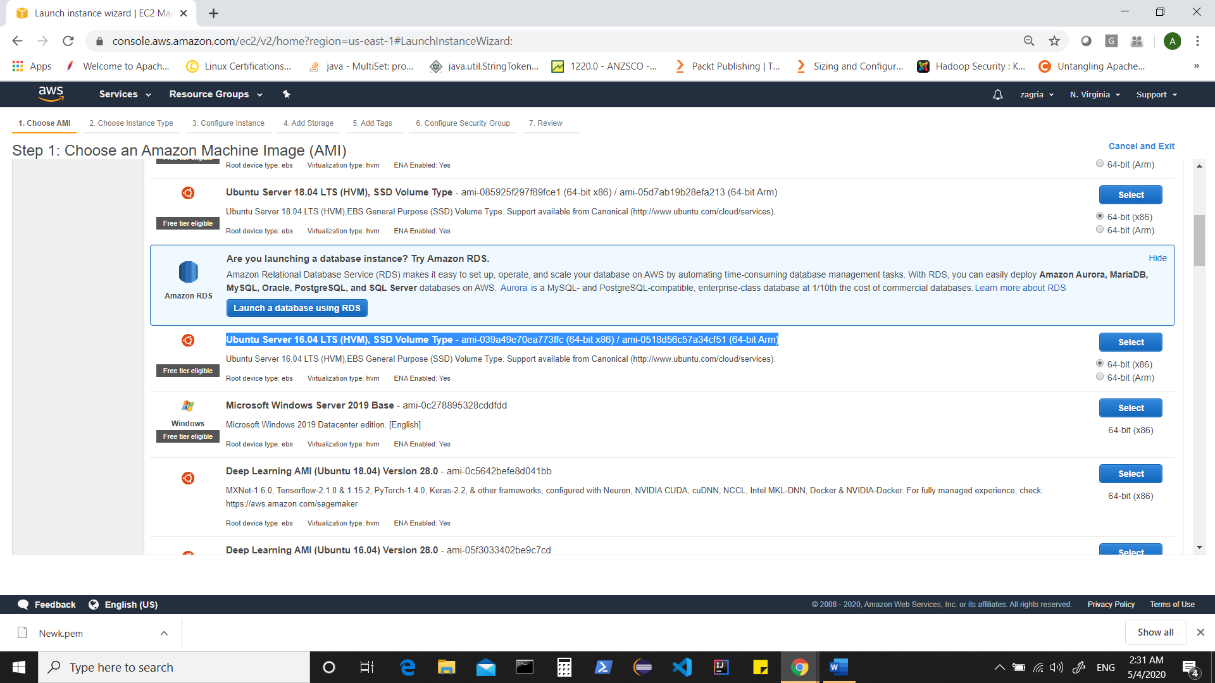

Choose Ubuntu Server 16.04 (AMI)

This is eligible for free tier

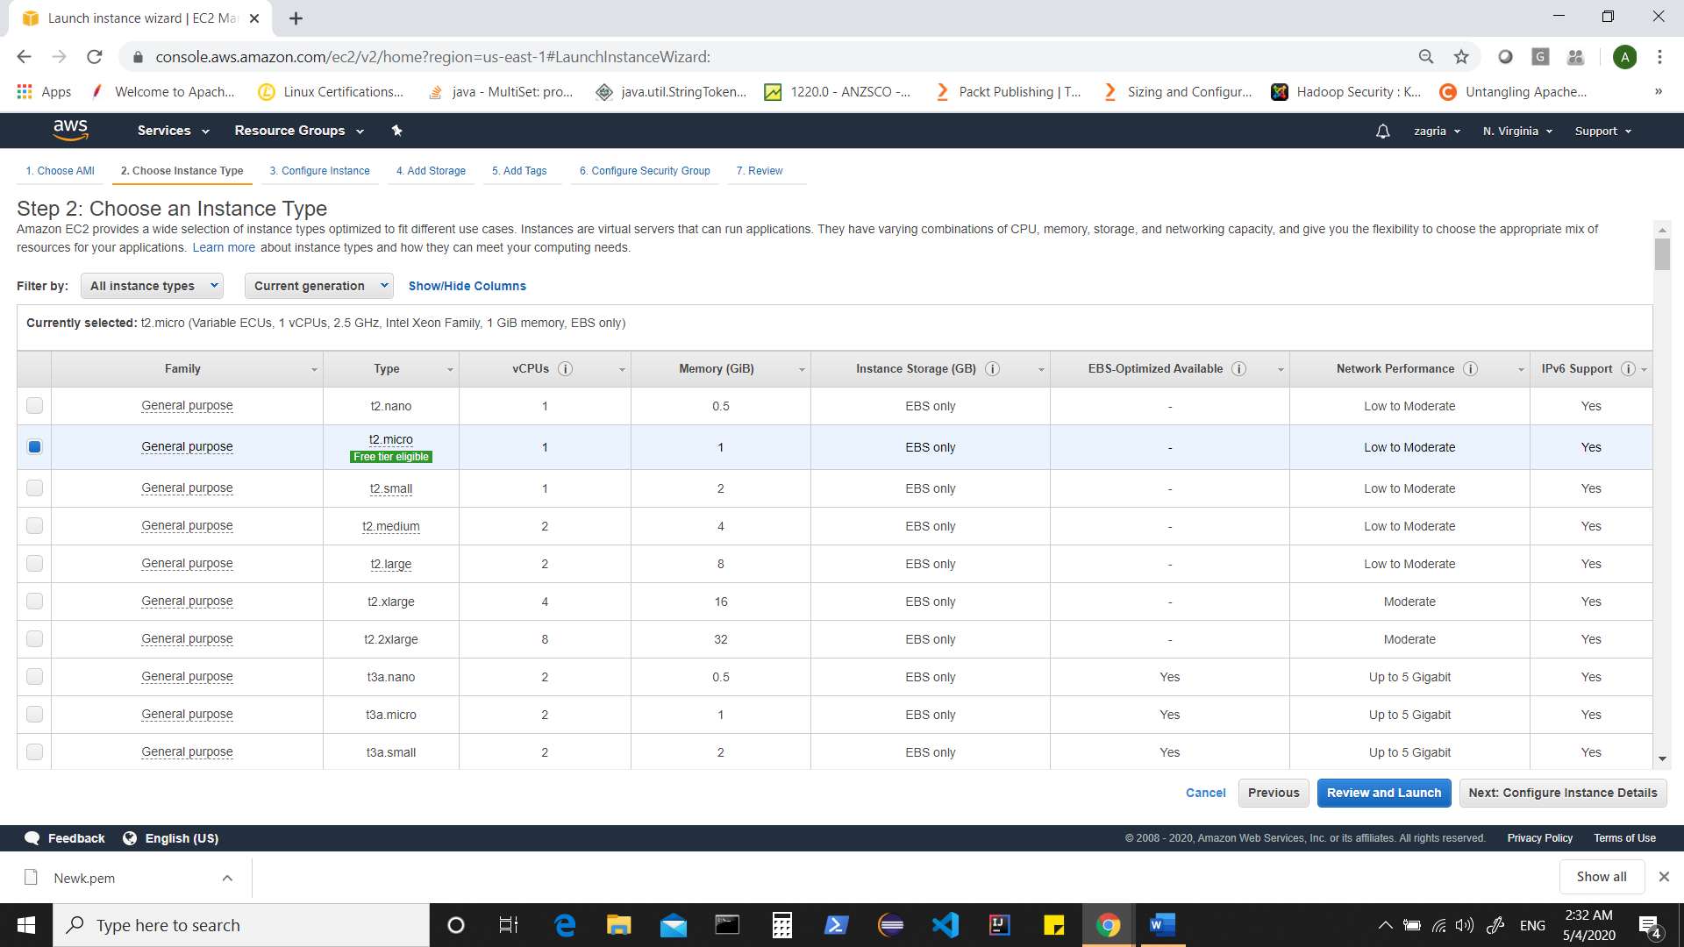

However we need powerful machines to setup a Cloudera Hadoop Cluster

Thus, let’s choose t2.large

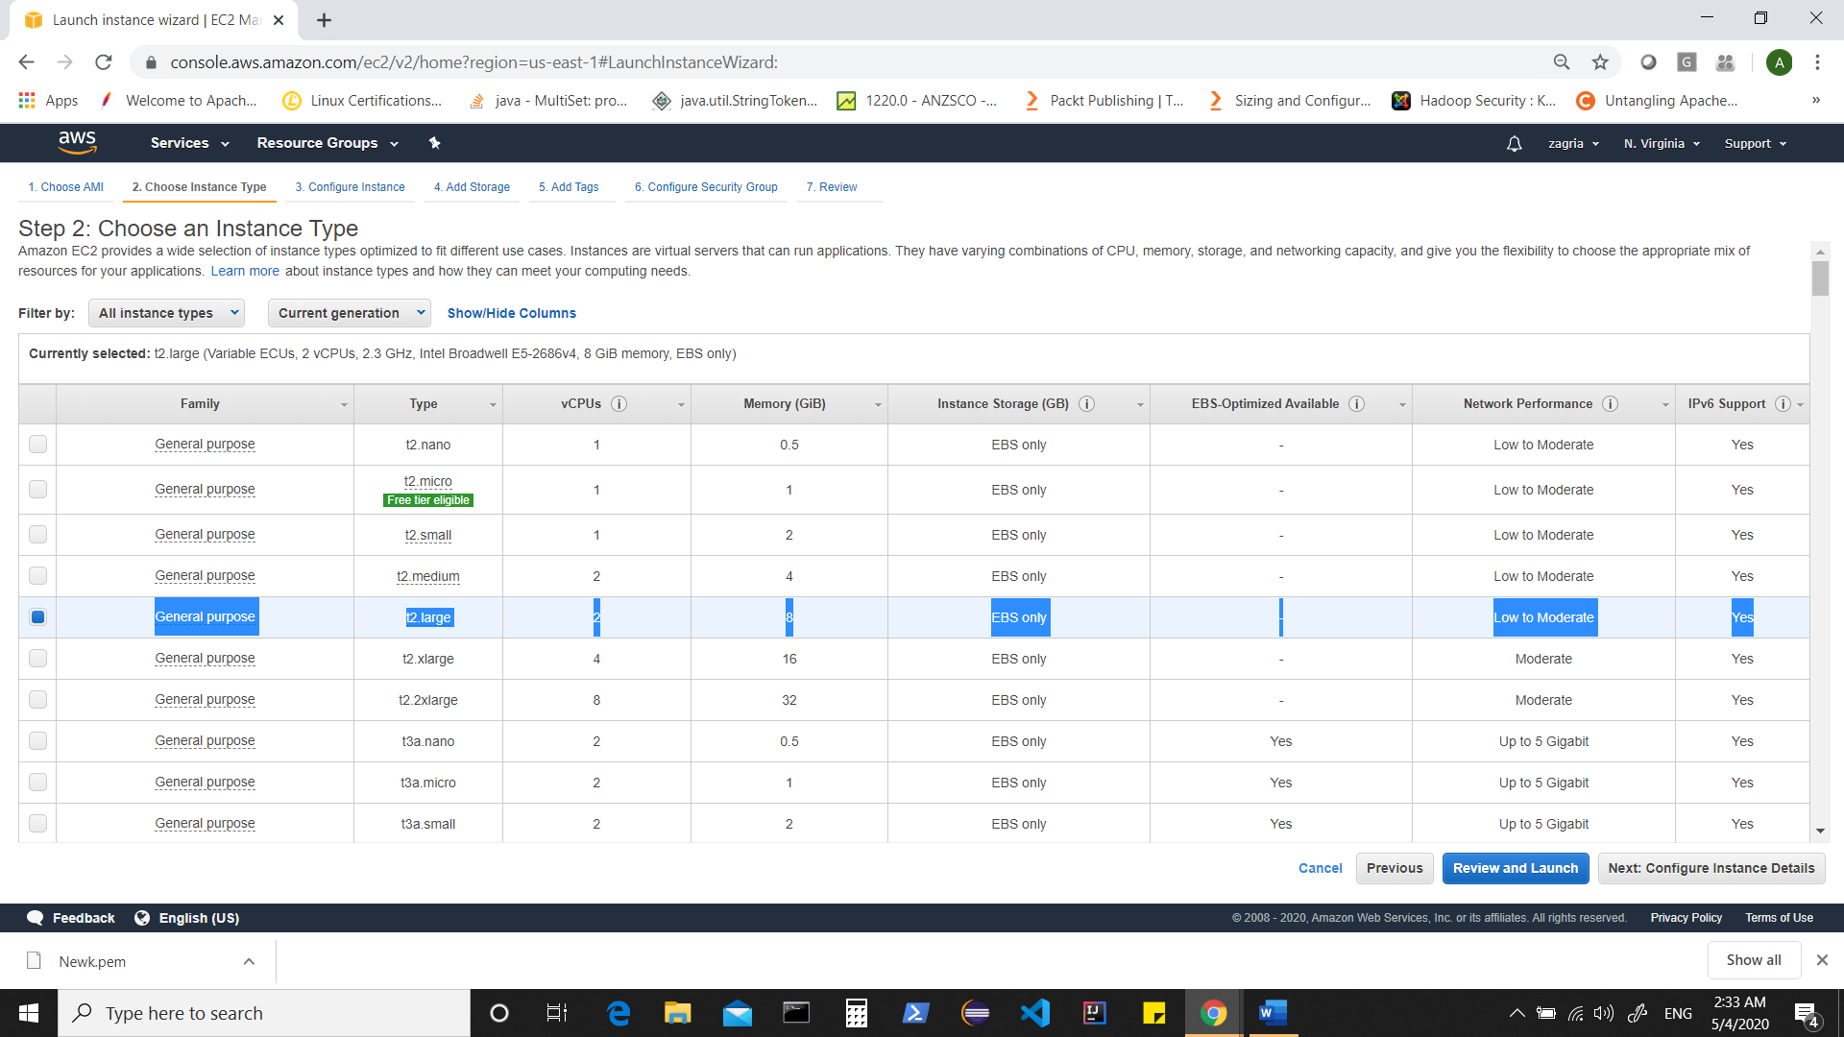

Click on “configure instance details”

Provide details as shown

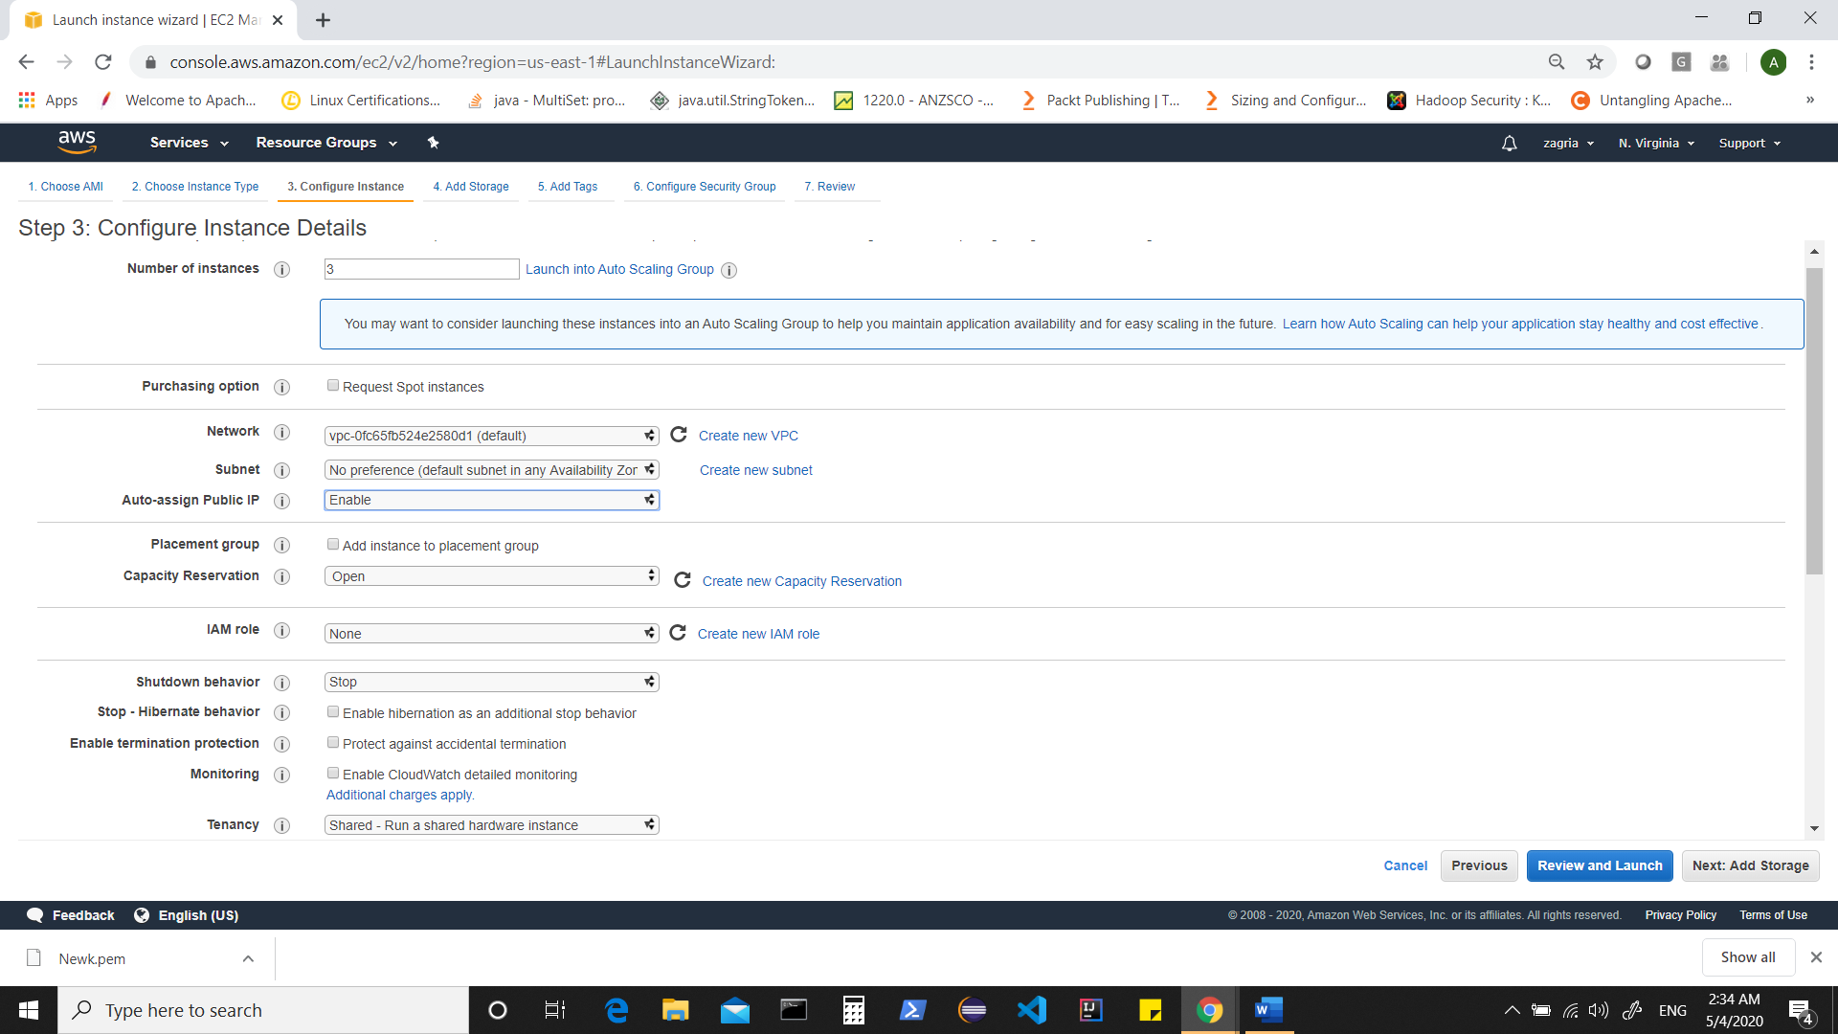

Click on Add storage

Configure as shown

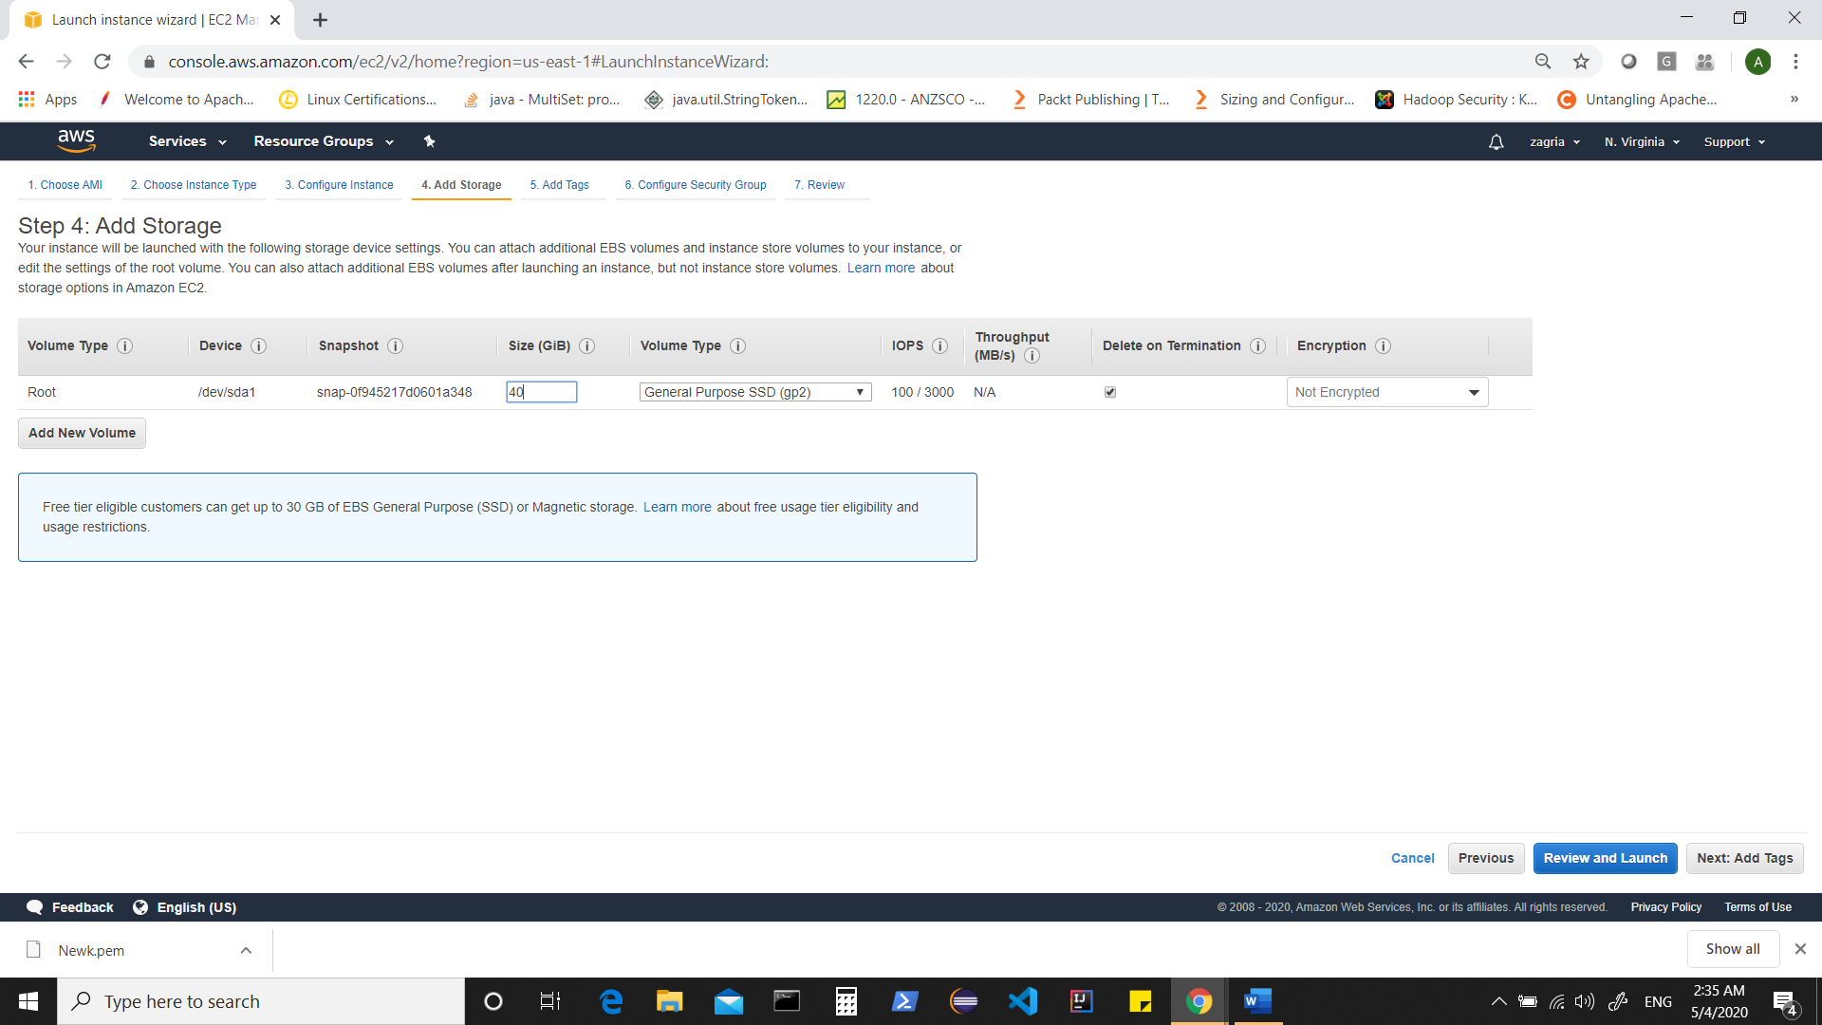

Note ** We can use additional Volumes by clicking on “Add volume” and choose EBS, but as of now that is not required.

Click on “Add tags” [Nothing required here as of now]

Click on “Configure Security Group”

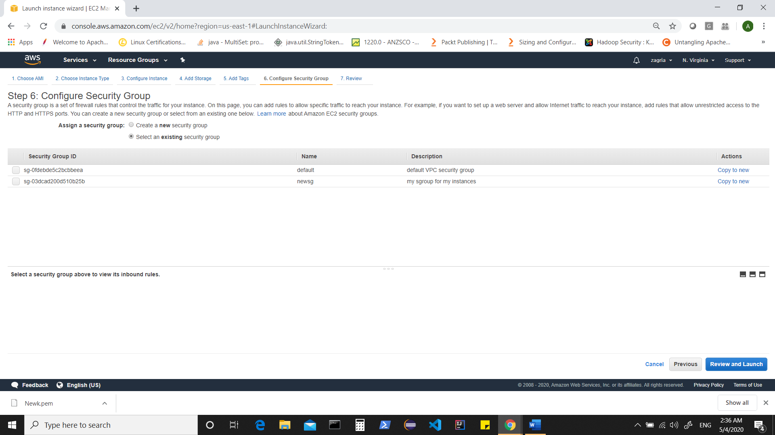

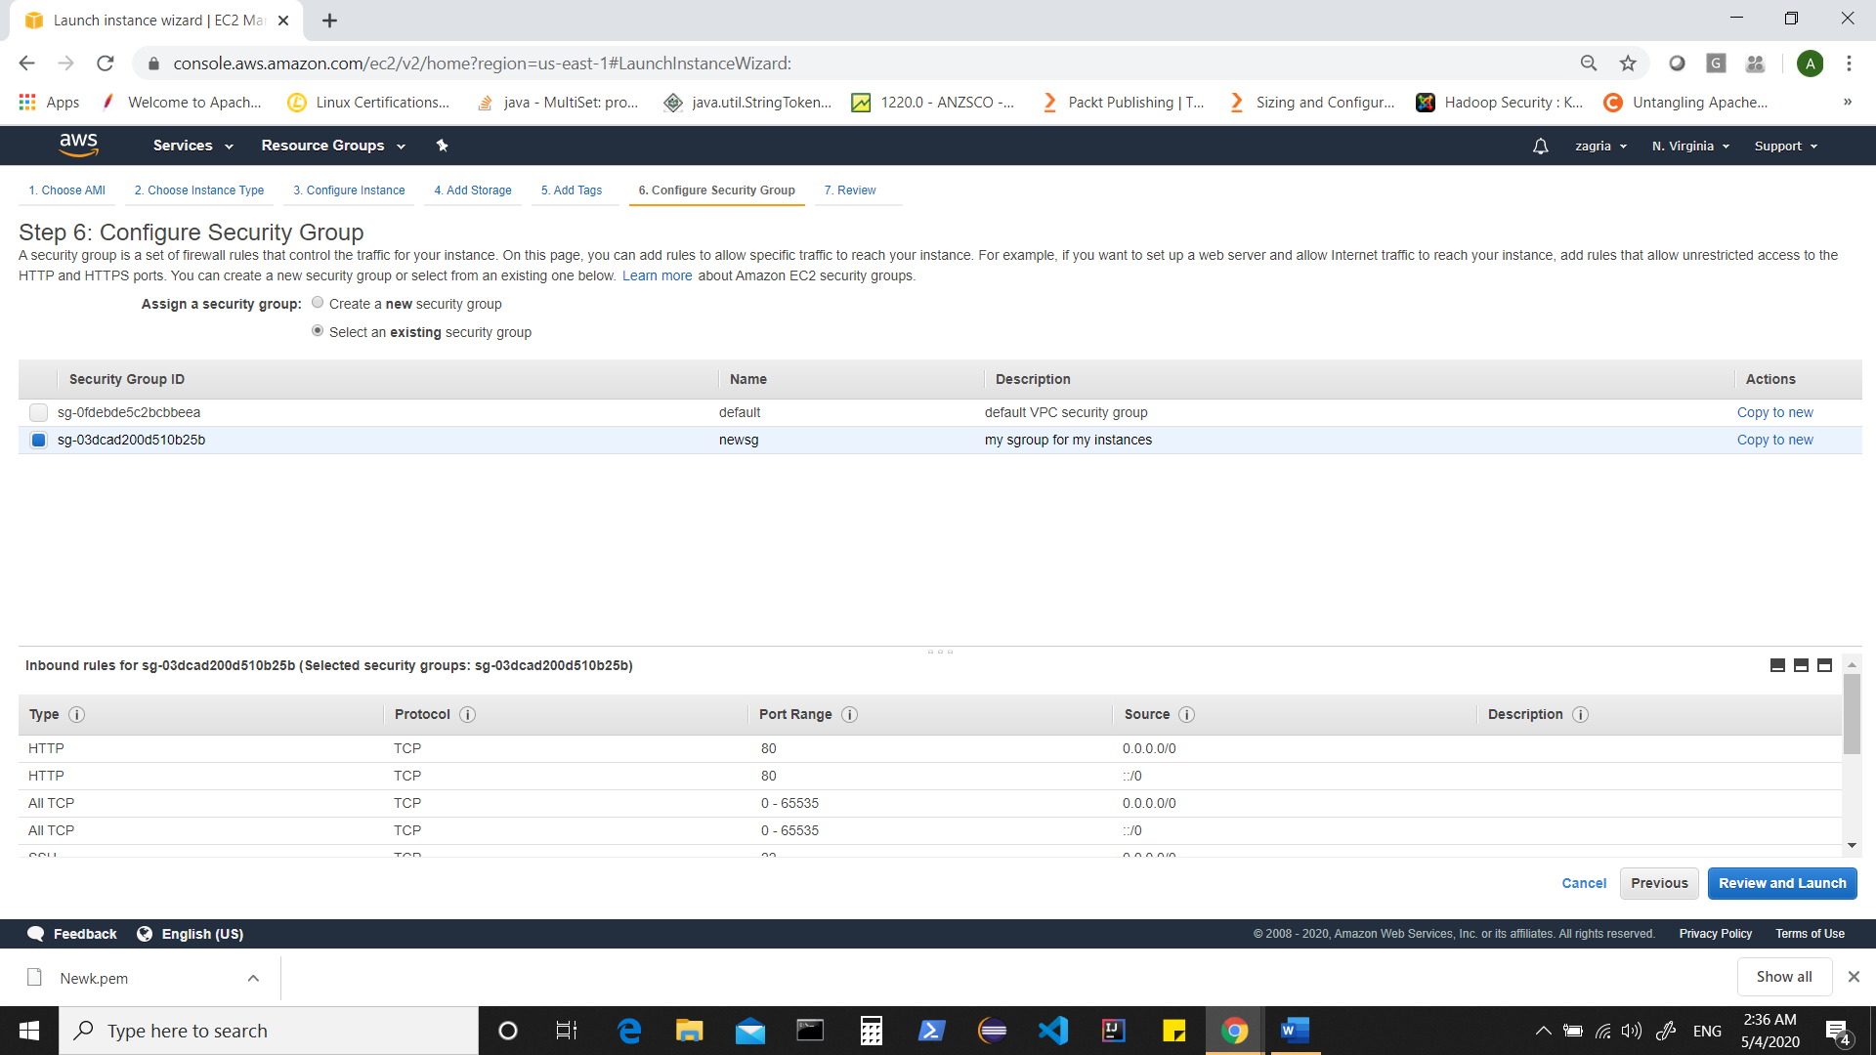

After selecting your already created security group,

Click on “review and launch”

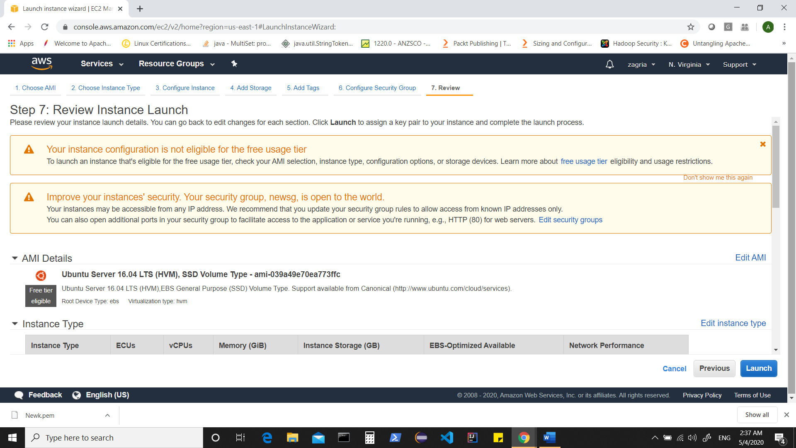

Click on “Launch”

Select your key pair

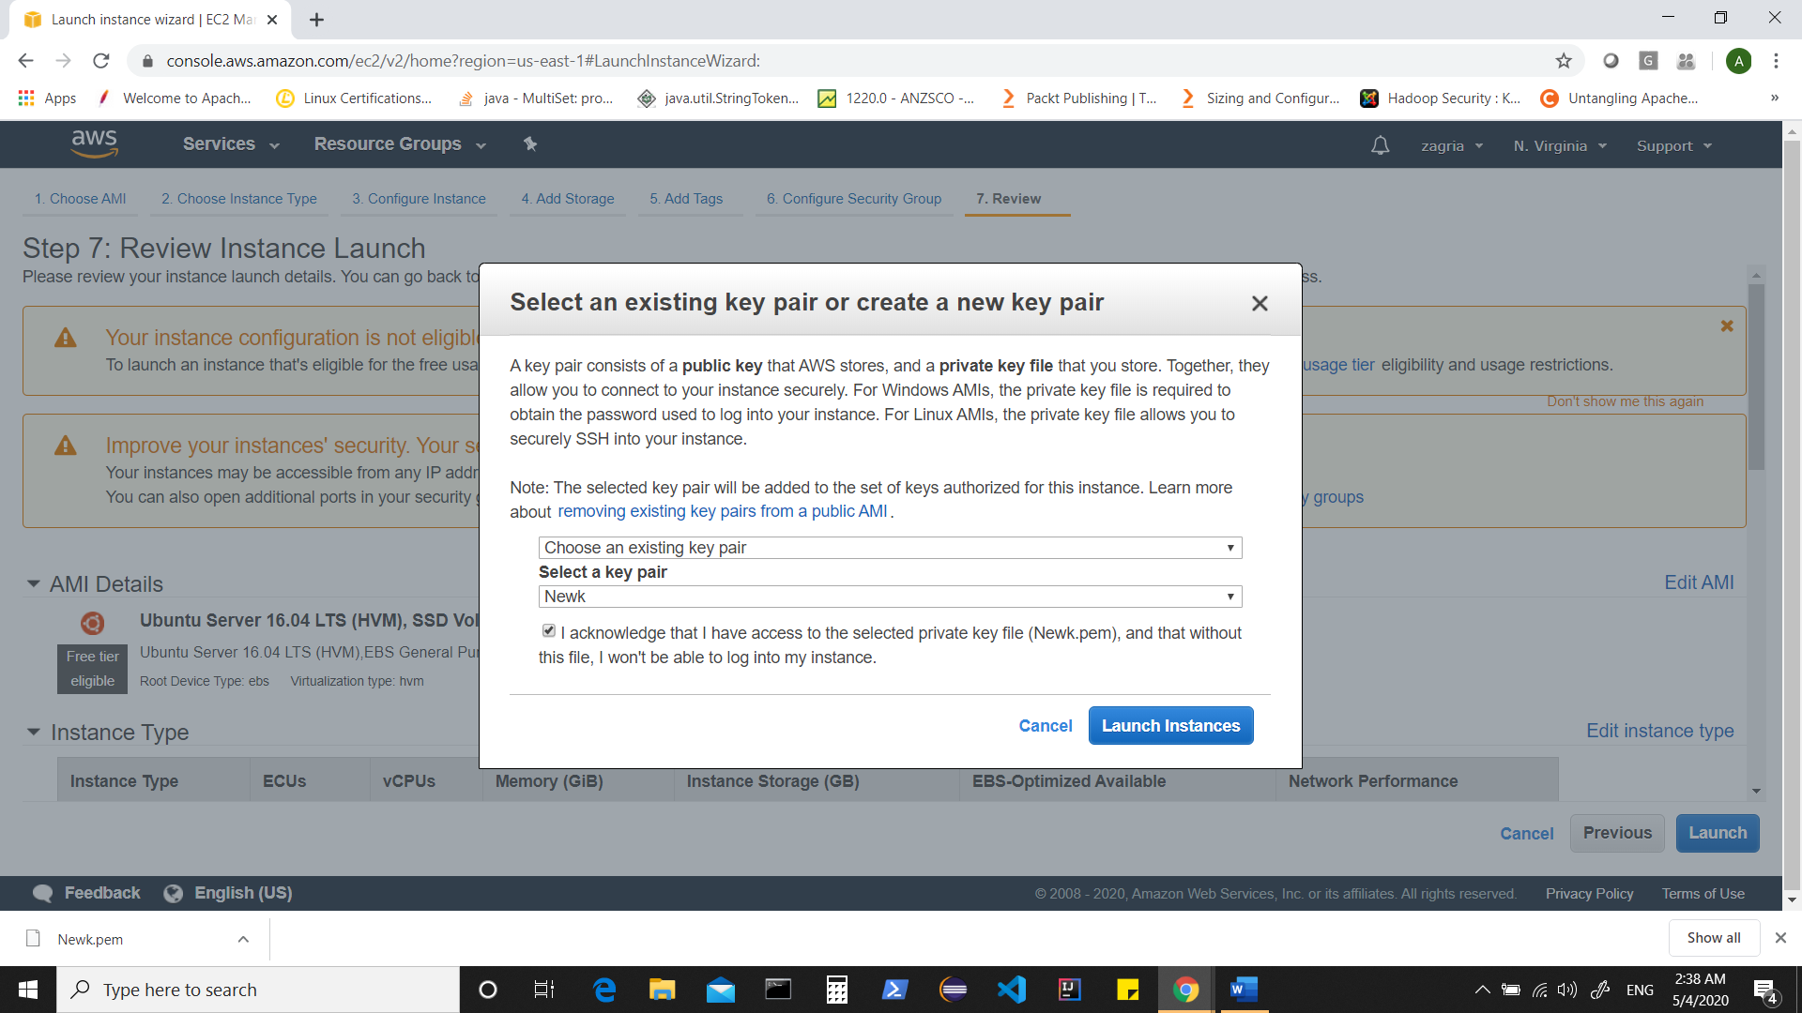

& “Launch Instances”

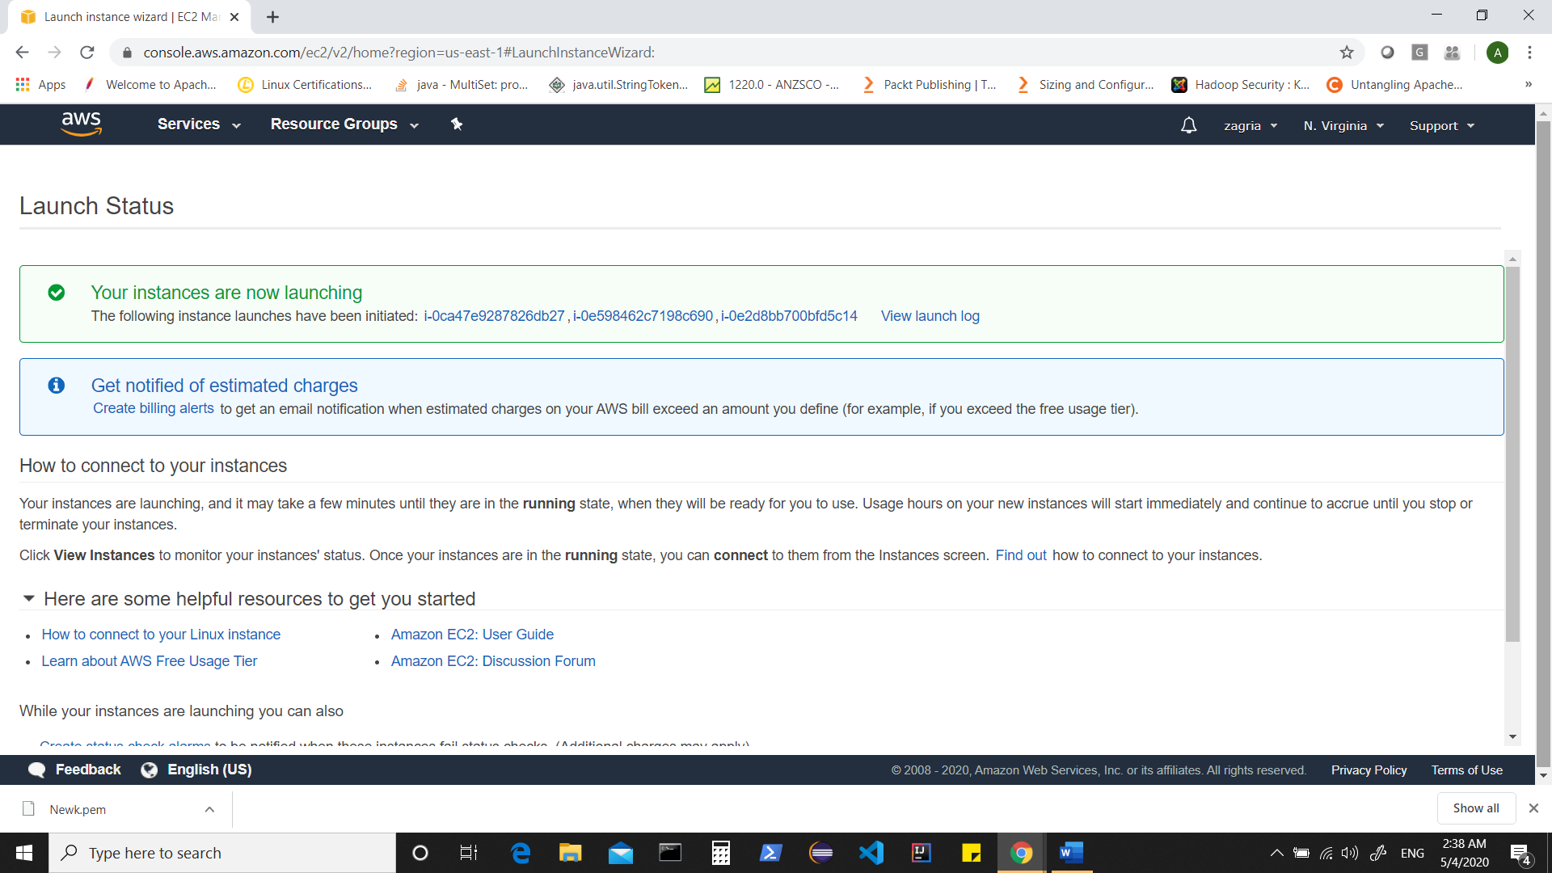

Click on any instance id,

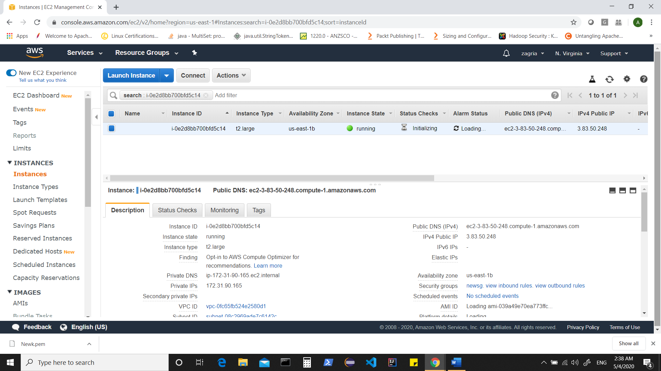

& in search ,remove the instance ID from search

That should show you all your instances

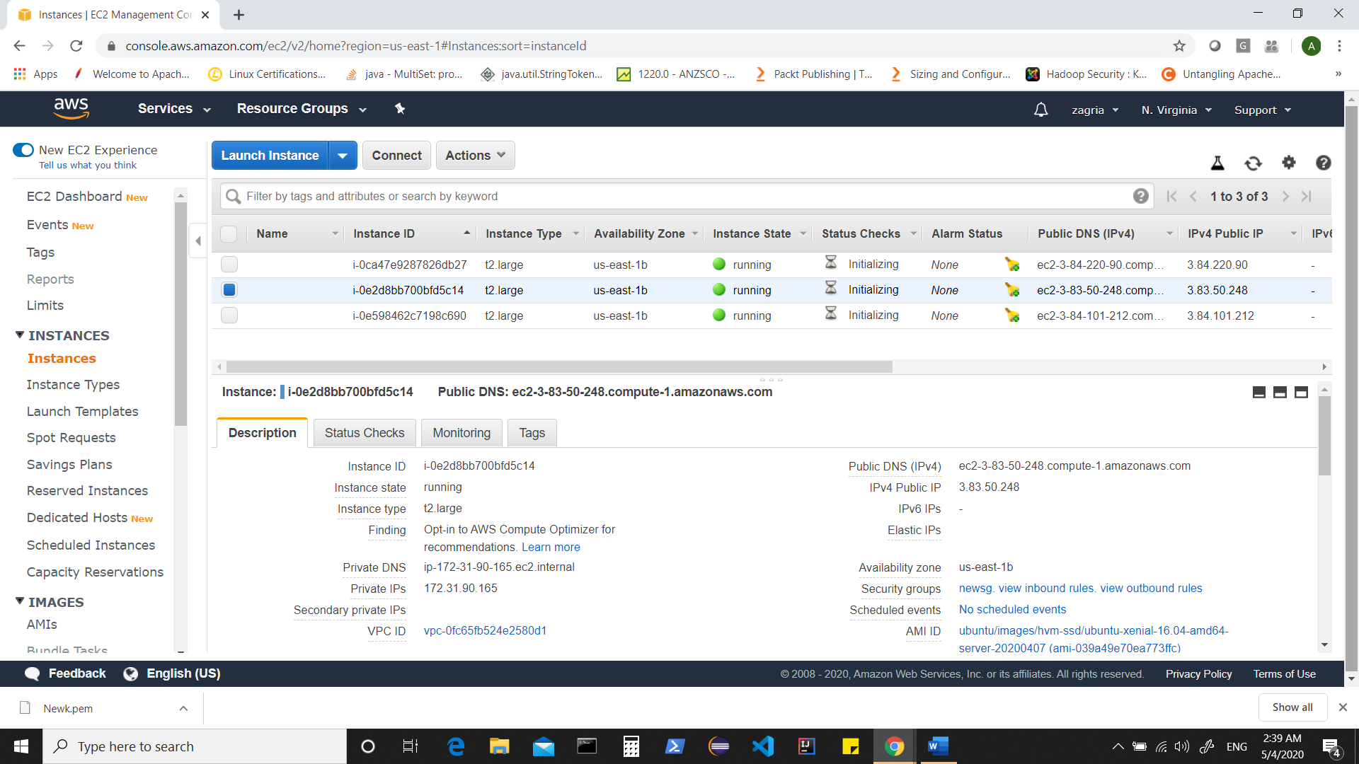

If All steps completed so far, your instances should be ready to be used.

To connect these instances using external ssh client such as “putty”, we need to convert “*.pem” to “*.ppk” file for which we can use “puttygen.exe”

Launch puttygen

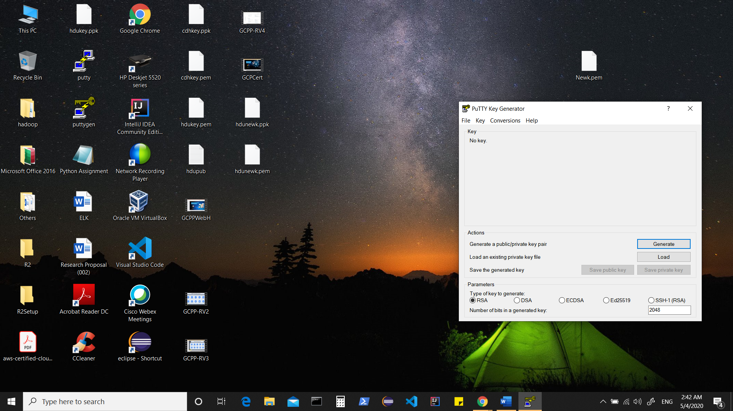

Click on “Load” and add your “*.pem” file.

Now give credentials

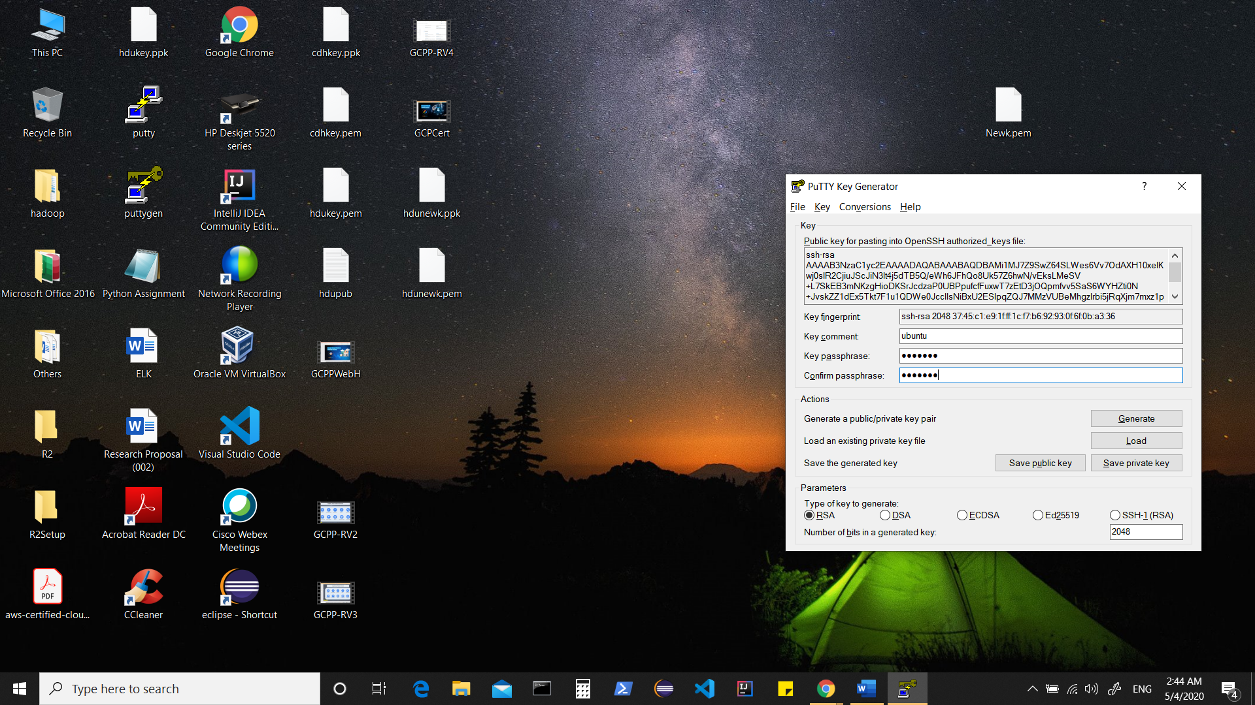

Click on “save private key” which should allow you to save your key as “*.ppk” file.

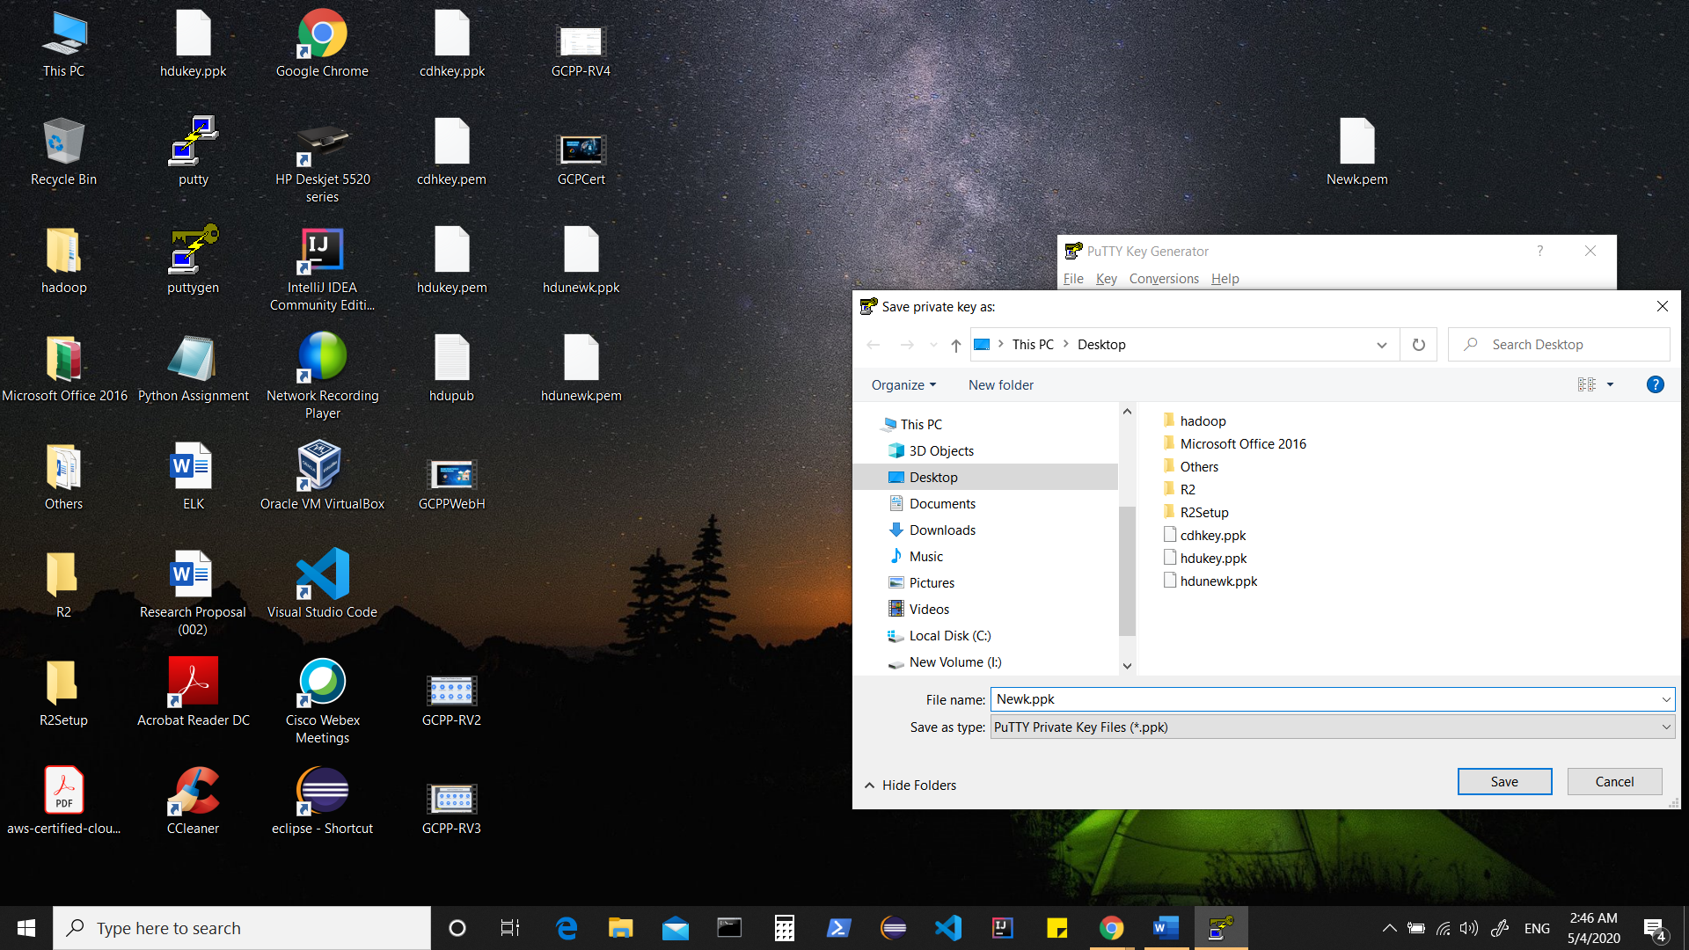

Now you have “*.pem” file to do ssh to your ec2 instances (say from one instance to another or when using some external software to ssh into your instances)

&

You have “*.ppk” file to ssh into your instances using external ssh client such as putty.

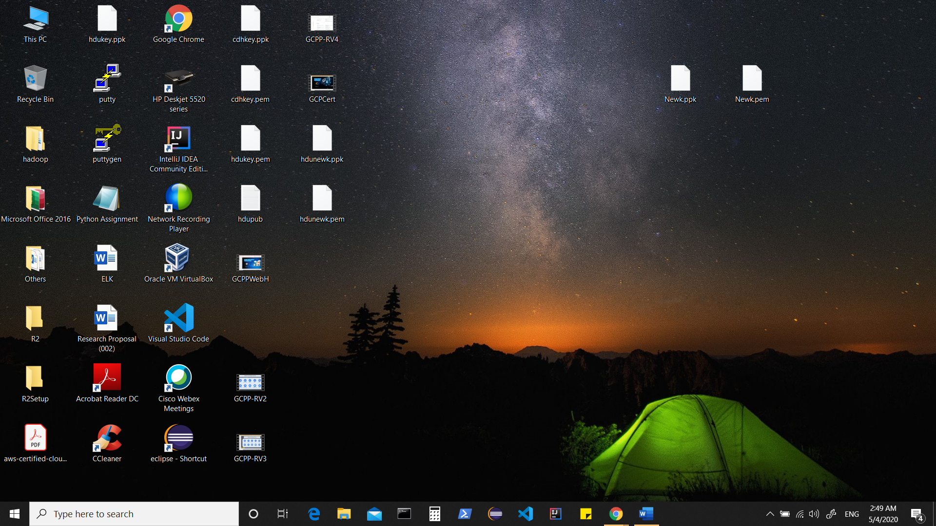

Now setup putty to connect to these instances.

Rename your instances to say “c1,c2,c3” for easier access.

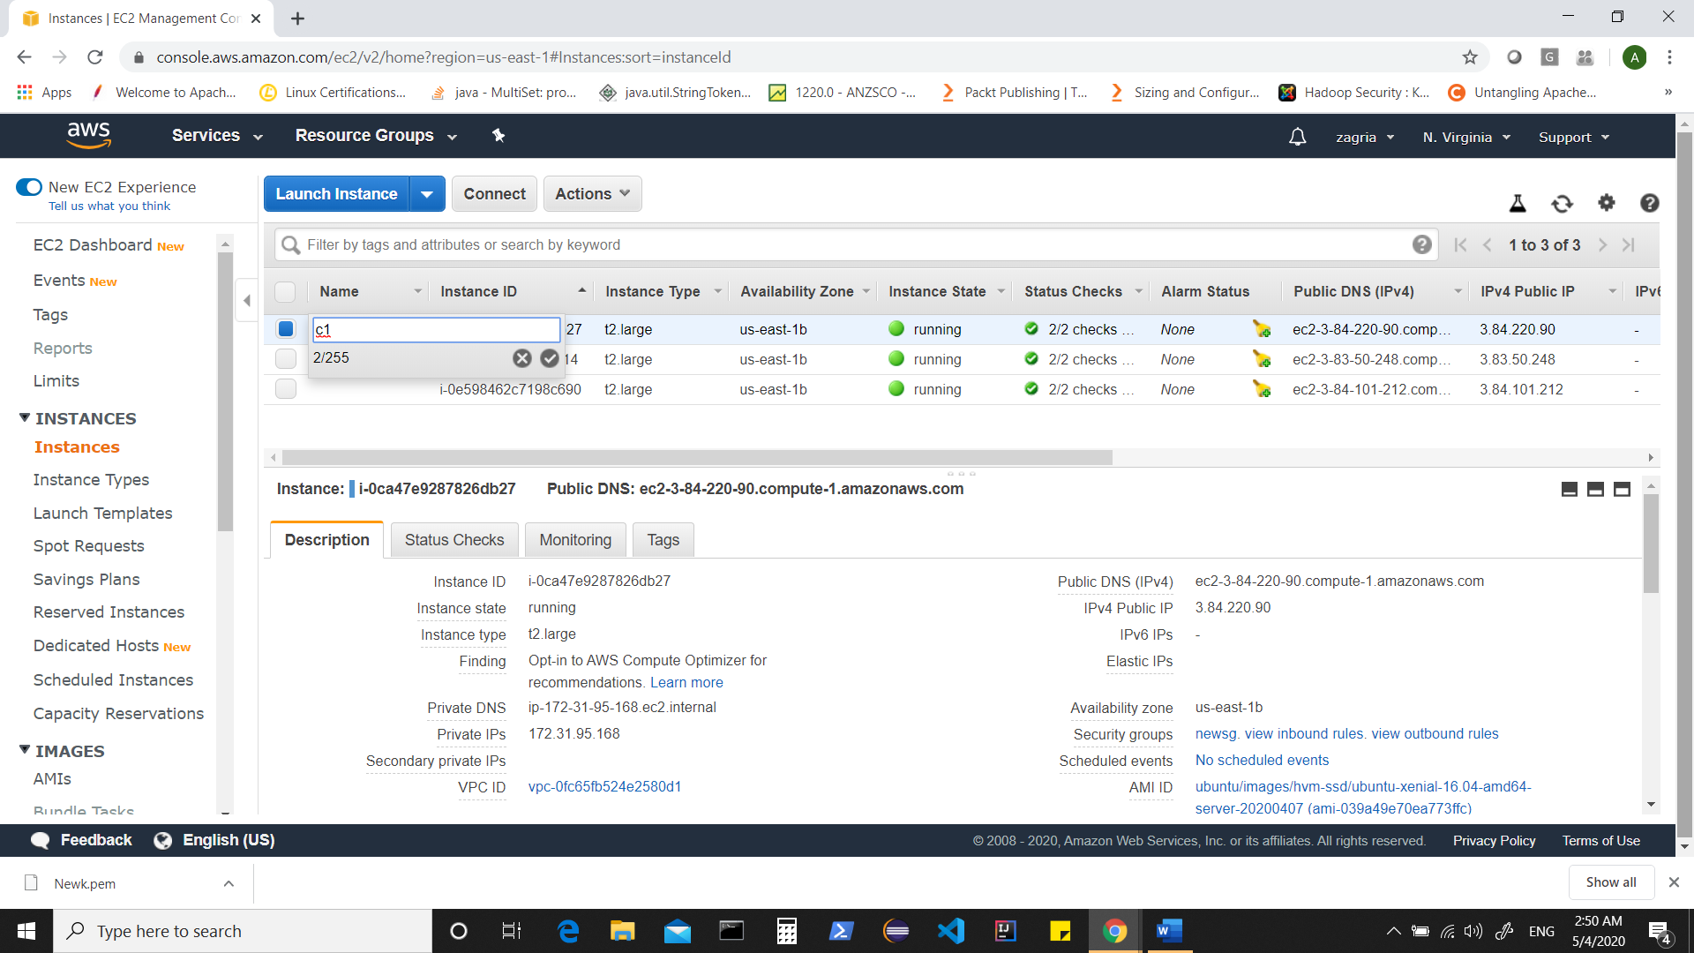

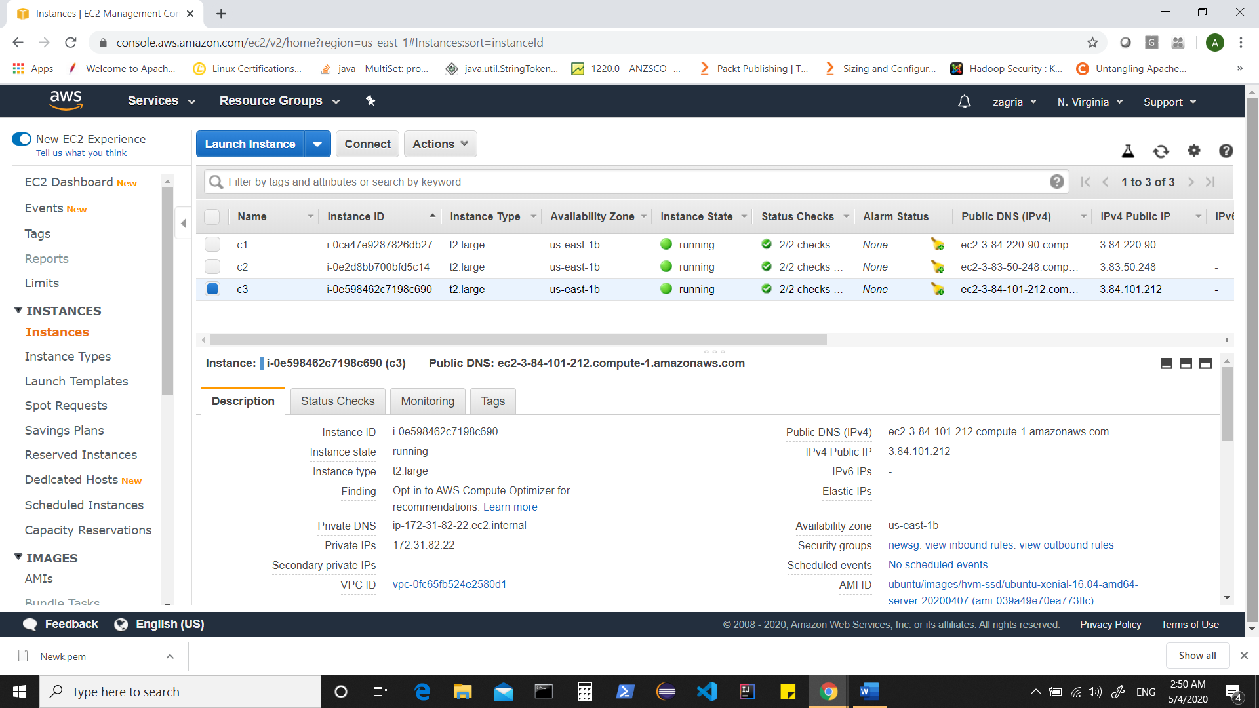

We need public IPs to connect from putty.

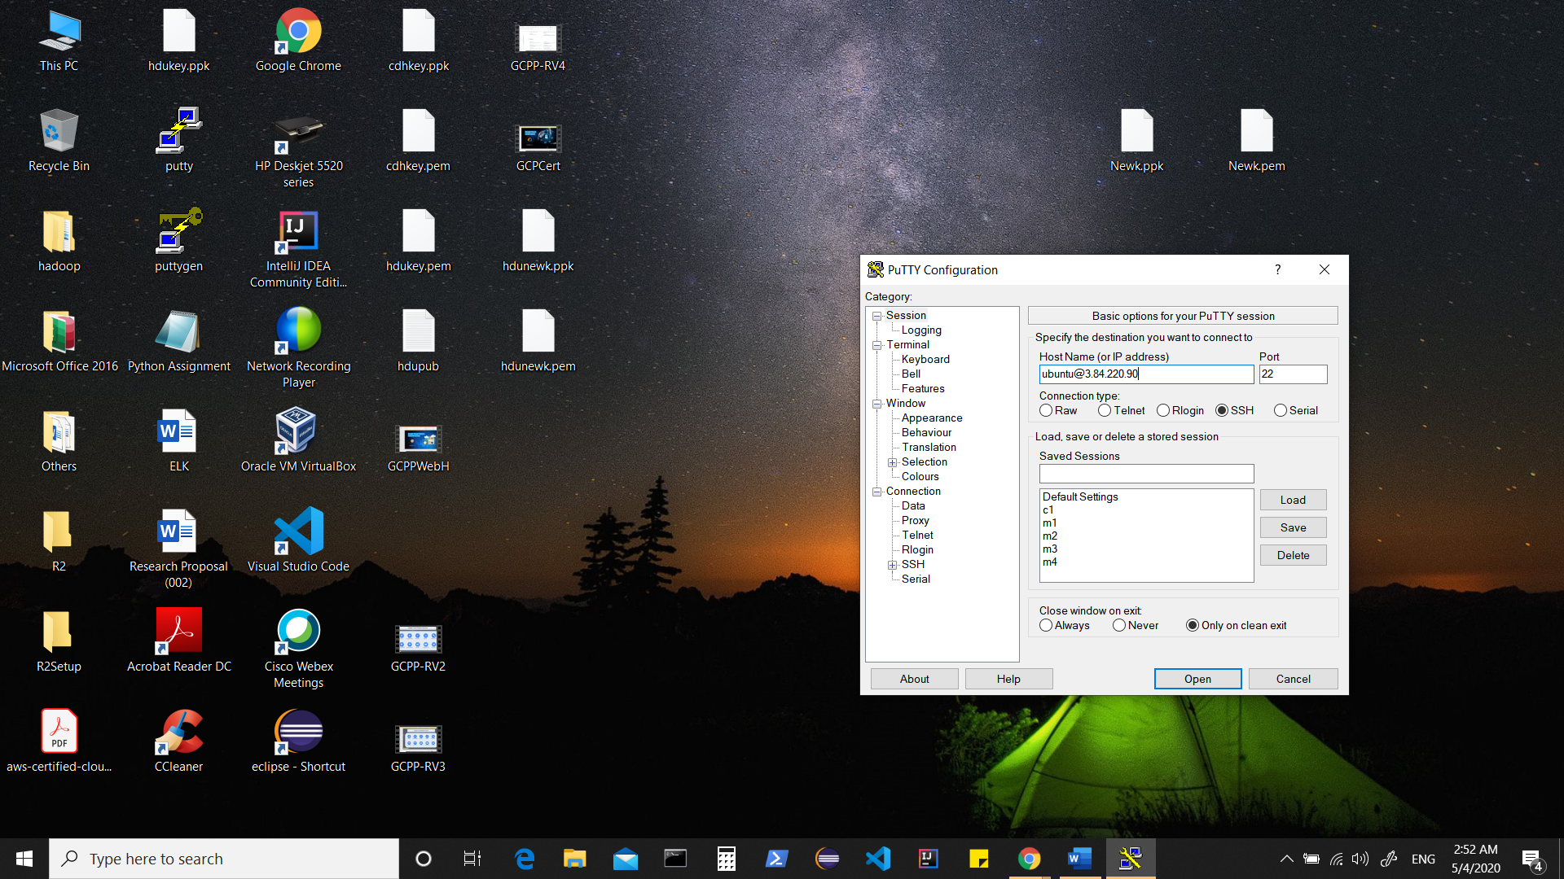

Click on ssh> auth and add your “*.ppk” file

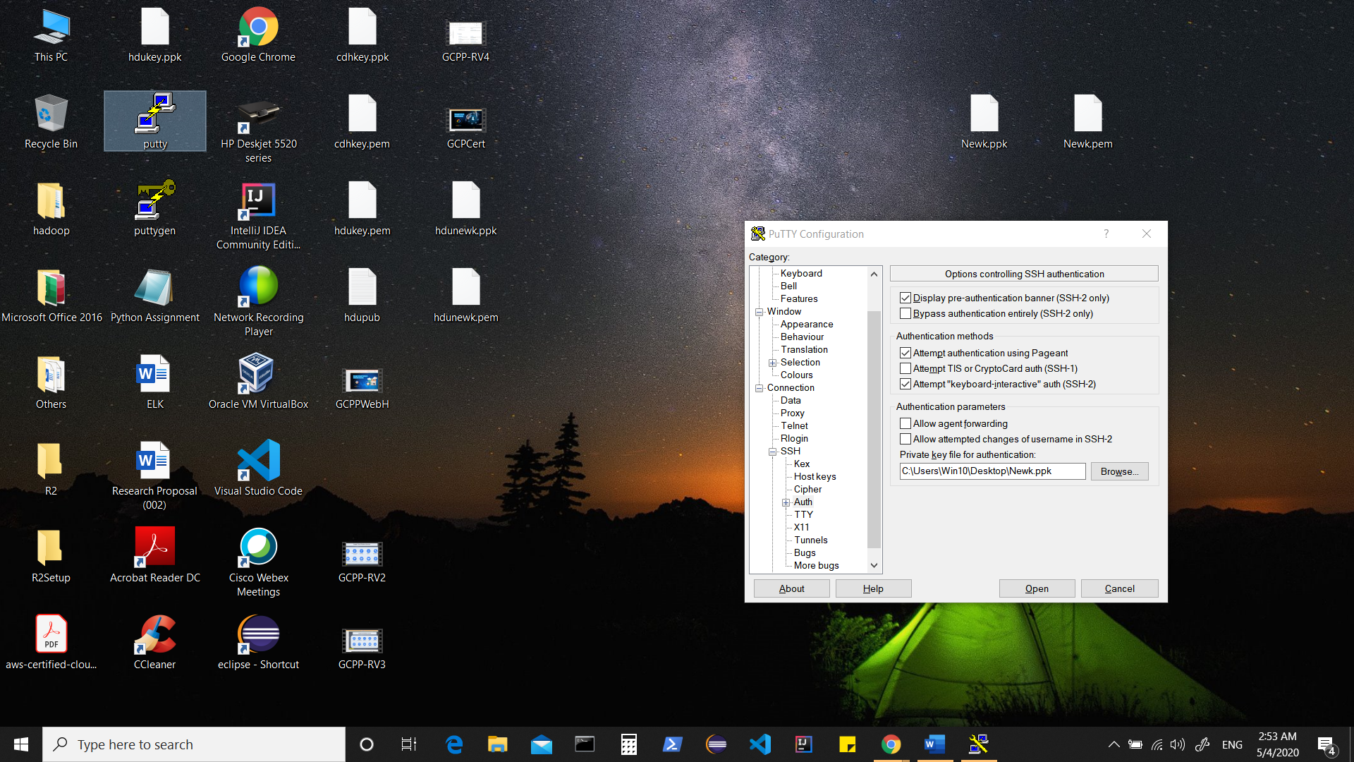

Save the session as c1

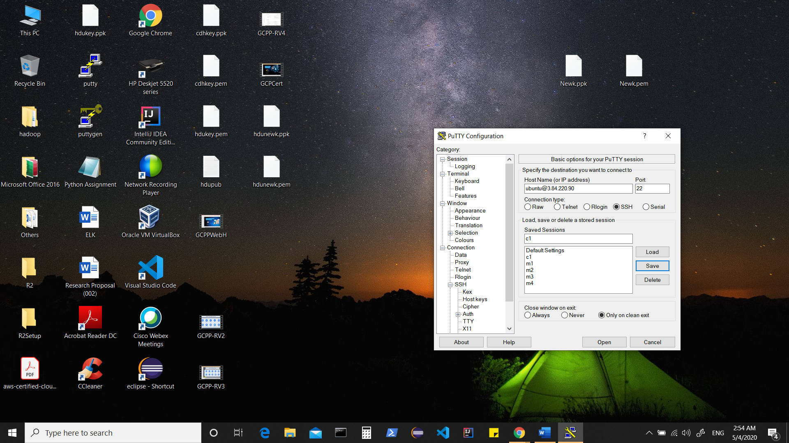

Click on open

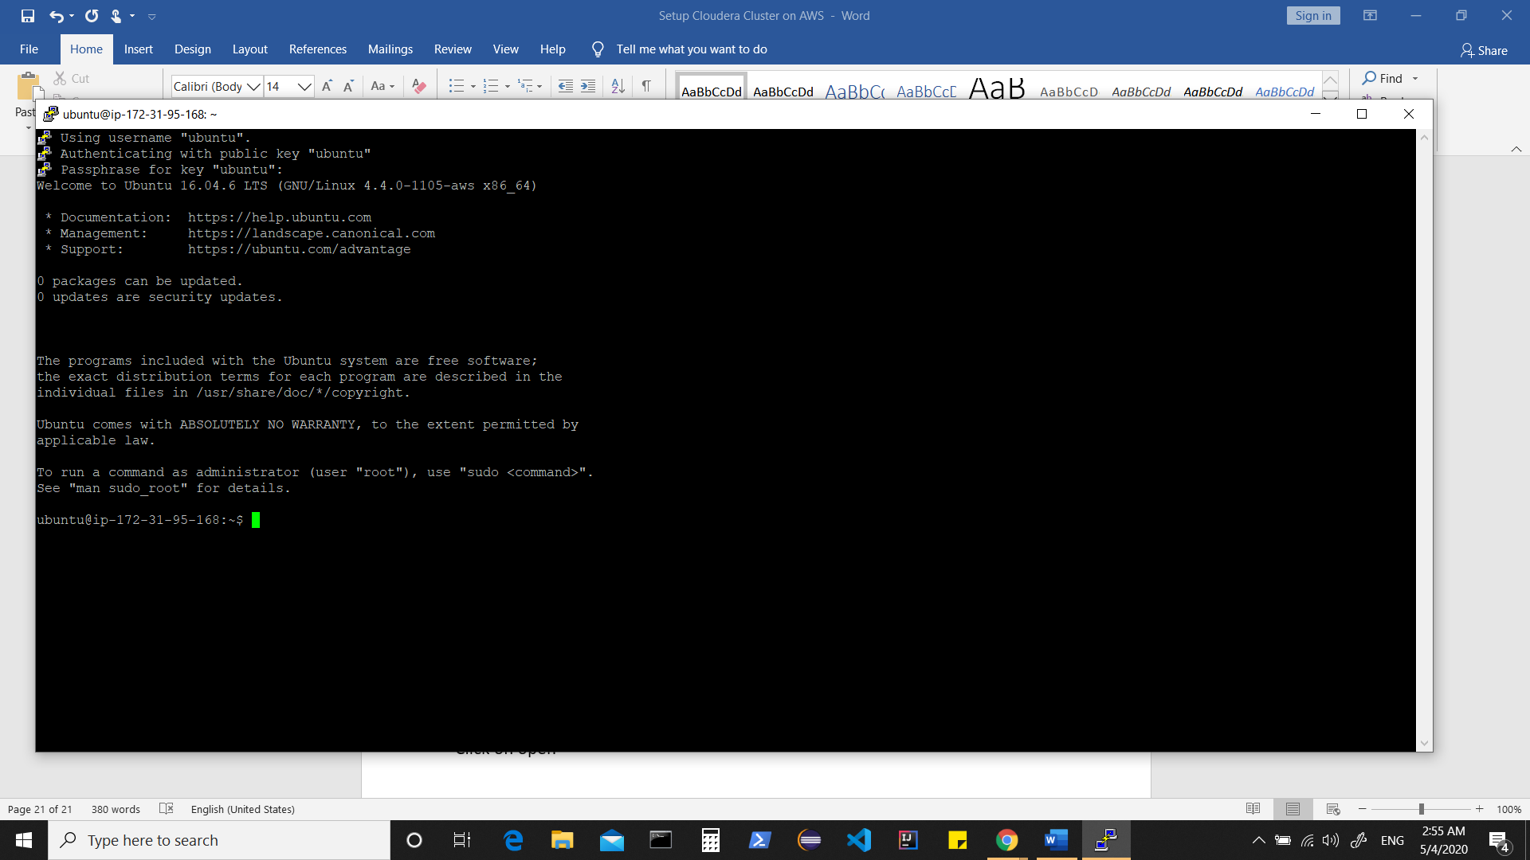

Similarly you can add other machines.

Now update /etc/hosts in all instances

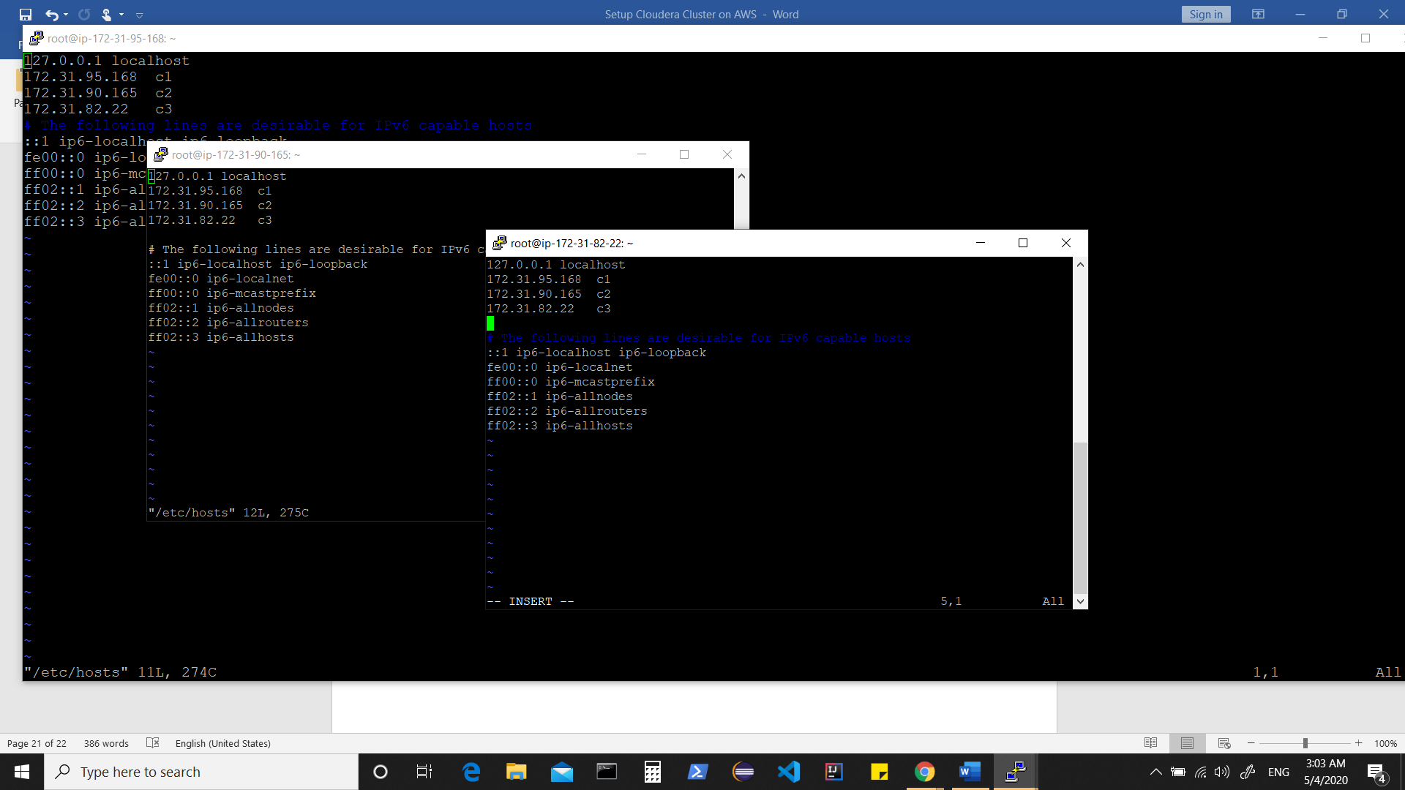

Now we download the “cloudera installer bin file “

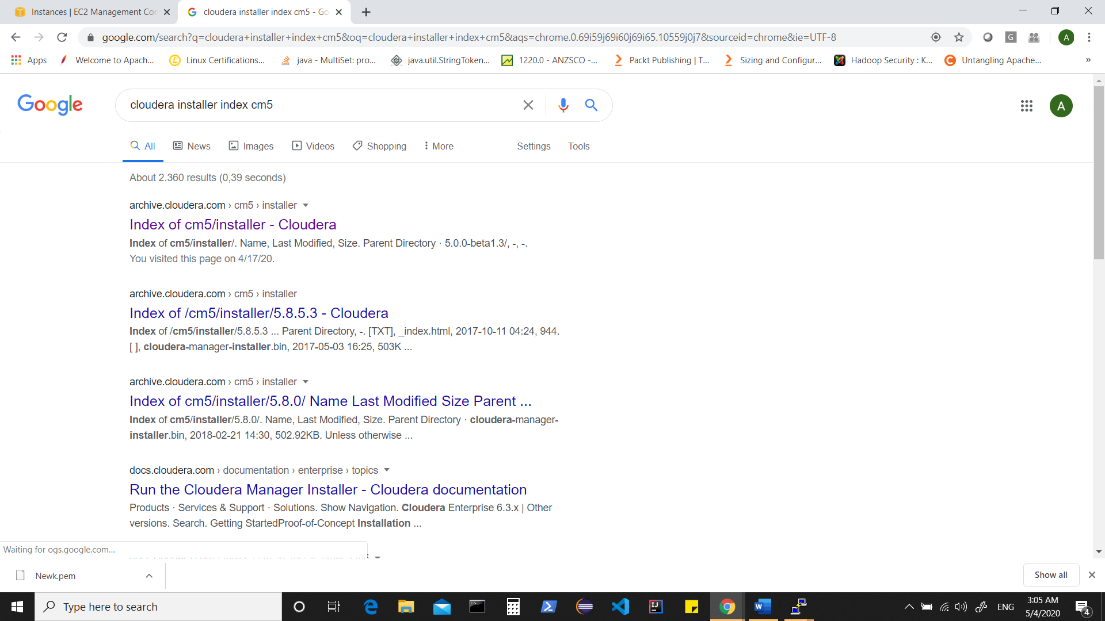

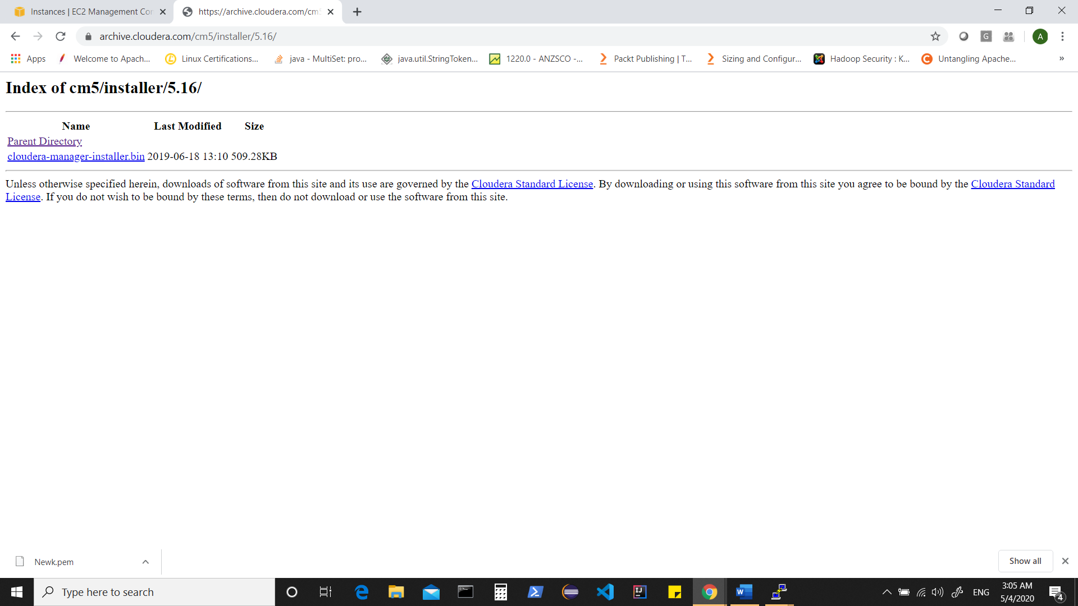

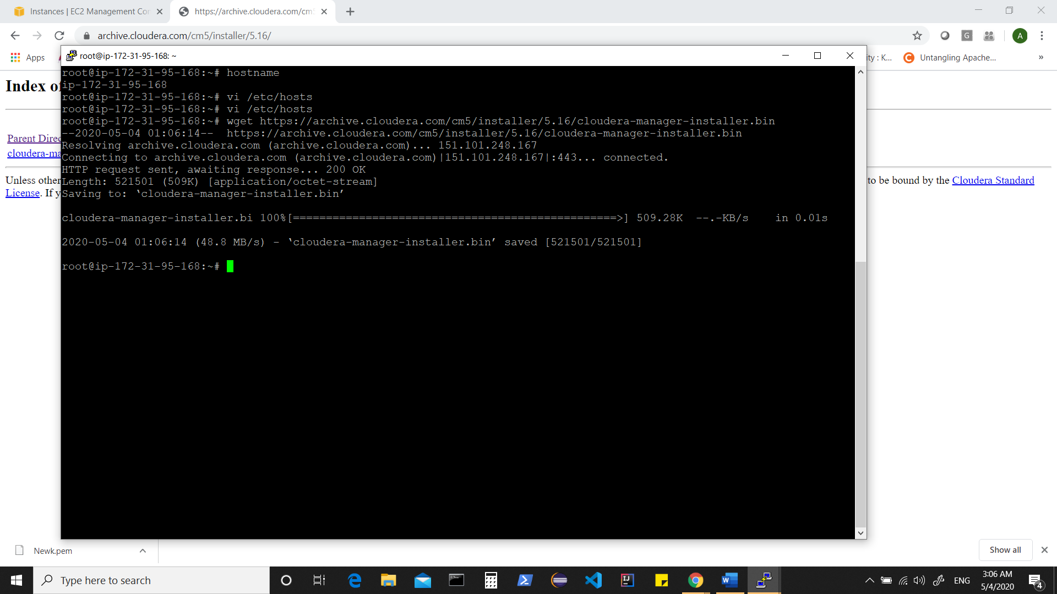

Change the permission of this installer to 777

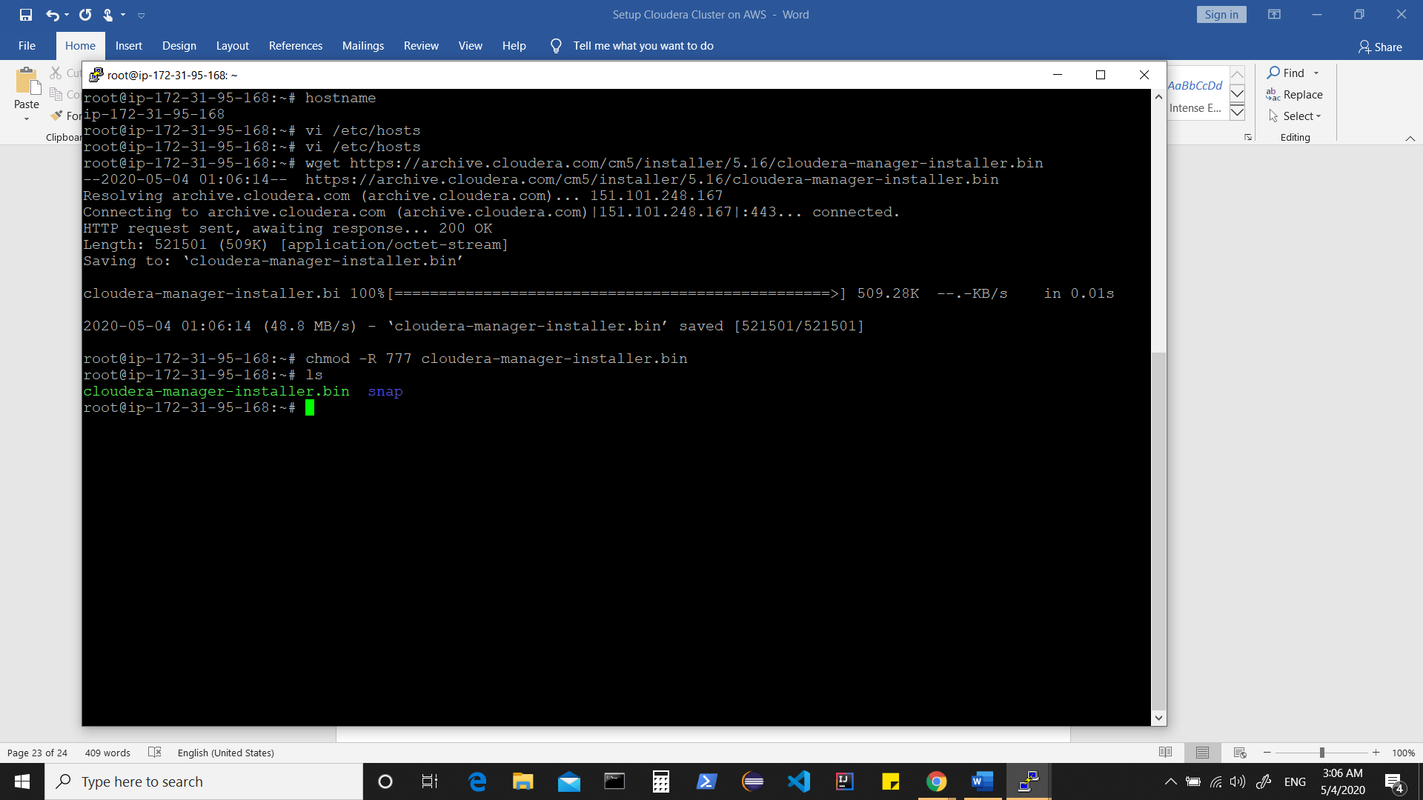

Run the installer which should start “CDH” installation.

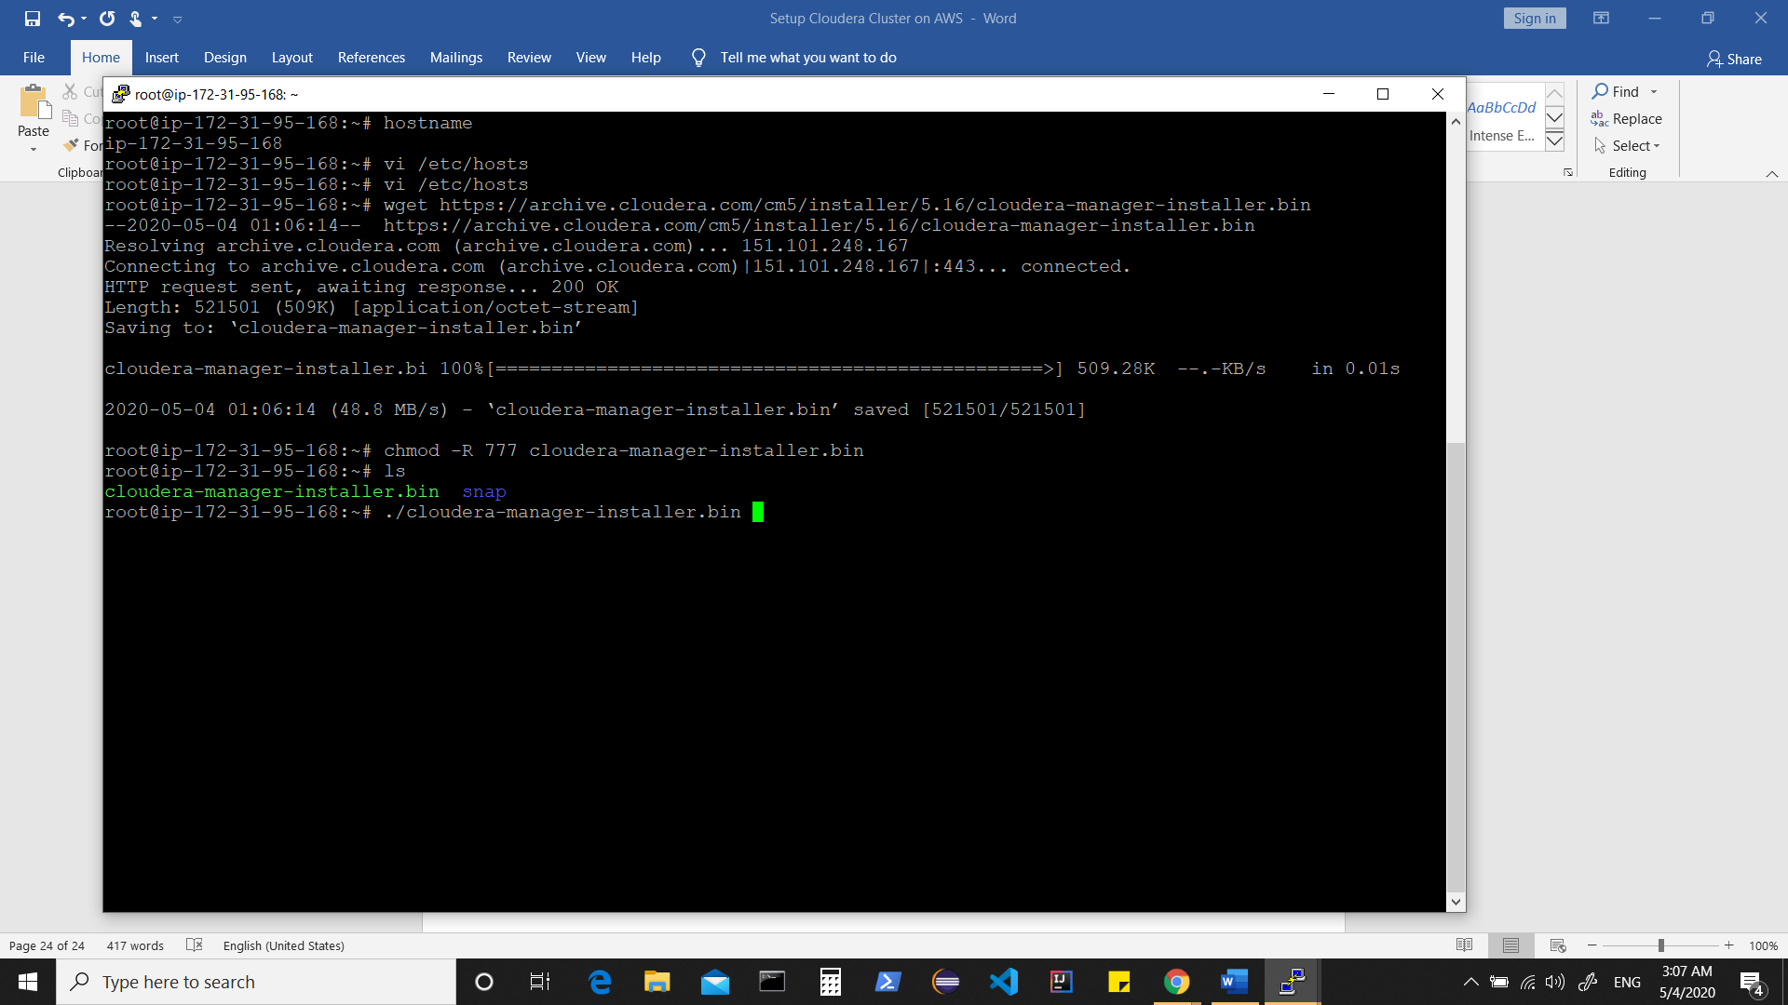

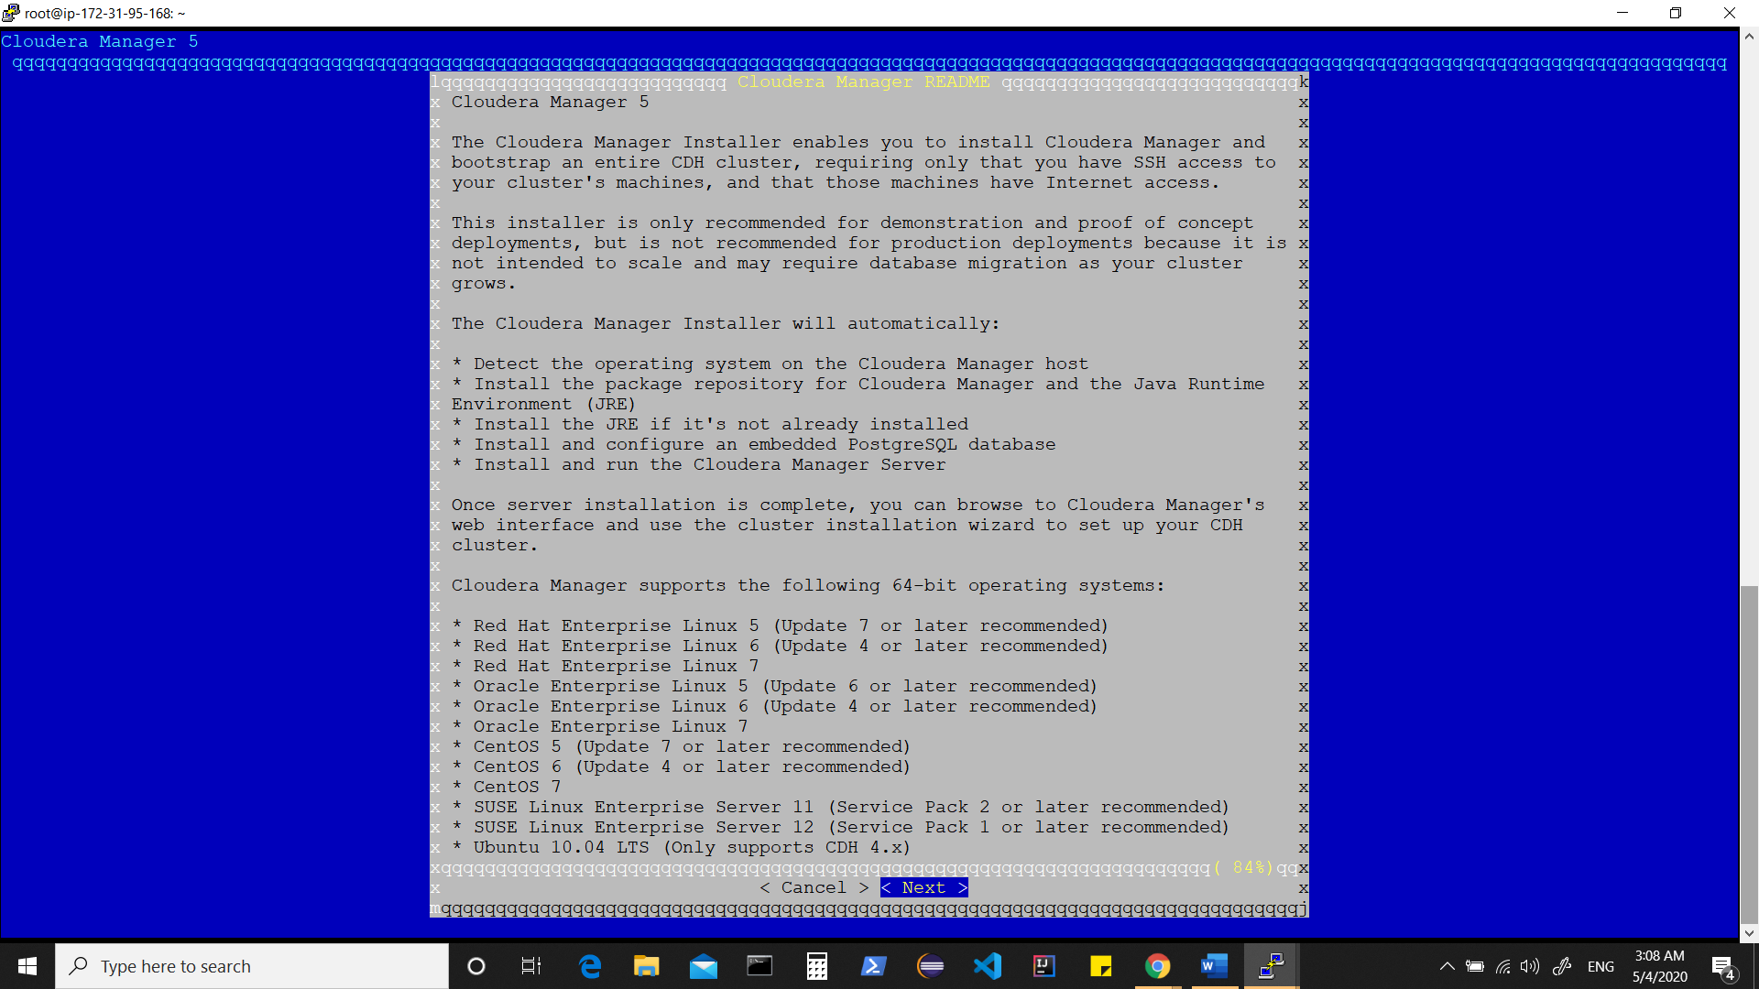

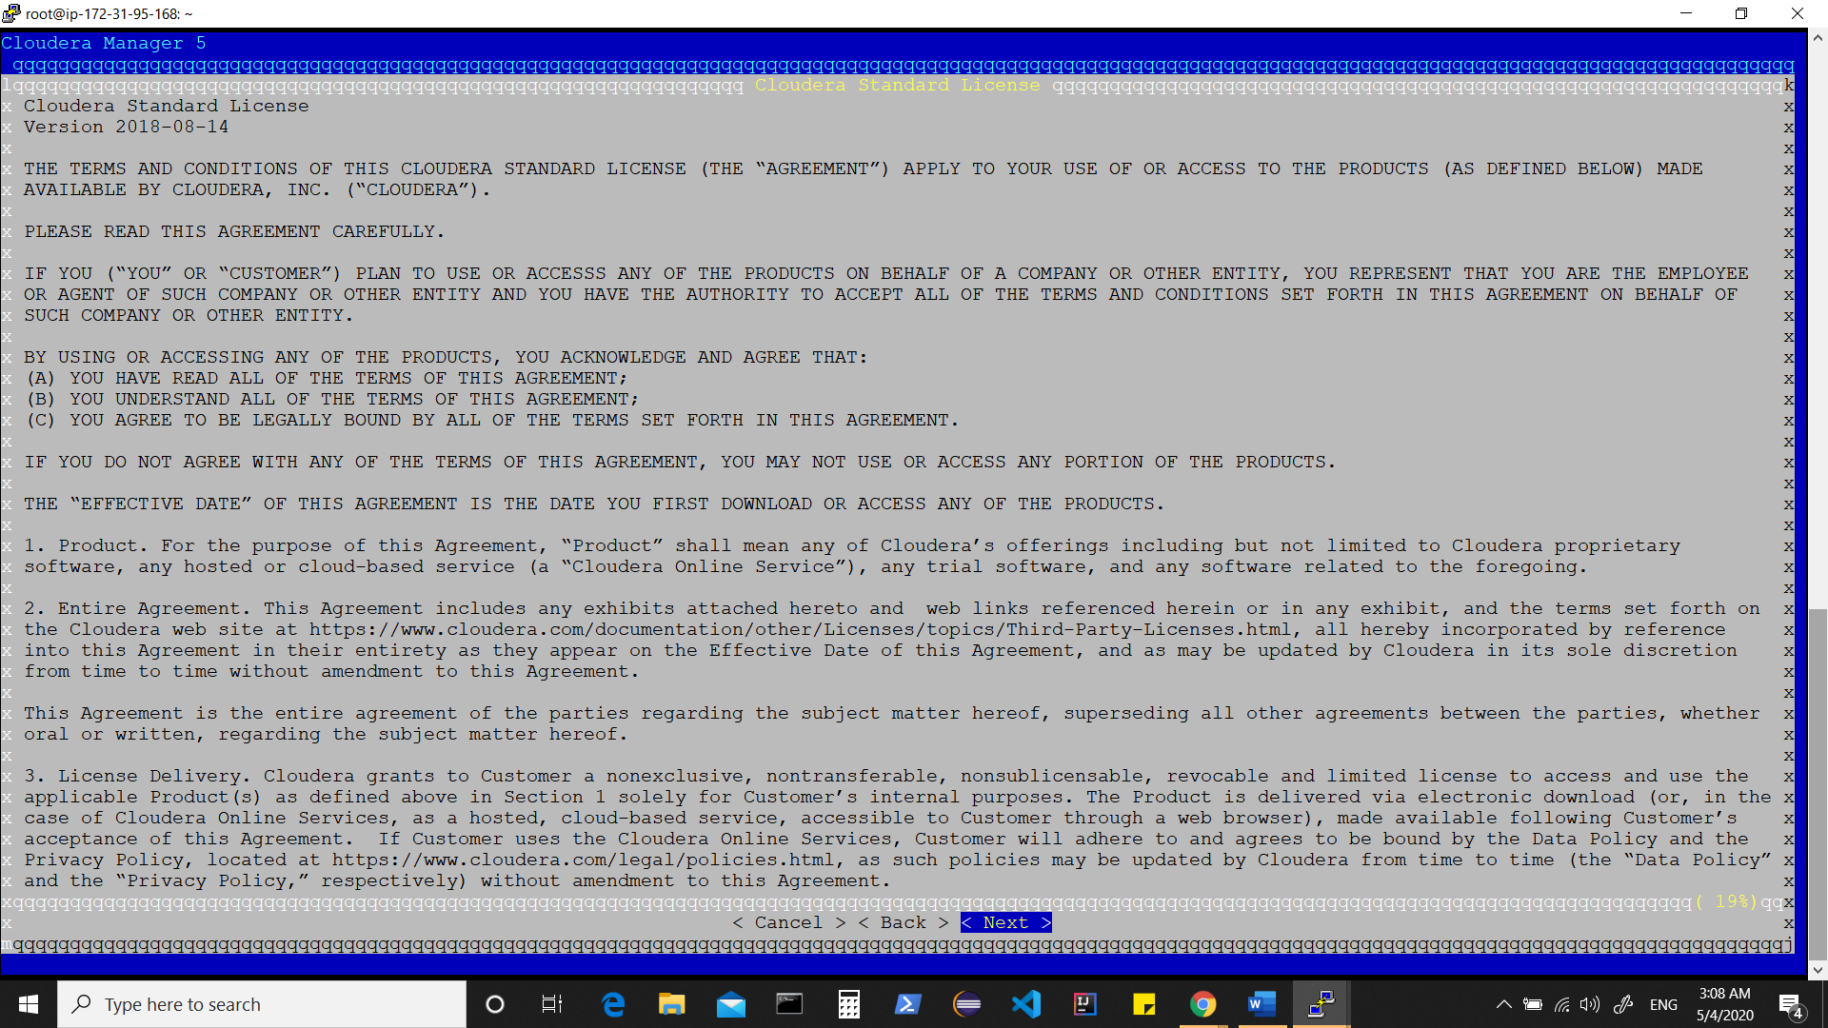

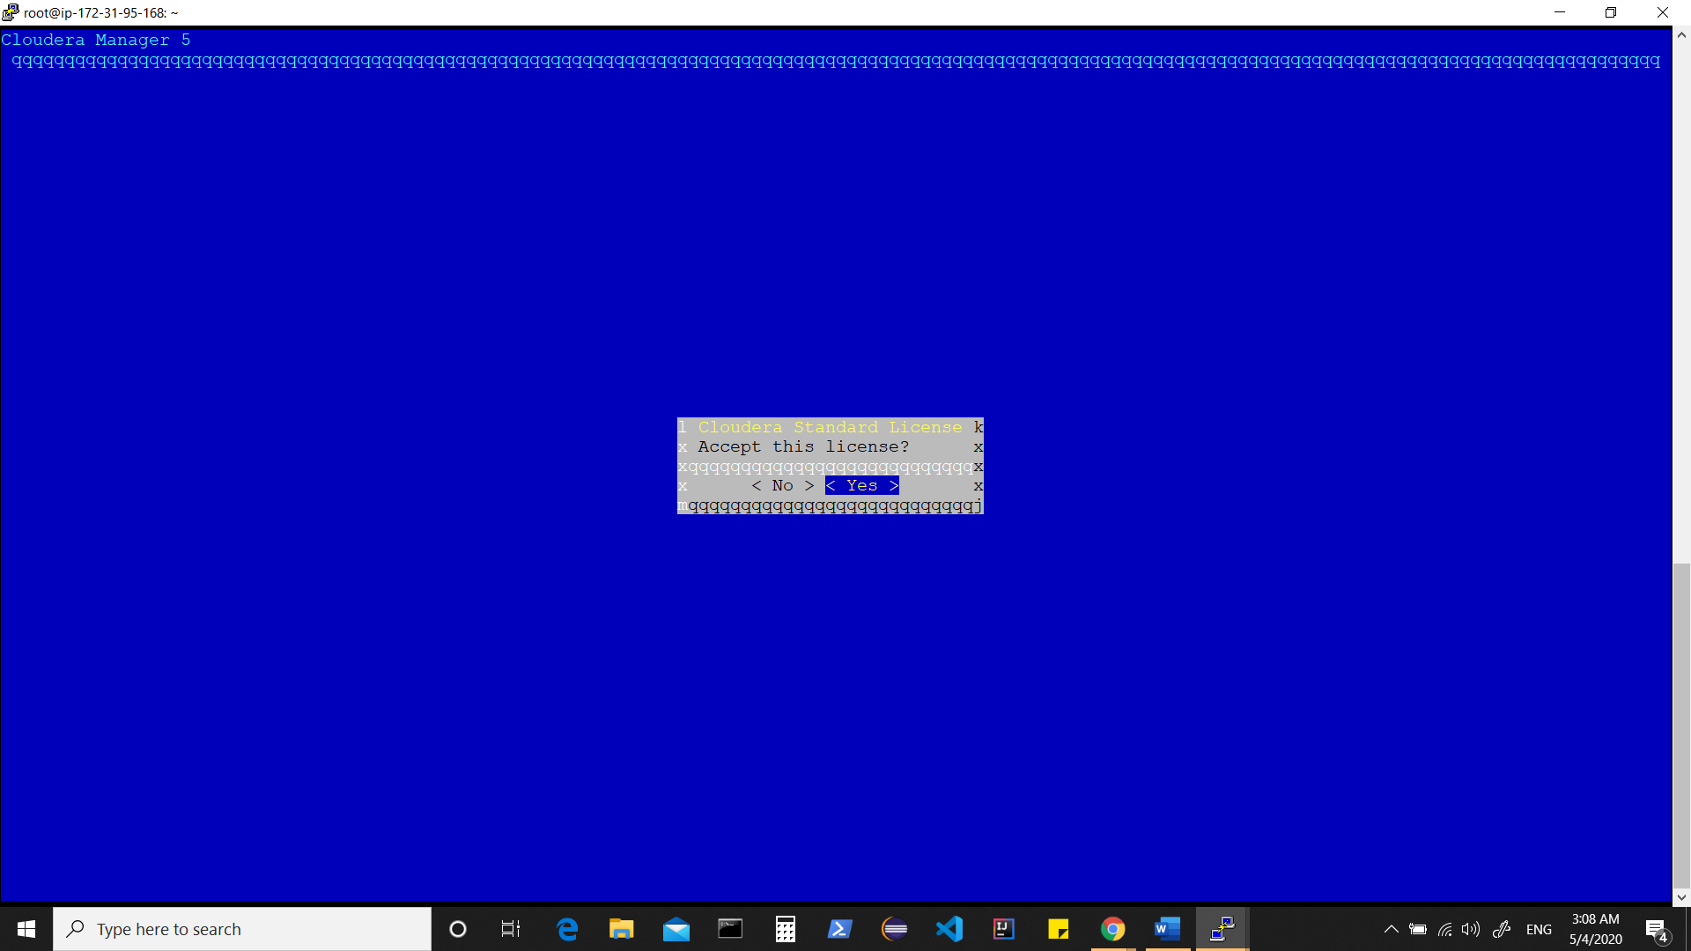

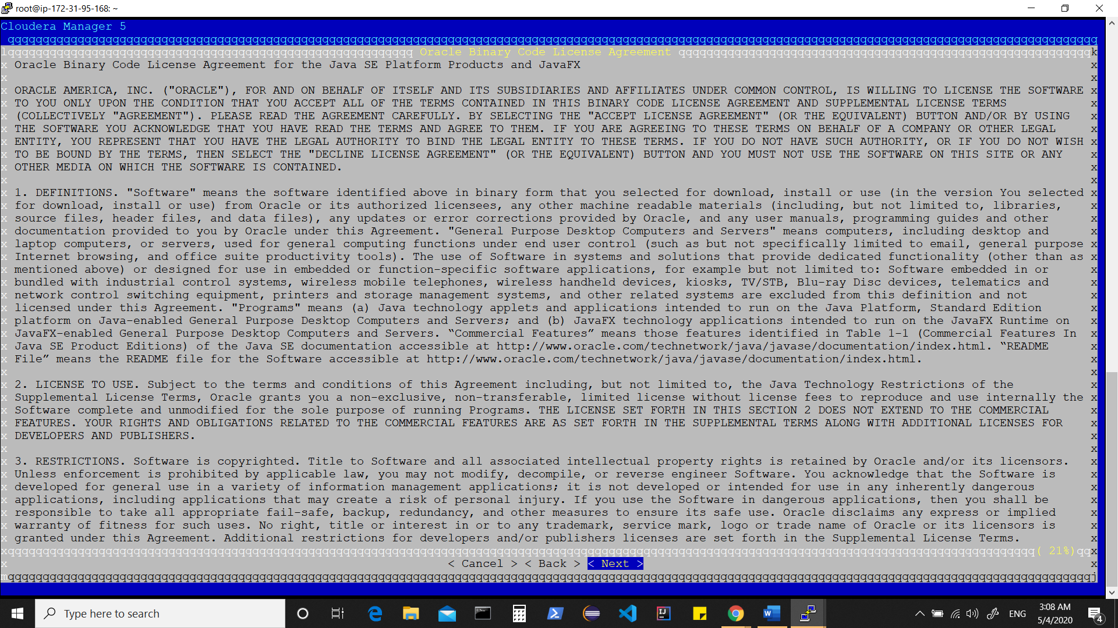

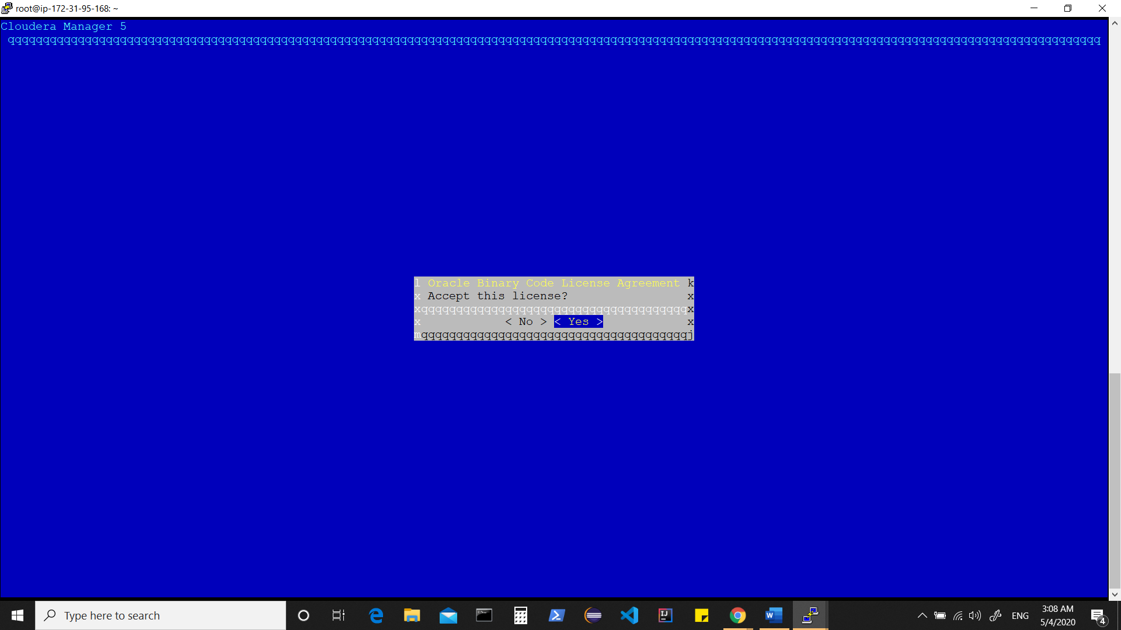

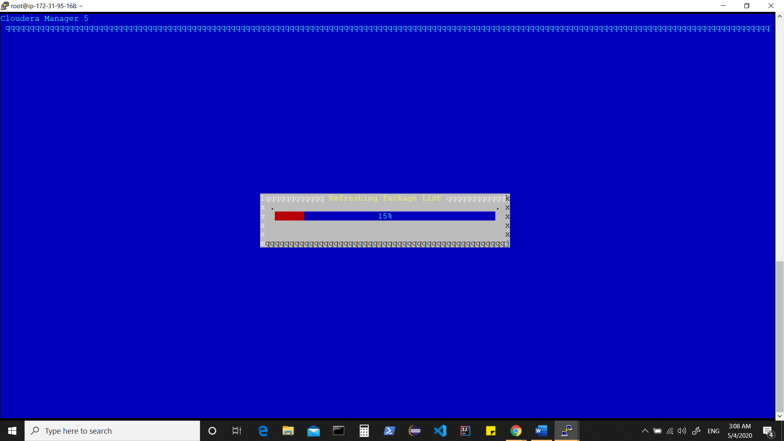

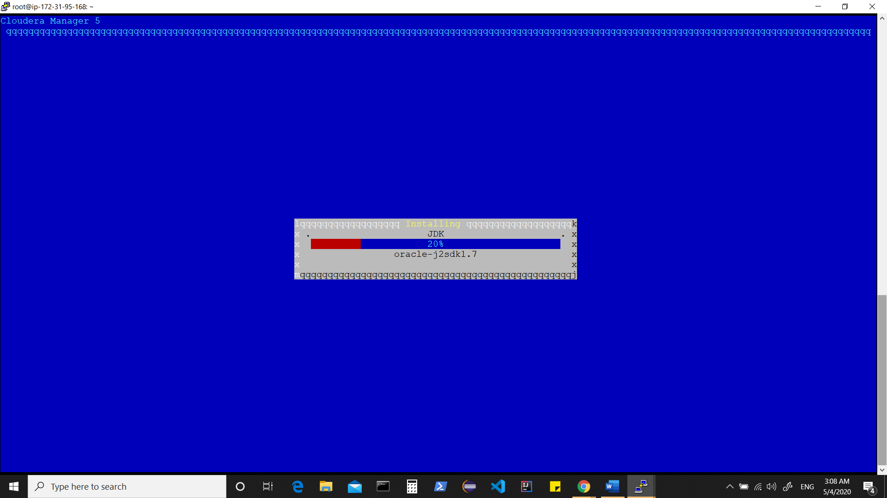

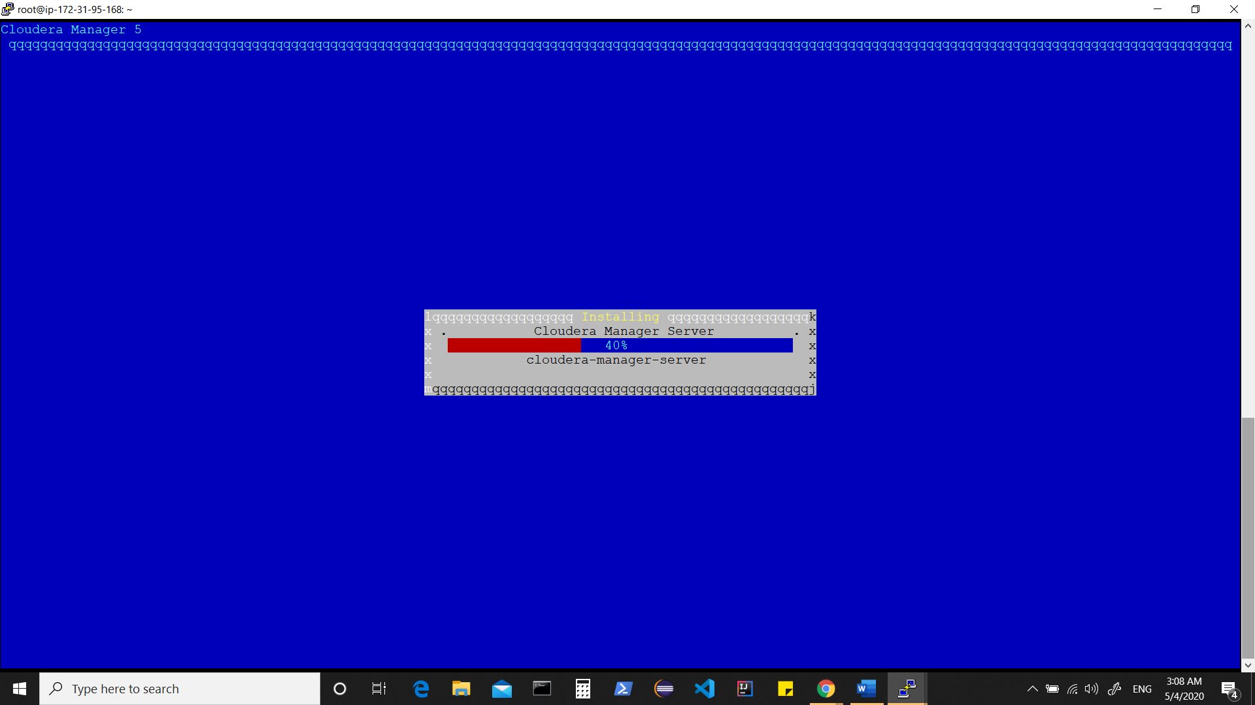

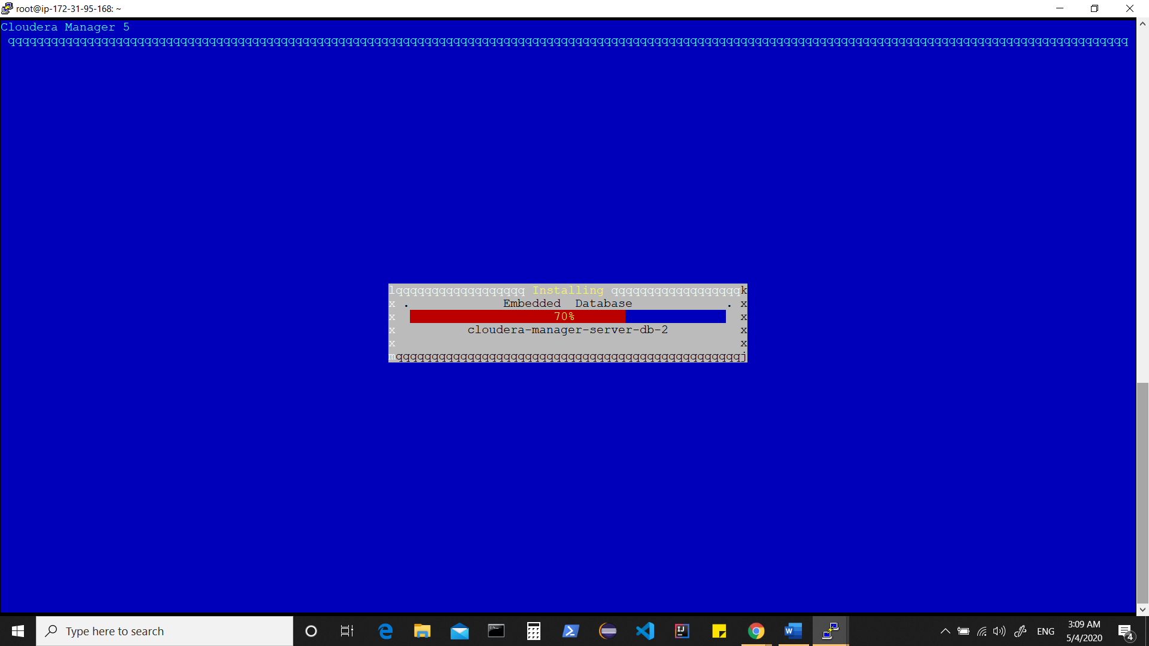

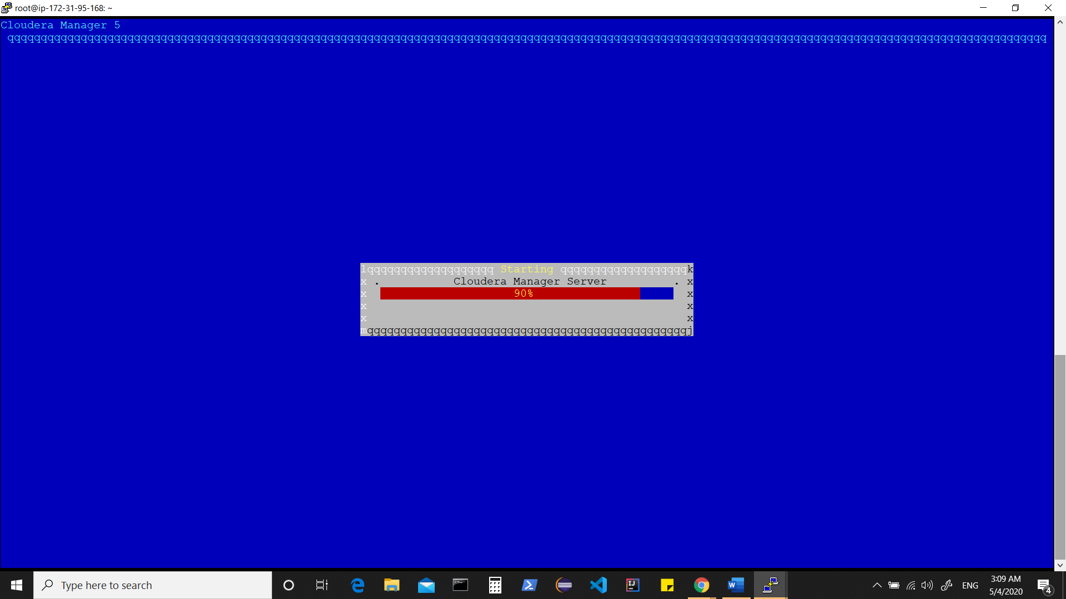

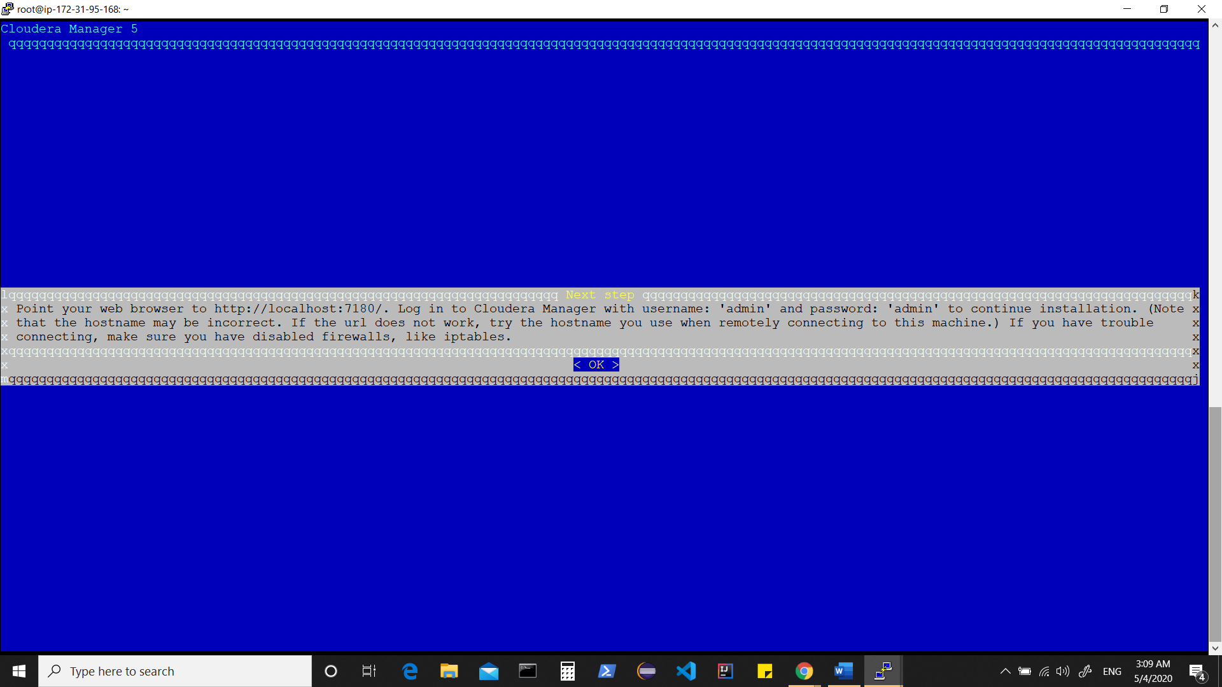

Waiting for few seconds or a minute before accessing the admin console.

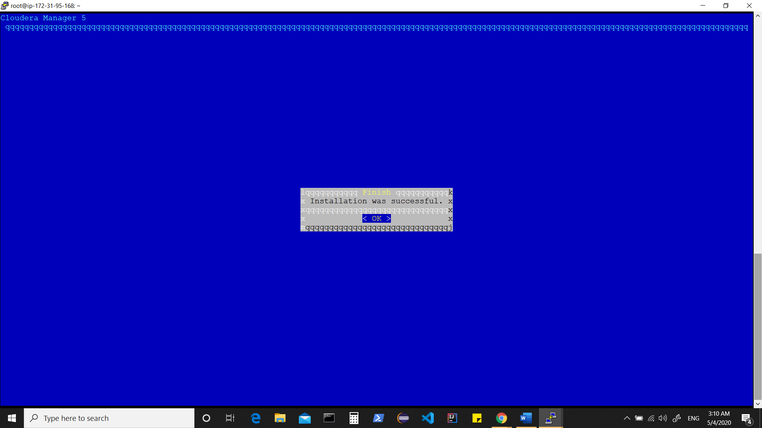

At this time, check the status of “cloudera-scm-server”

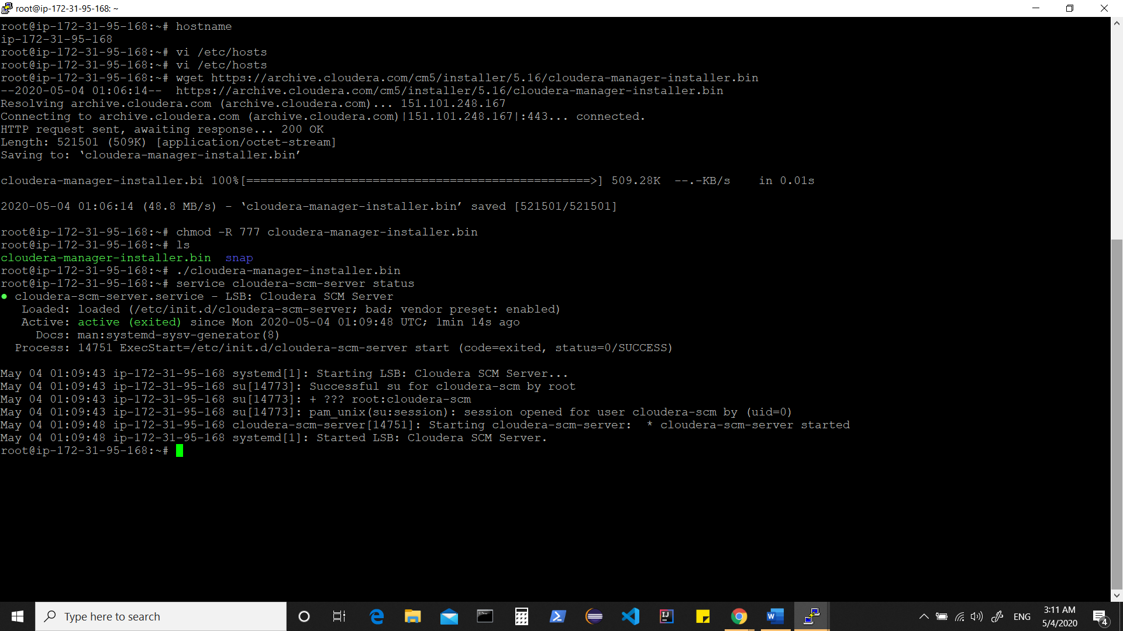

Access your admin console by using public ip of the host where cloudera installer was run

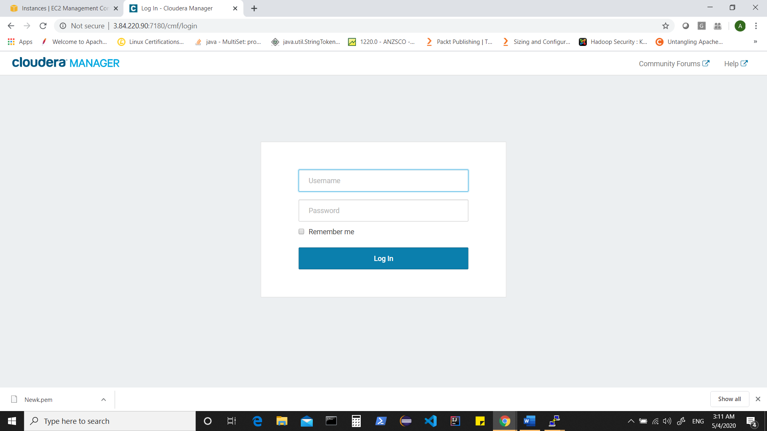

<http://publicipaddressofyourhost:7180>

Login with default id and pswd as ‘admin’

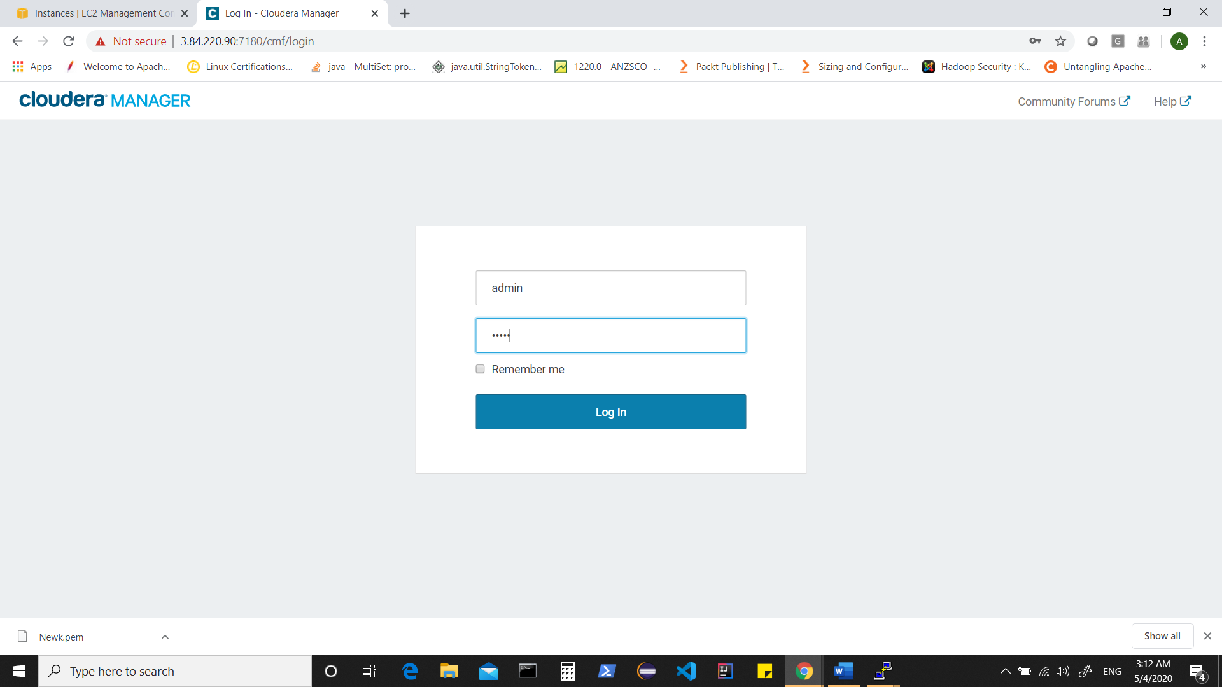

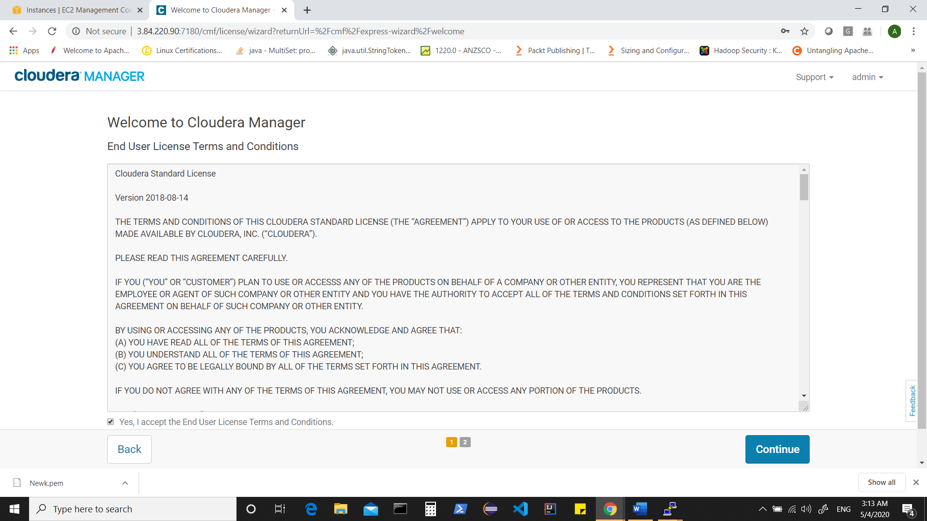

Access License Agreement and click on continue

By default “Cloudera Enterprise Trial” edition would be selected, click on continue

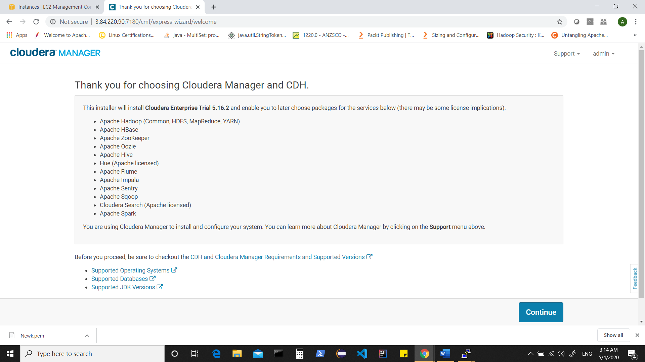

Click on continue

And provide hostnames as updated in /etc/hosts

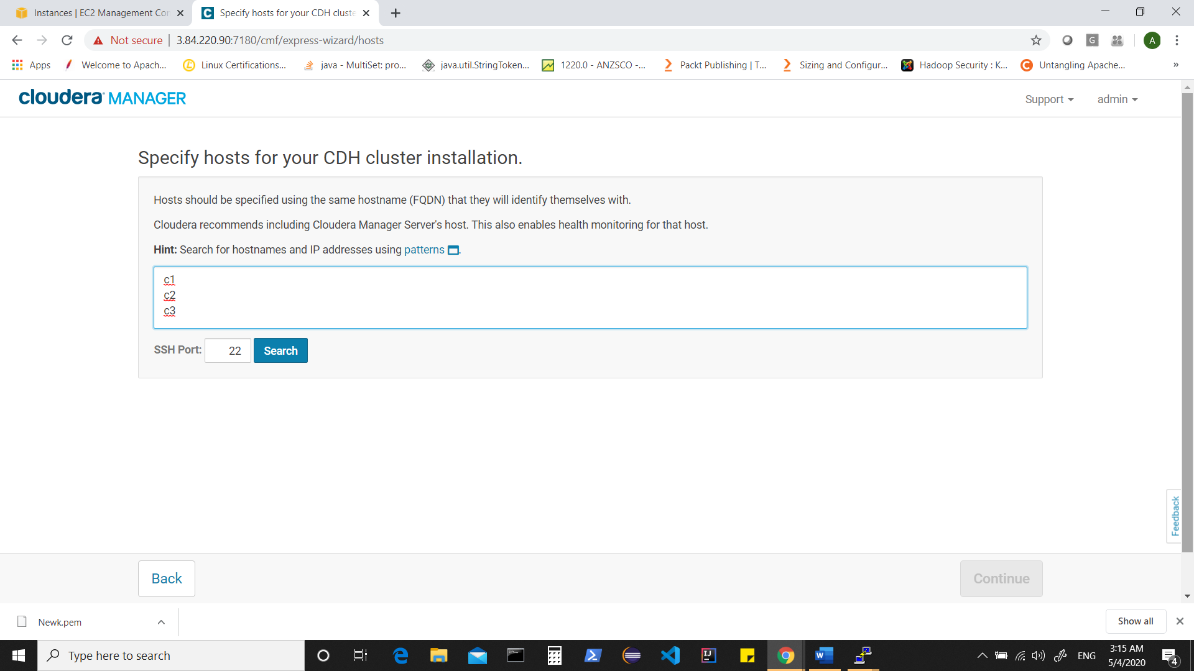

Click on search

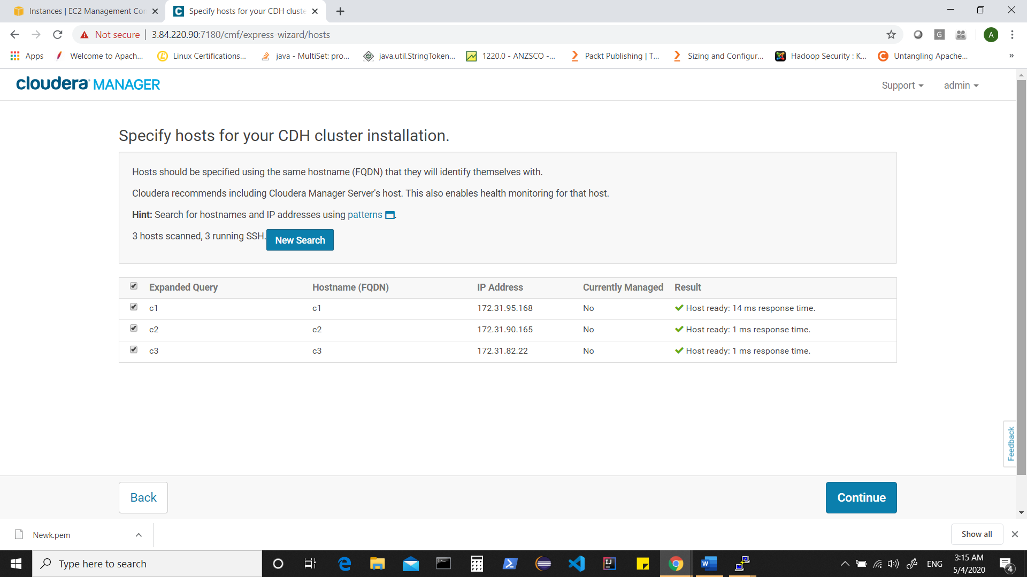

Click on continue

Here let the selection be parcels as recommended and scroll down to see options available for other parcels, although we can later add any parcels, so as of now click on continue.

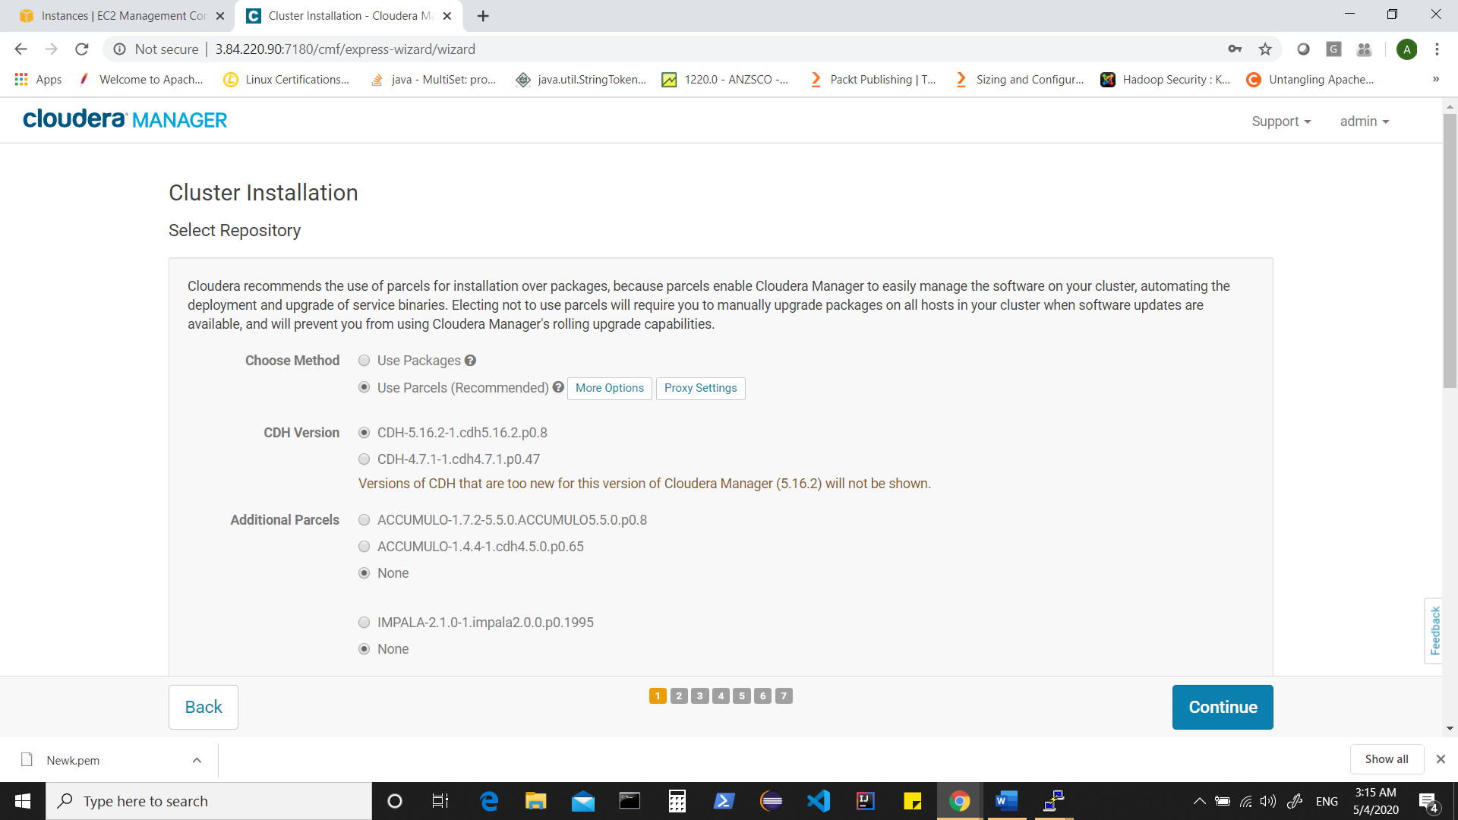

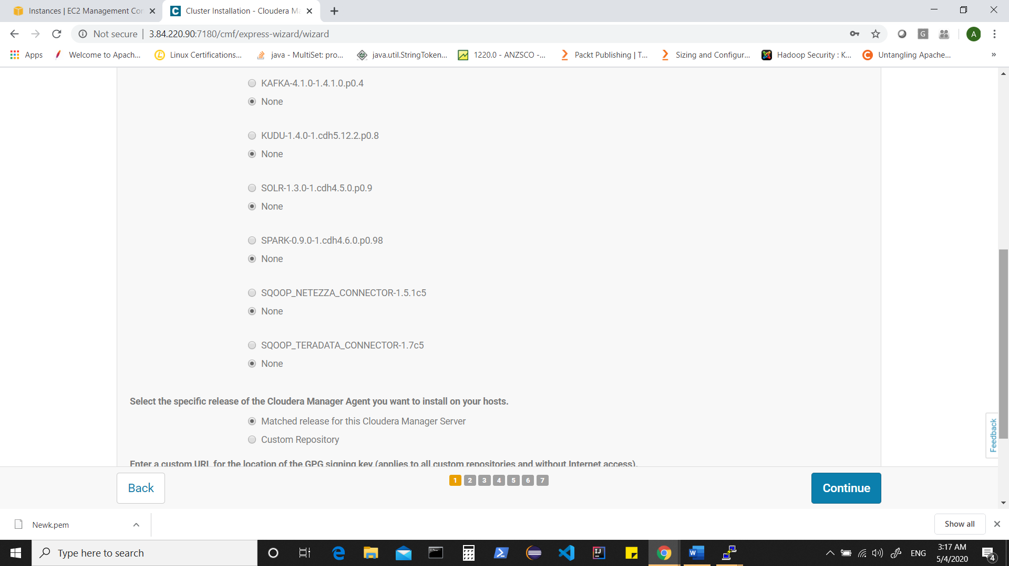

Accept JDK license

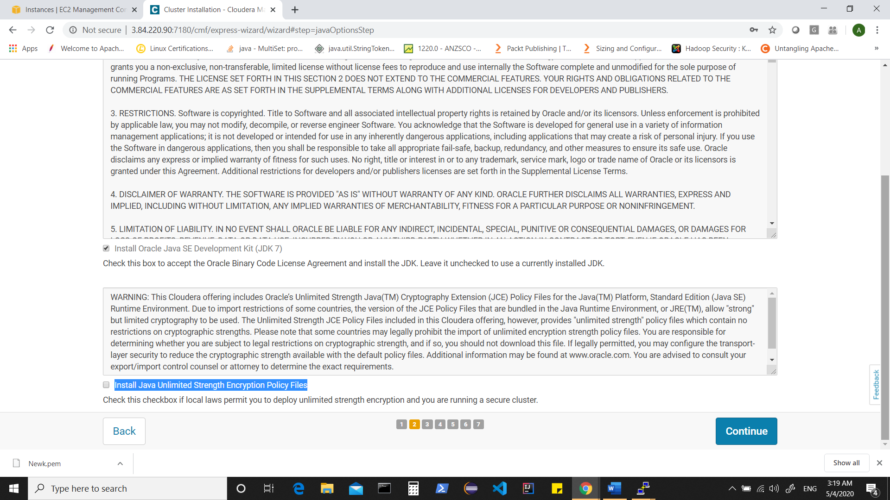

You can optionally select Install Java Unlimited Strength Encryption Policy Files,

however, that can be chosen later when needed.

Click on continue

On single user mode, leave it as default and click on continue

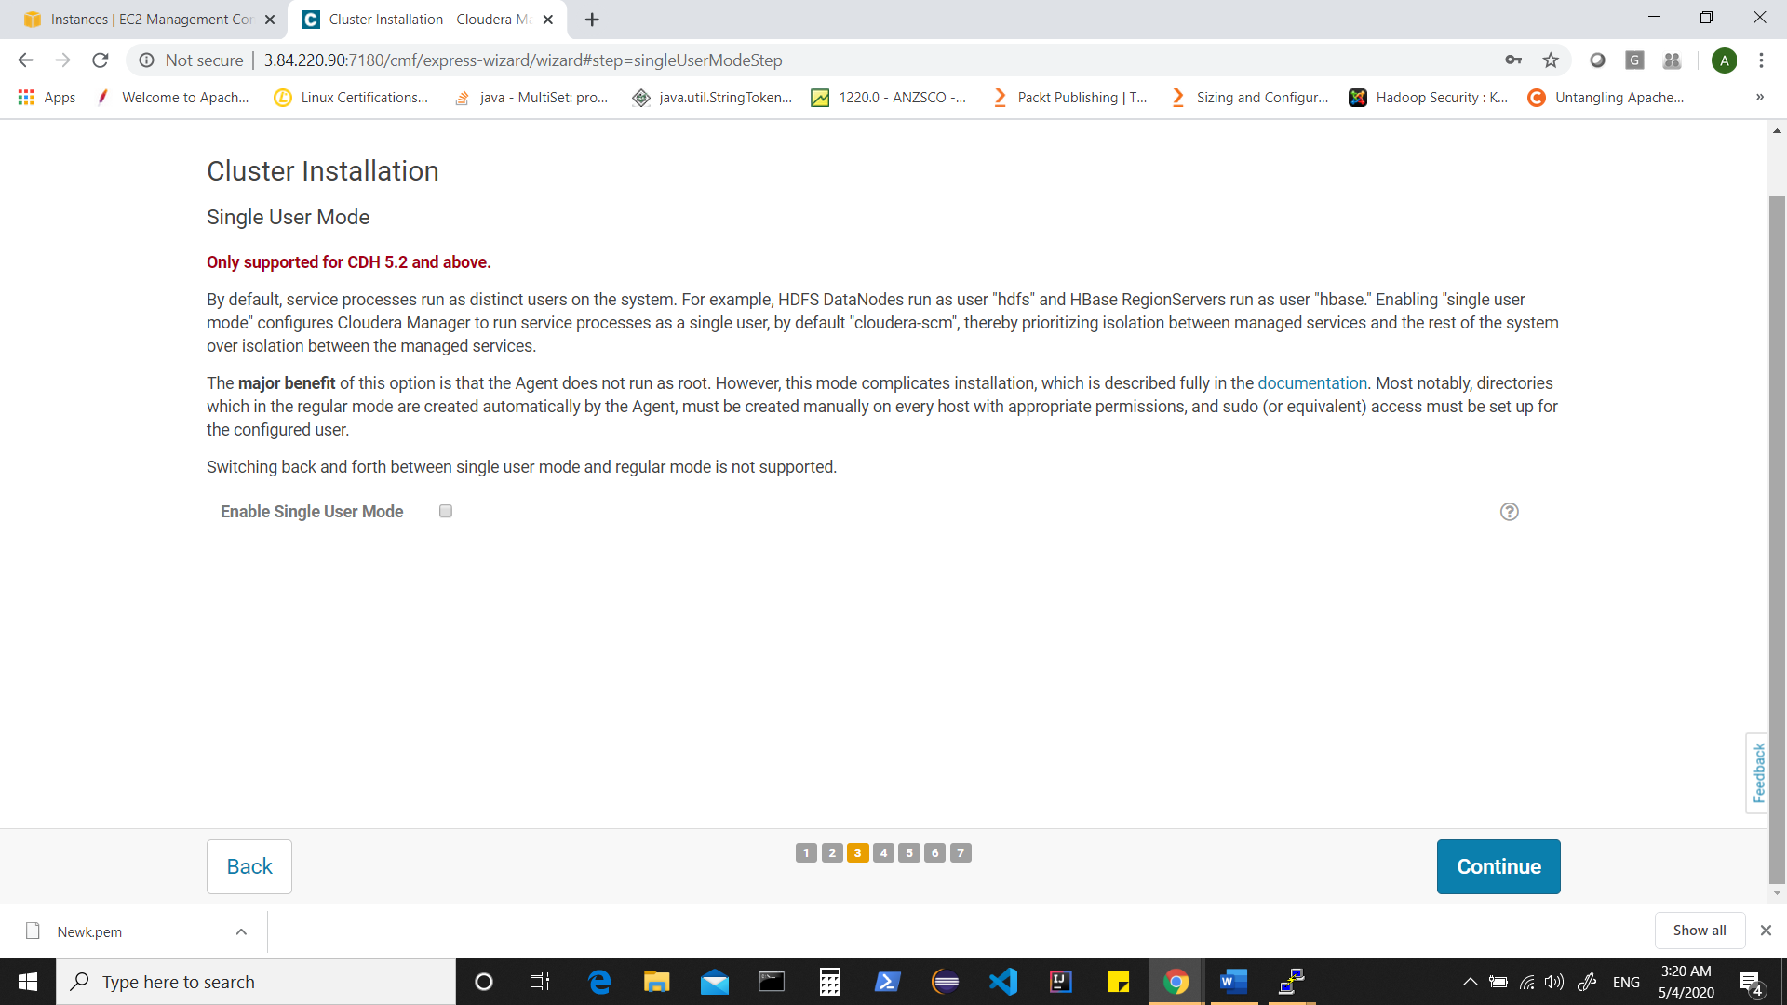

Here we will now provide our user and the “*.pem” file which we have downloaded when we created key pair.

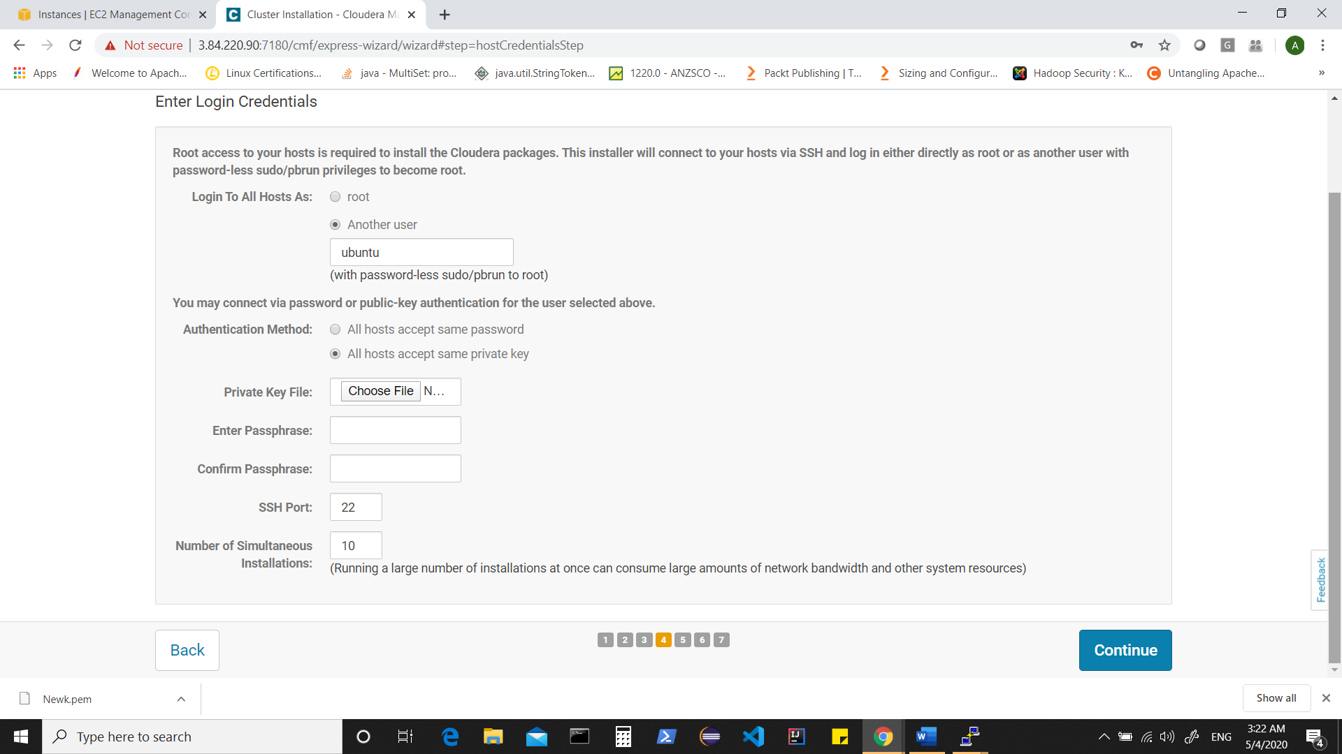

Default user for ubuntu machines is “ubuntu” and provide your “*.pem” file.

Note** Irrespective of whatever user & passphrase your created when converting pem to ppk, use default user for ec2 instance and pem as private key to connect.

Click on continue

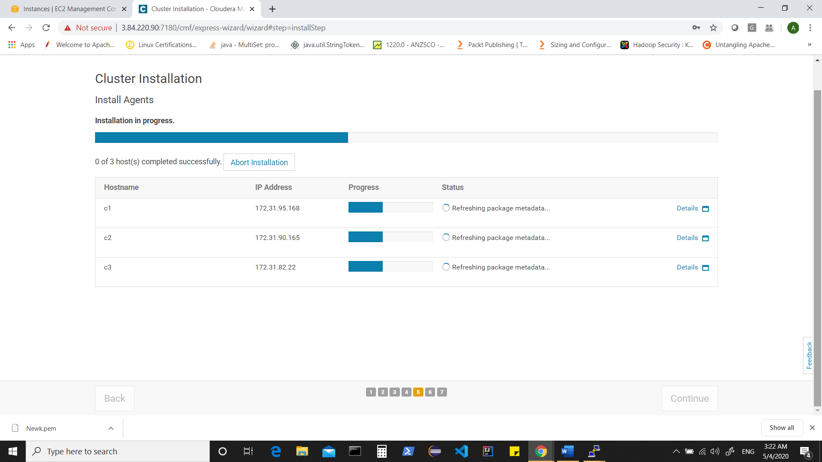

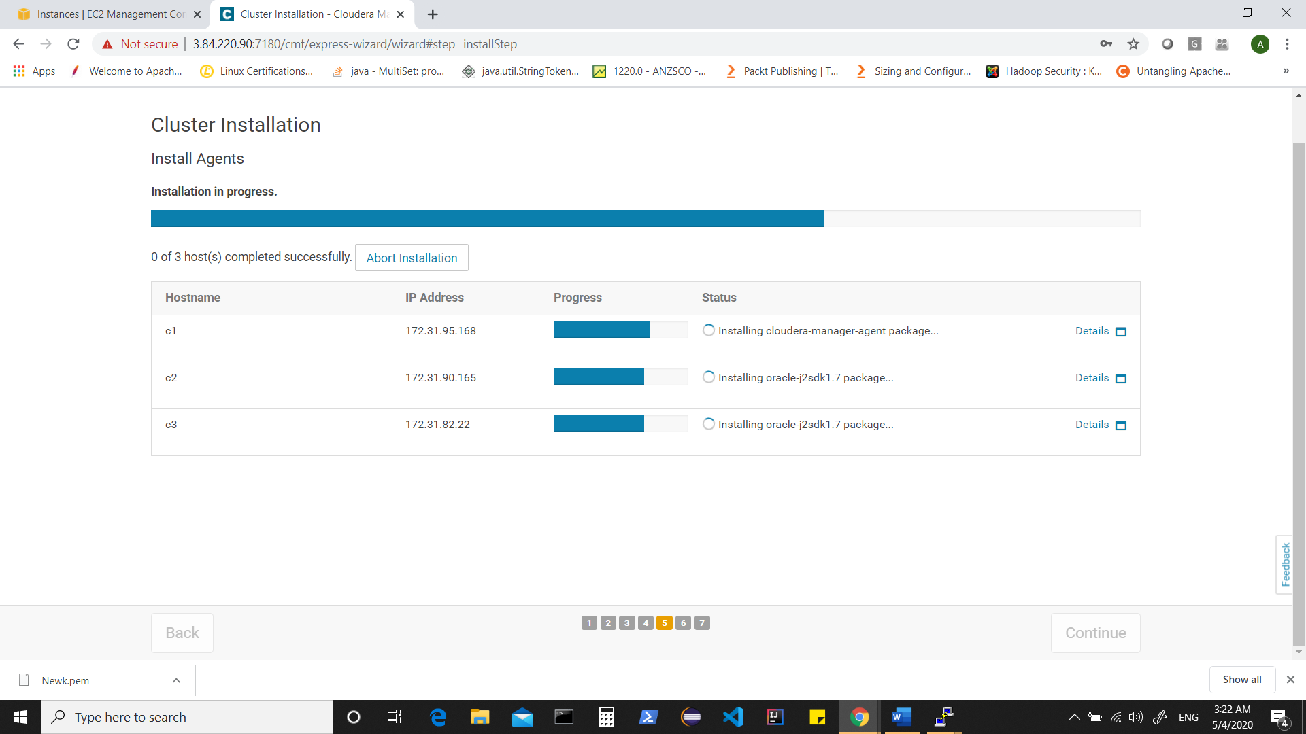

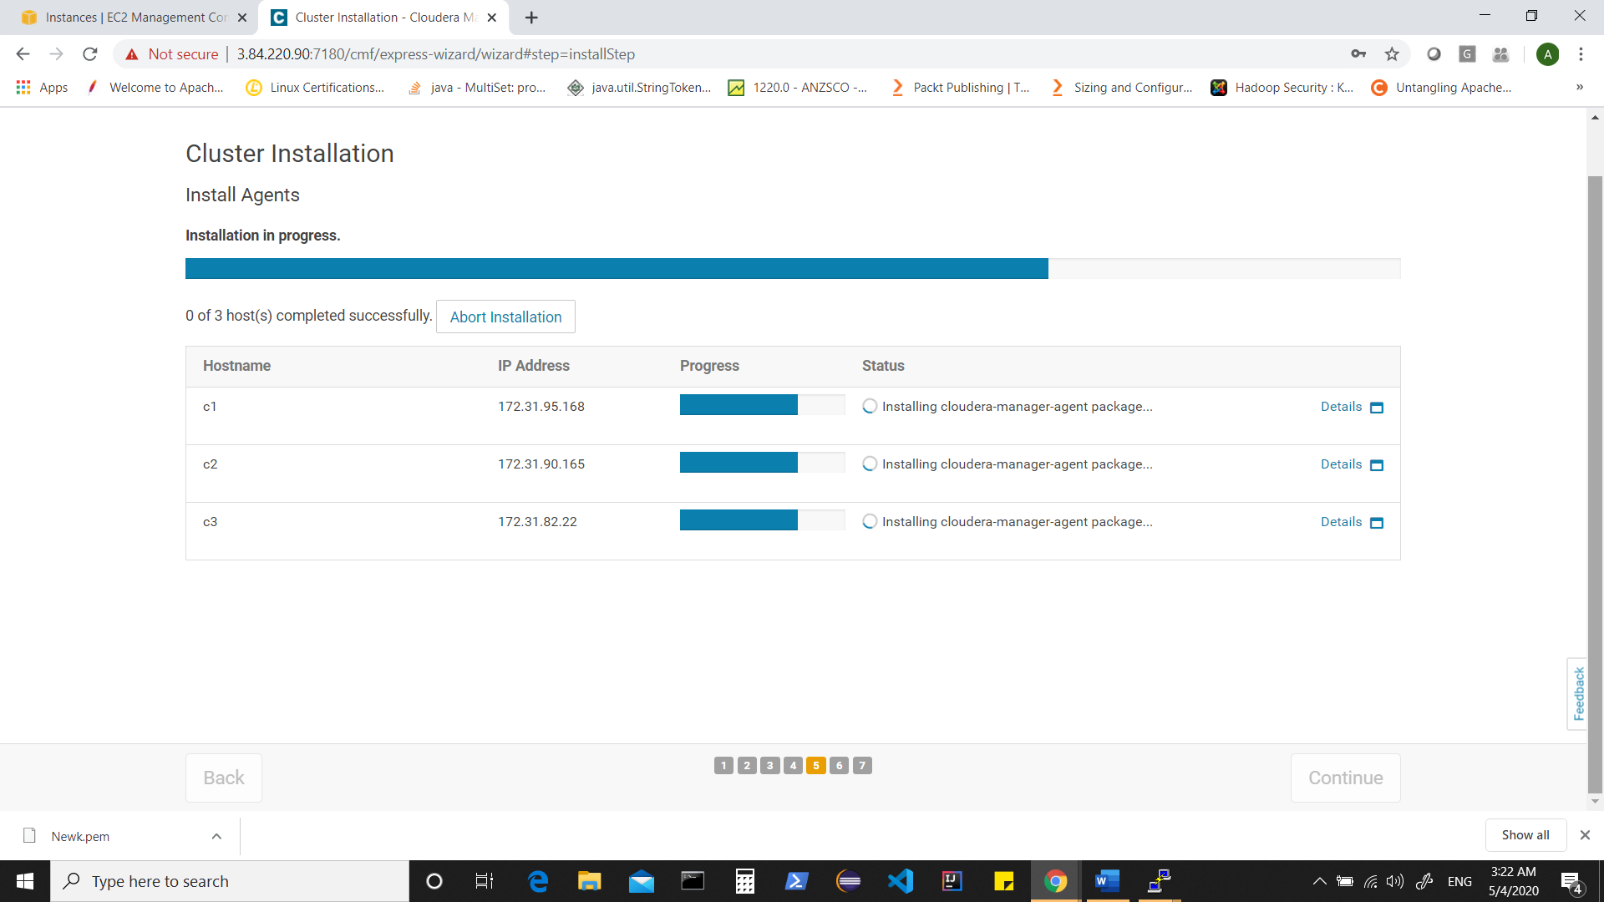

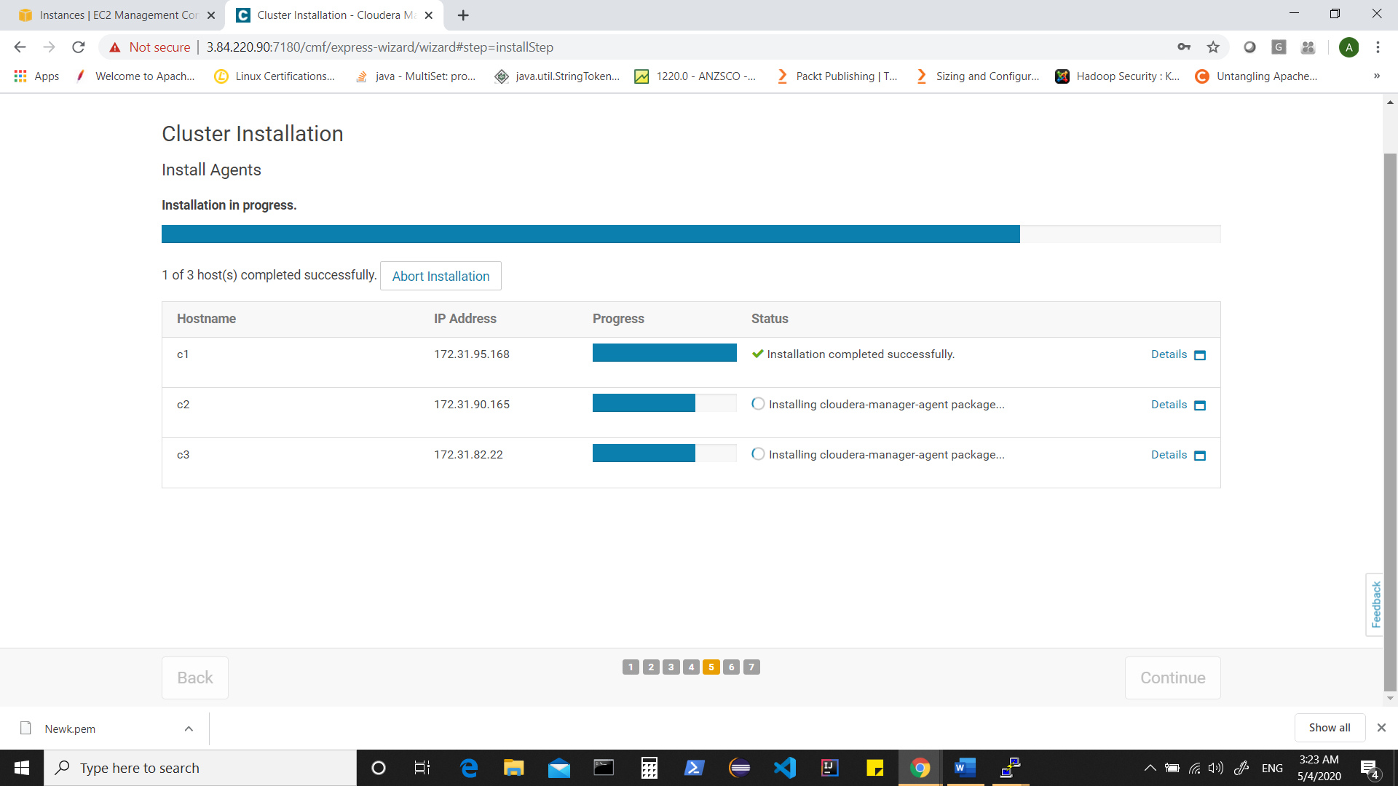

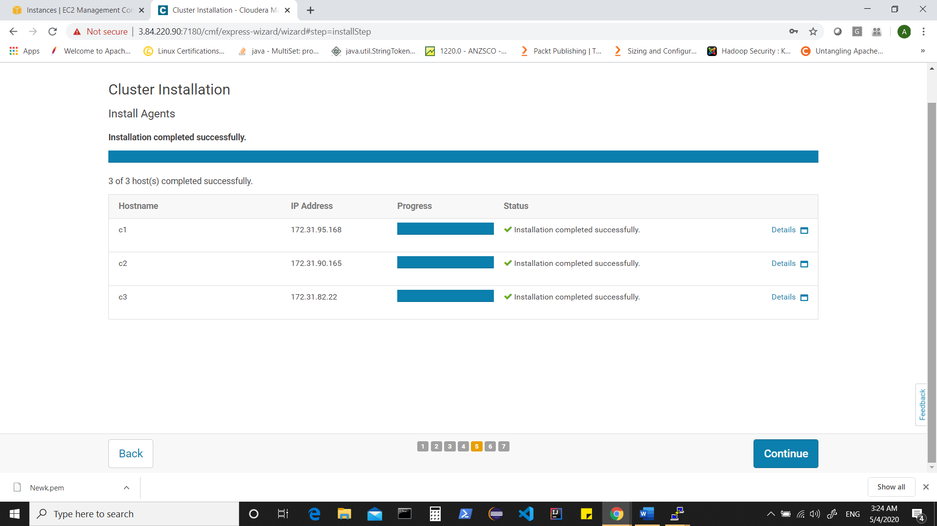

Click on continue

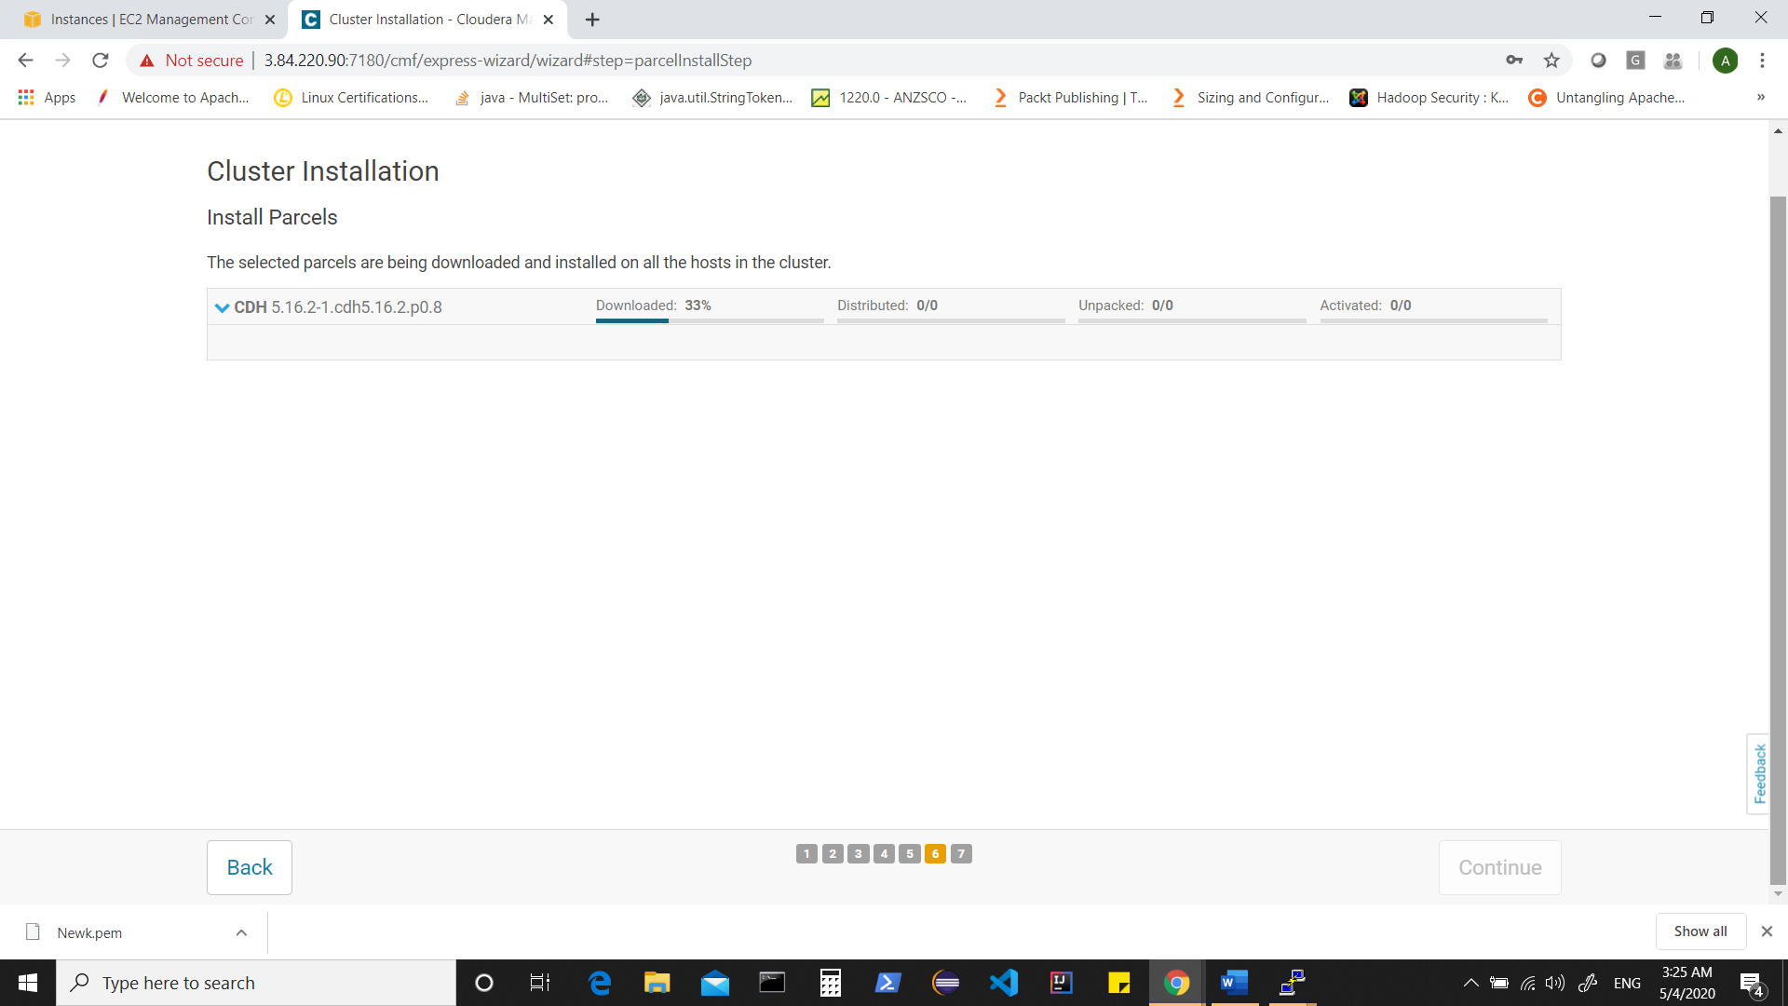

Wait for parcels to be downloaded + distributed + unpacked and activated

If you have any connectivity issues, wait and see if those resolved.

In previous step, cloudera-scm-agent would be installed in all your instances and that would be already sending heartbeats to cloudera-scm-server running on your first instance (i.e. c1)

You can optionally connect to instance and check for status of “cloudera-scm-agent” on each instance.

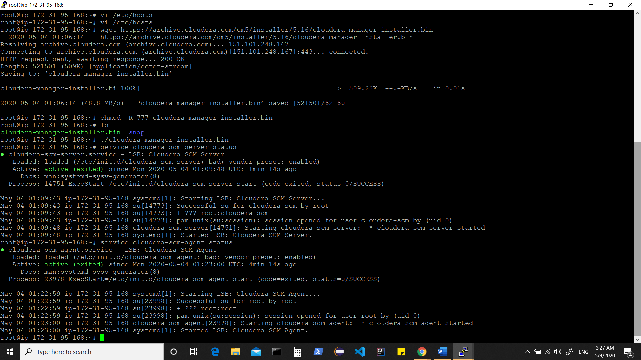

Back to admin console

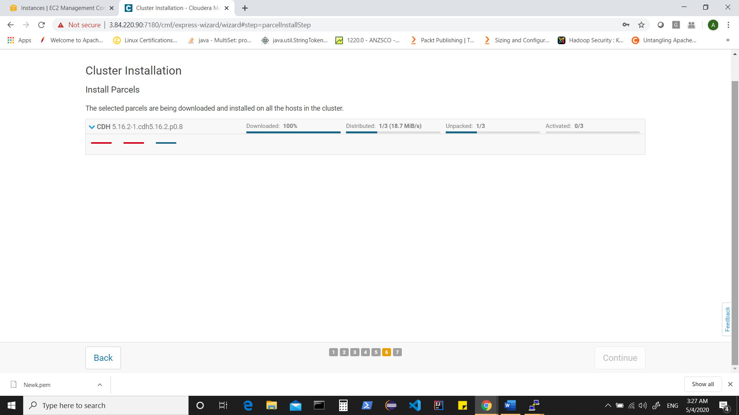

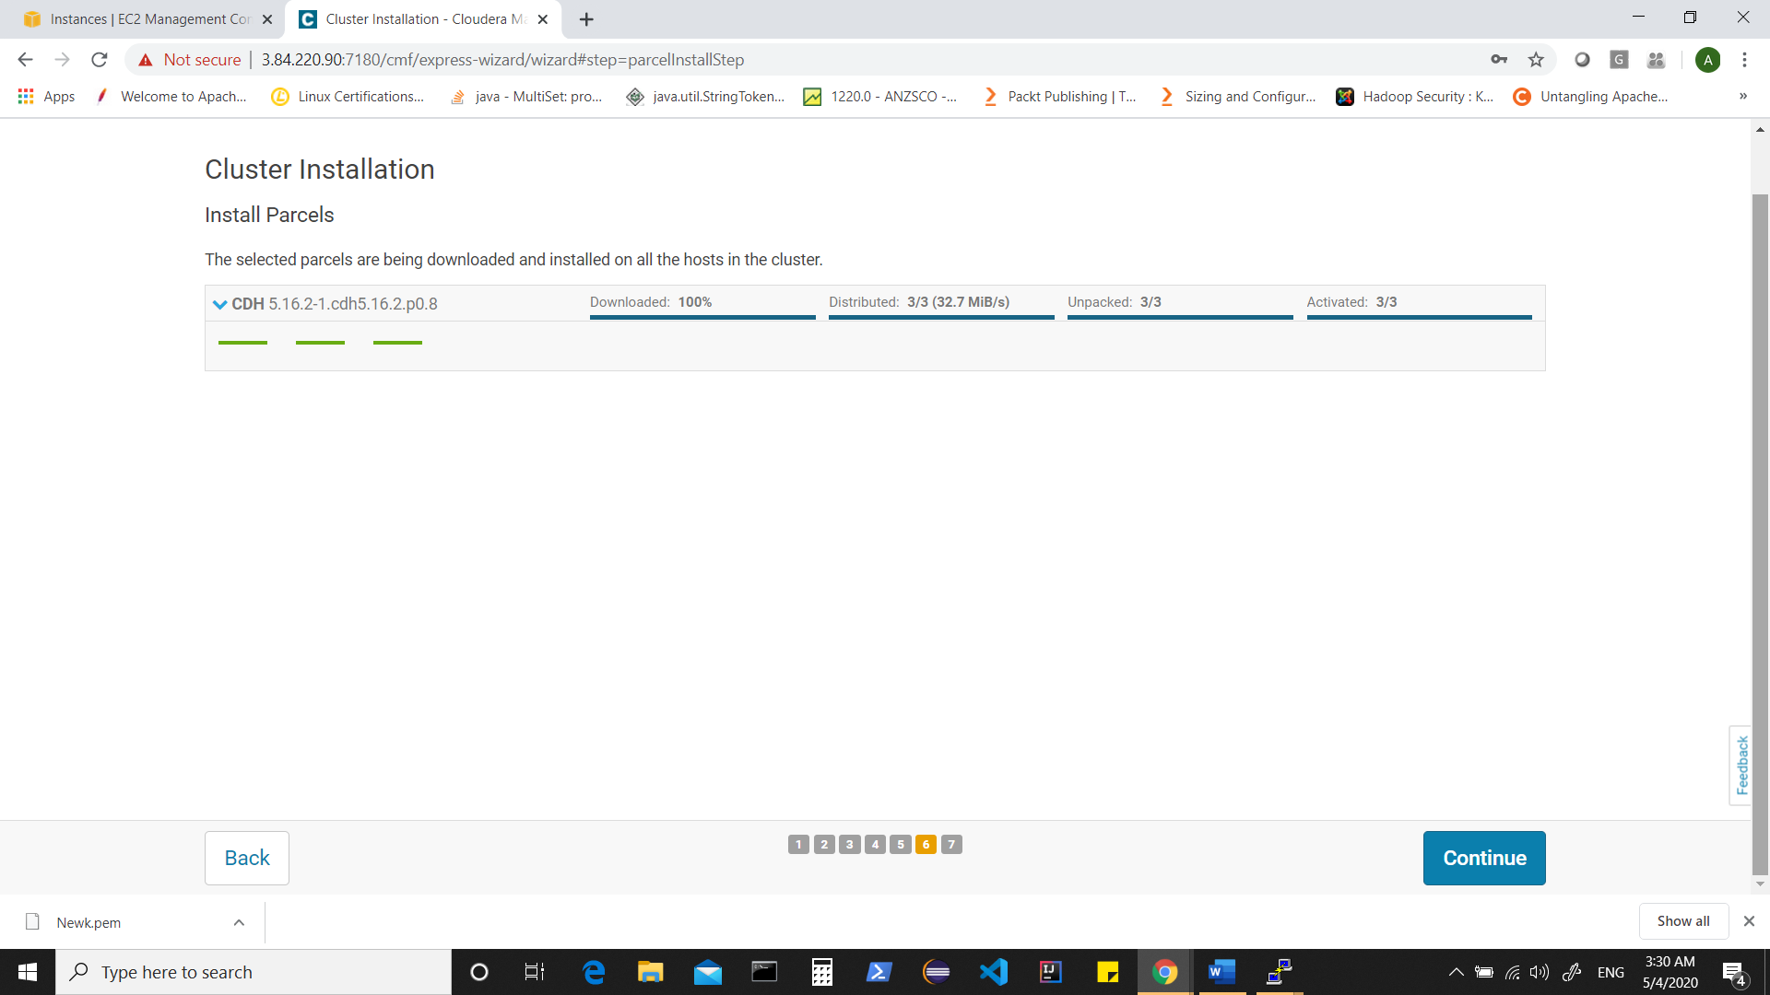

Click on continue

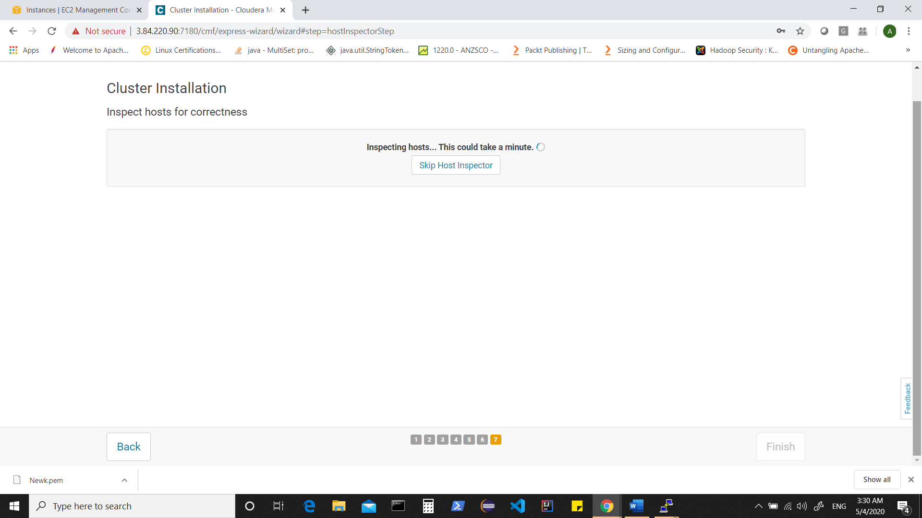

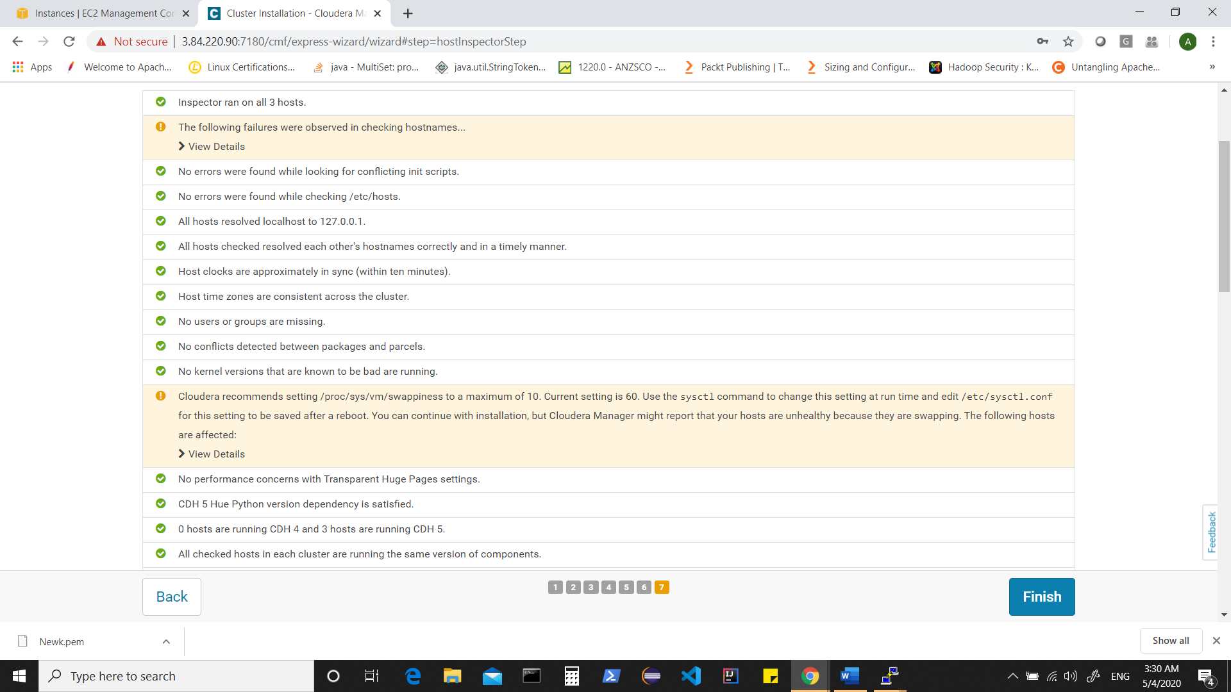

Let’s set swappiness on instances to 10 and then run host inspector again

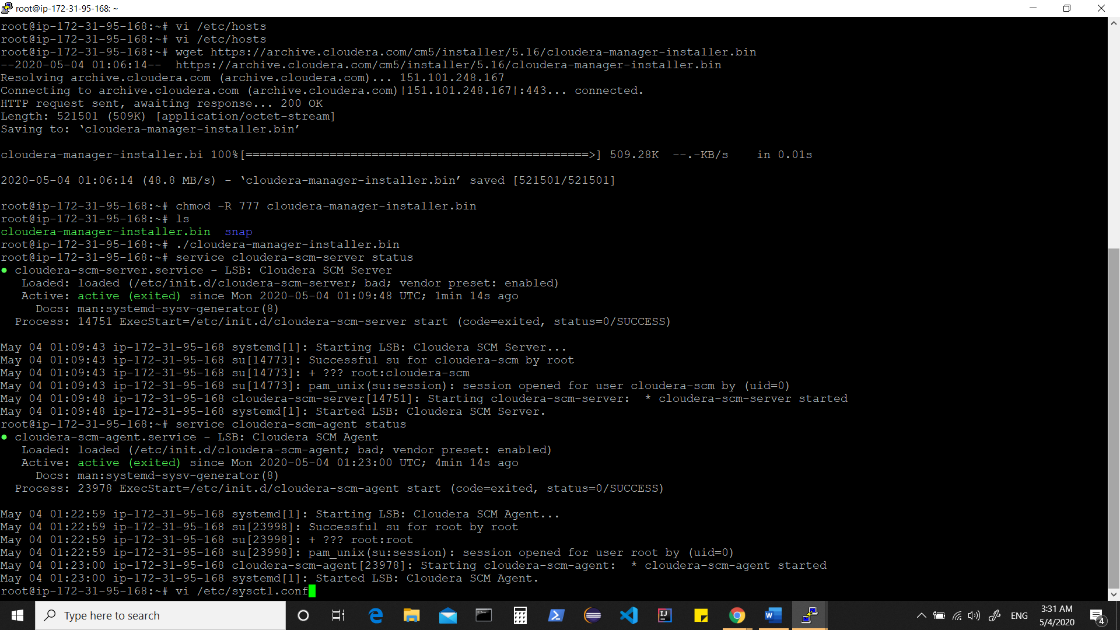

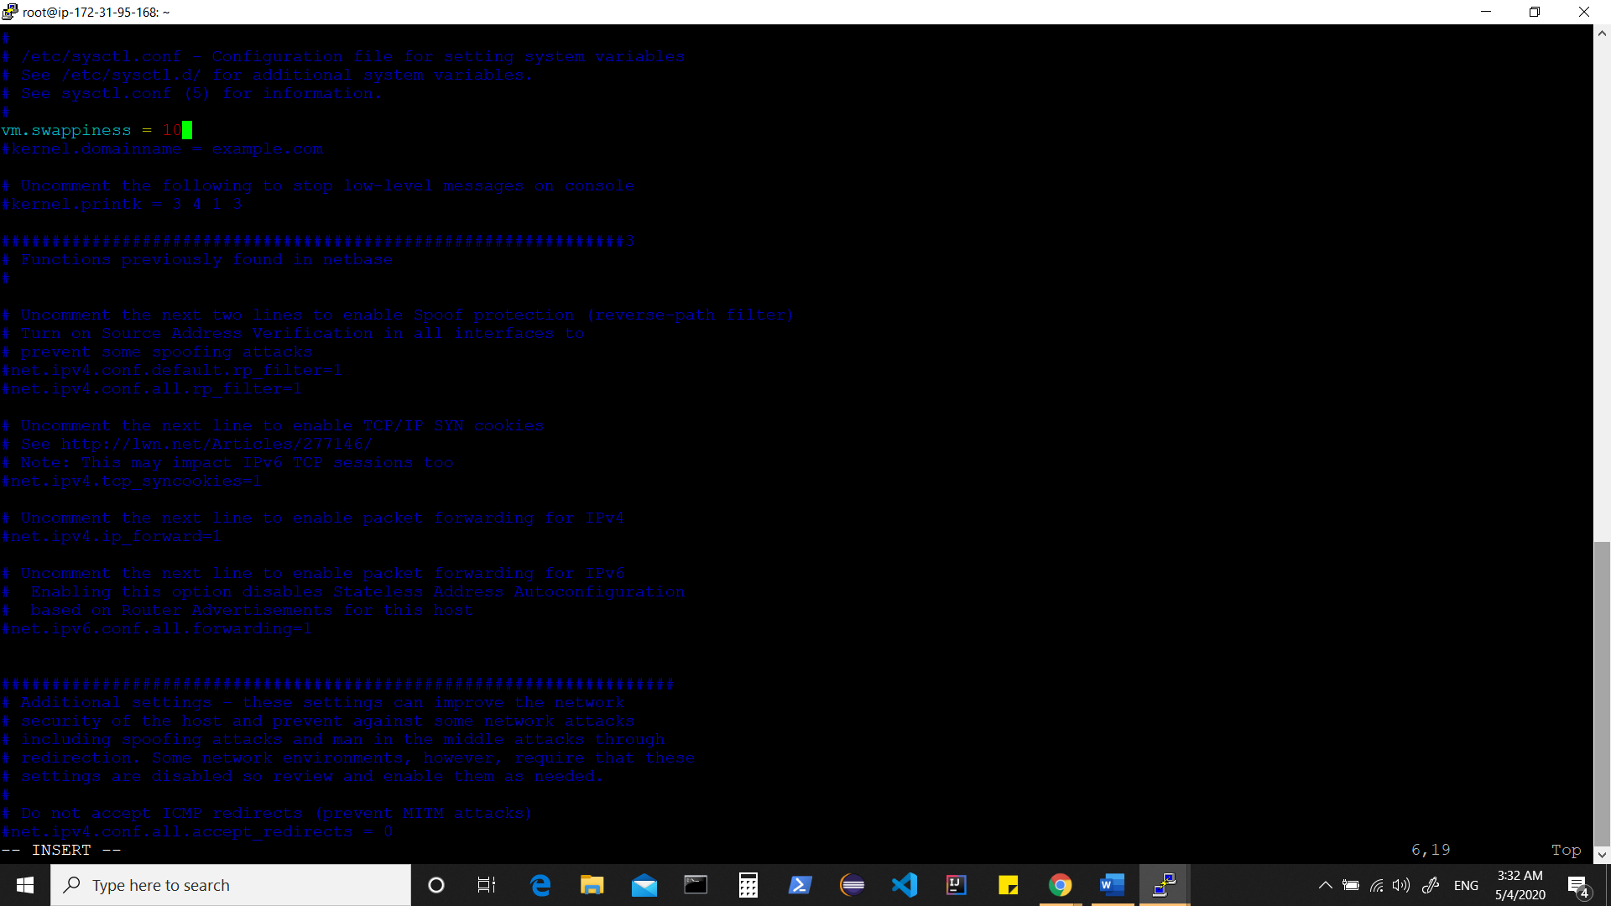

:wq

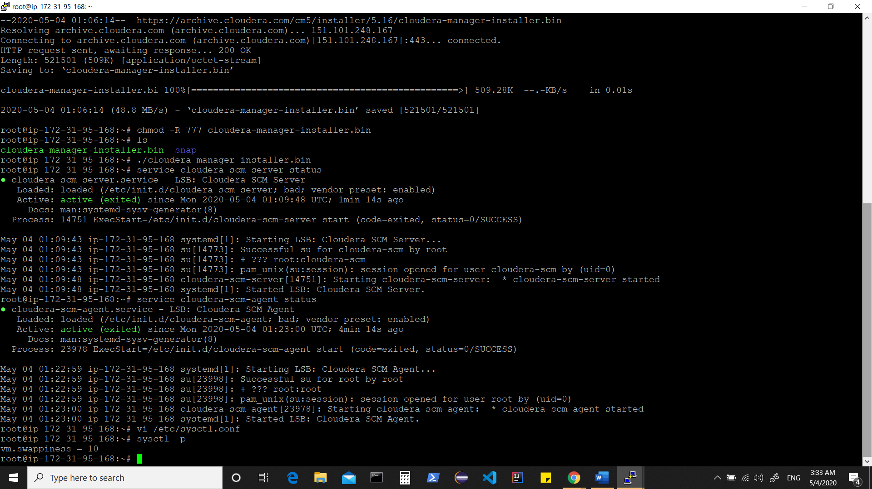

Similarly on all instances

Let’s also check if NTP service is installed on each instance and running, if not install and start it ( to ensure all machines are in sync)

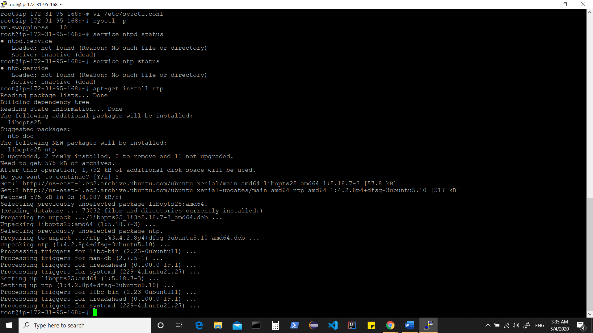

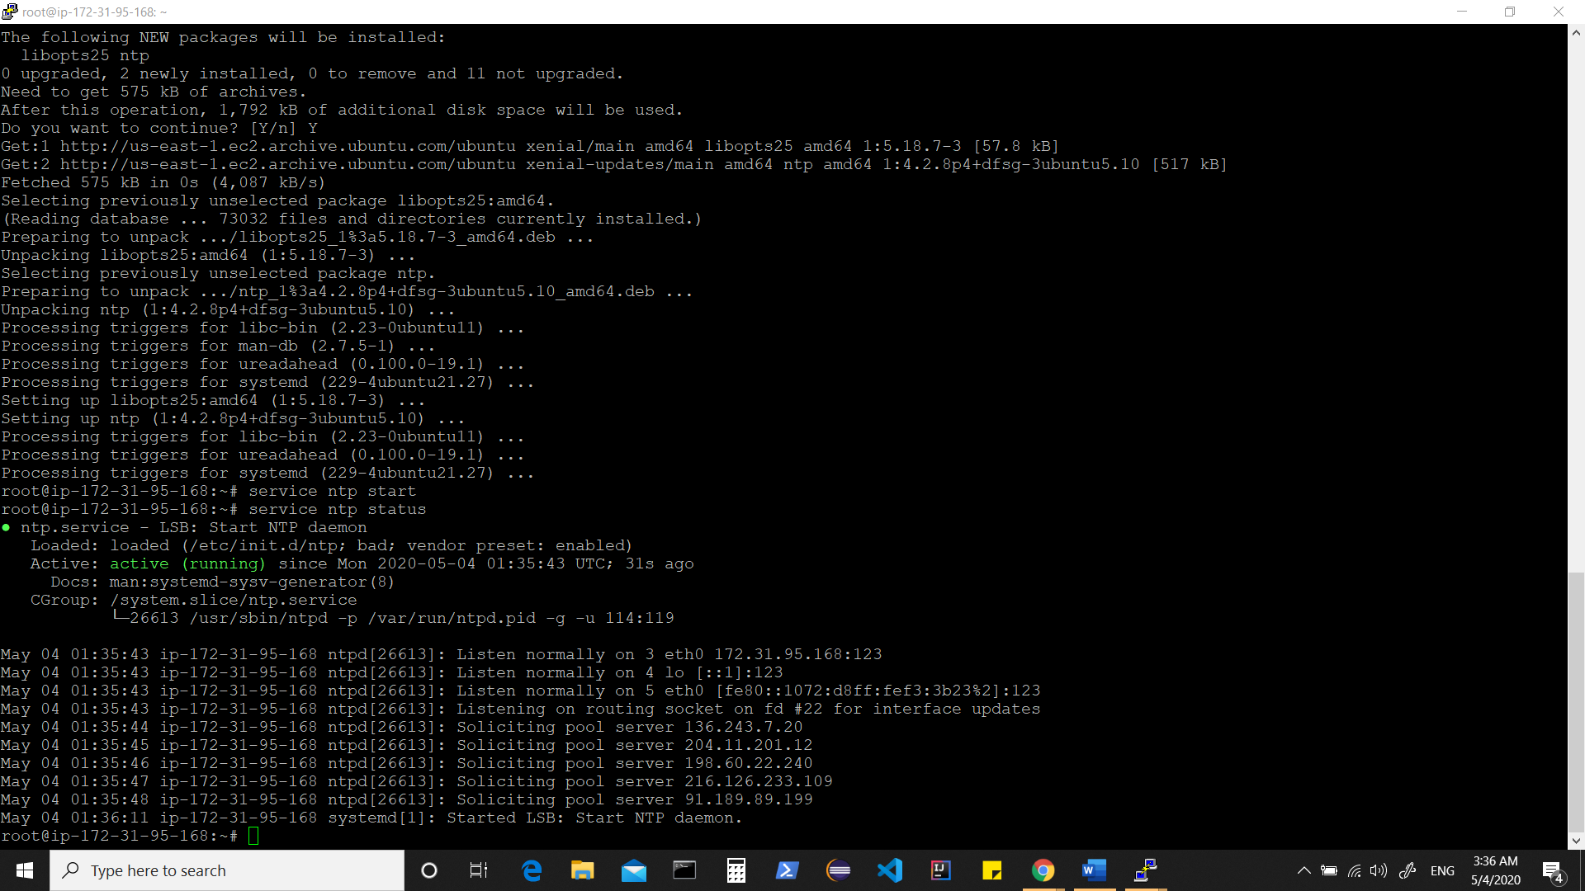

Note** if using centos/redhat machines, you will have to disable SELINUX in /etc/sysconfig. Since I am using Ubuntu, its not required.

Now back to admin console and rerun “host inspector”

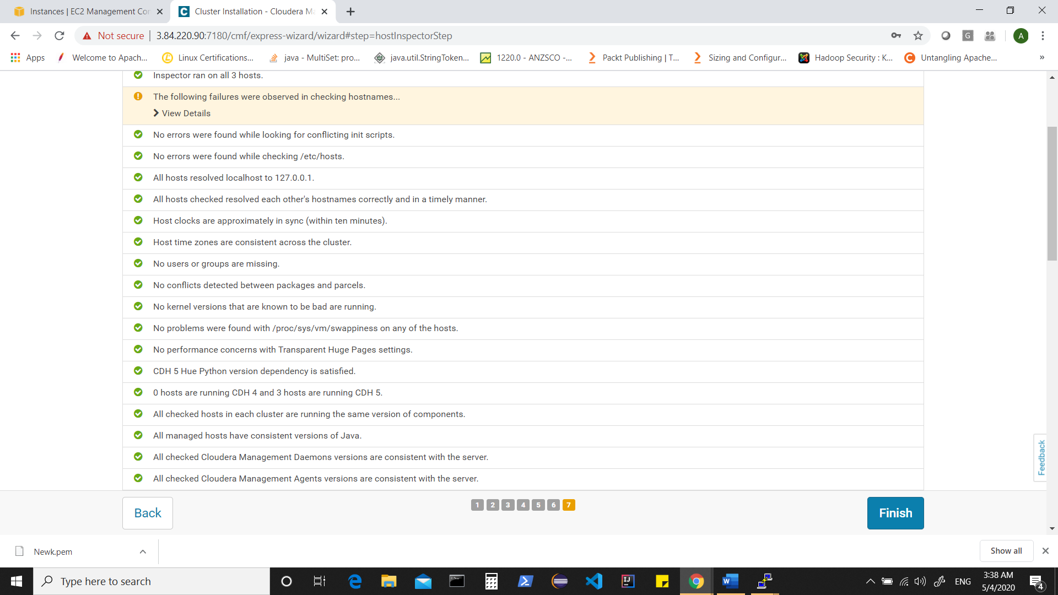

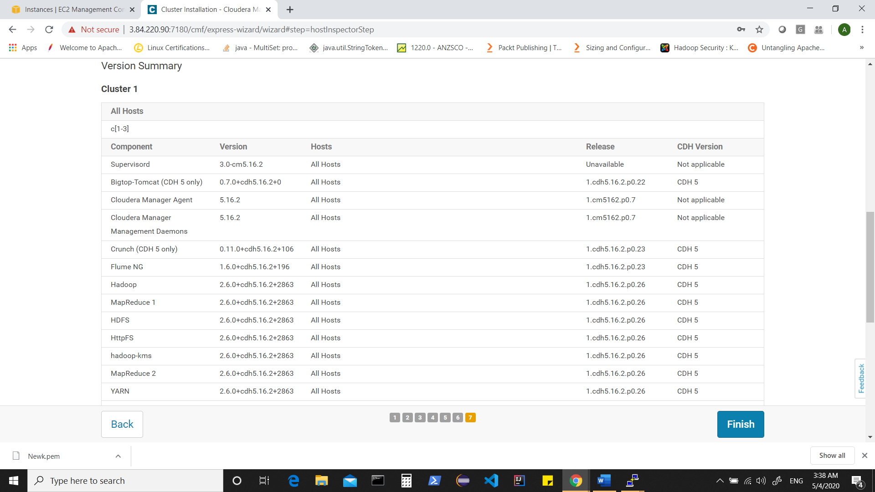

Check versions of software packages and click on Finish

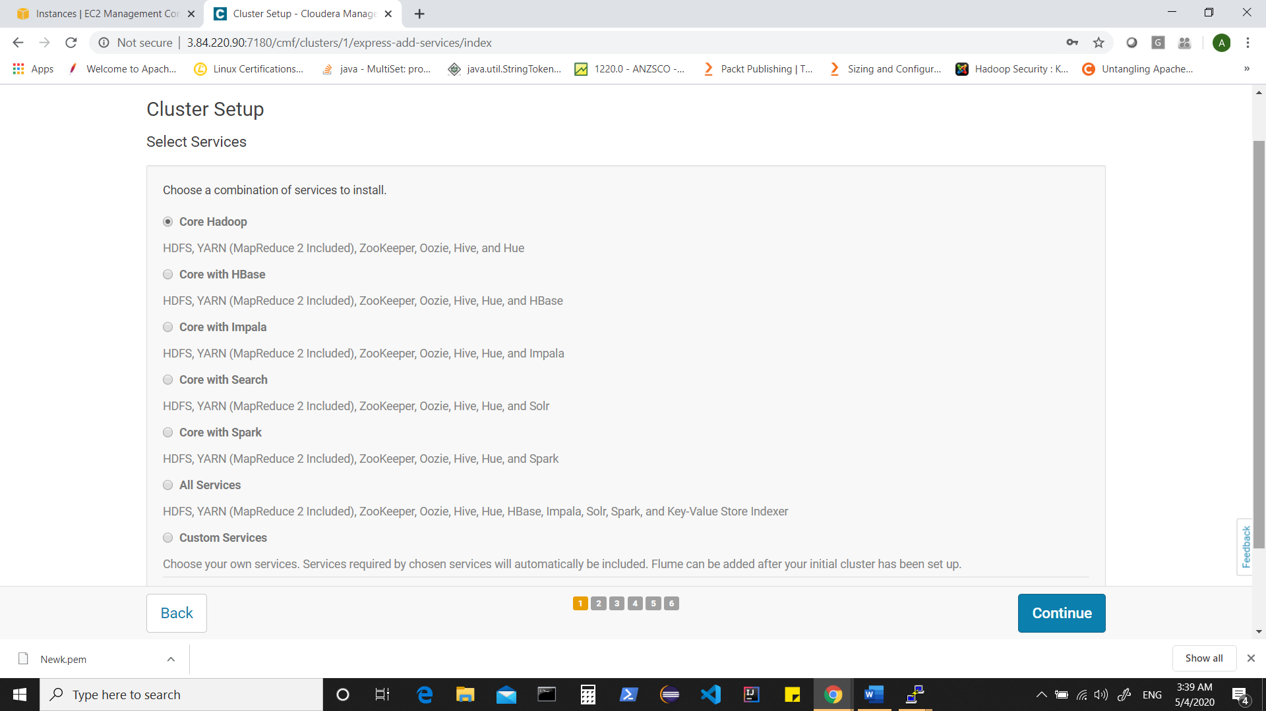

In cluster setup , let’s choose Core Hadoop as of now. We can optionally choose any option or later add services to our cluster.

Click on Continue and it takes to “role assignment” page.

Assign roles and distribute roles across machines for your cluster services.

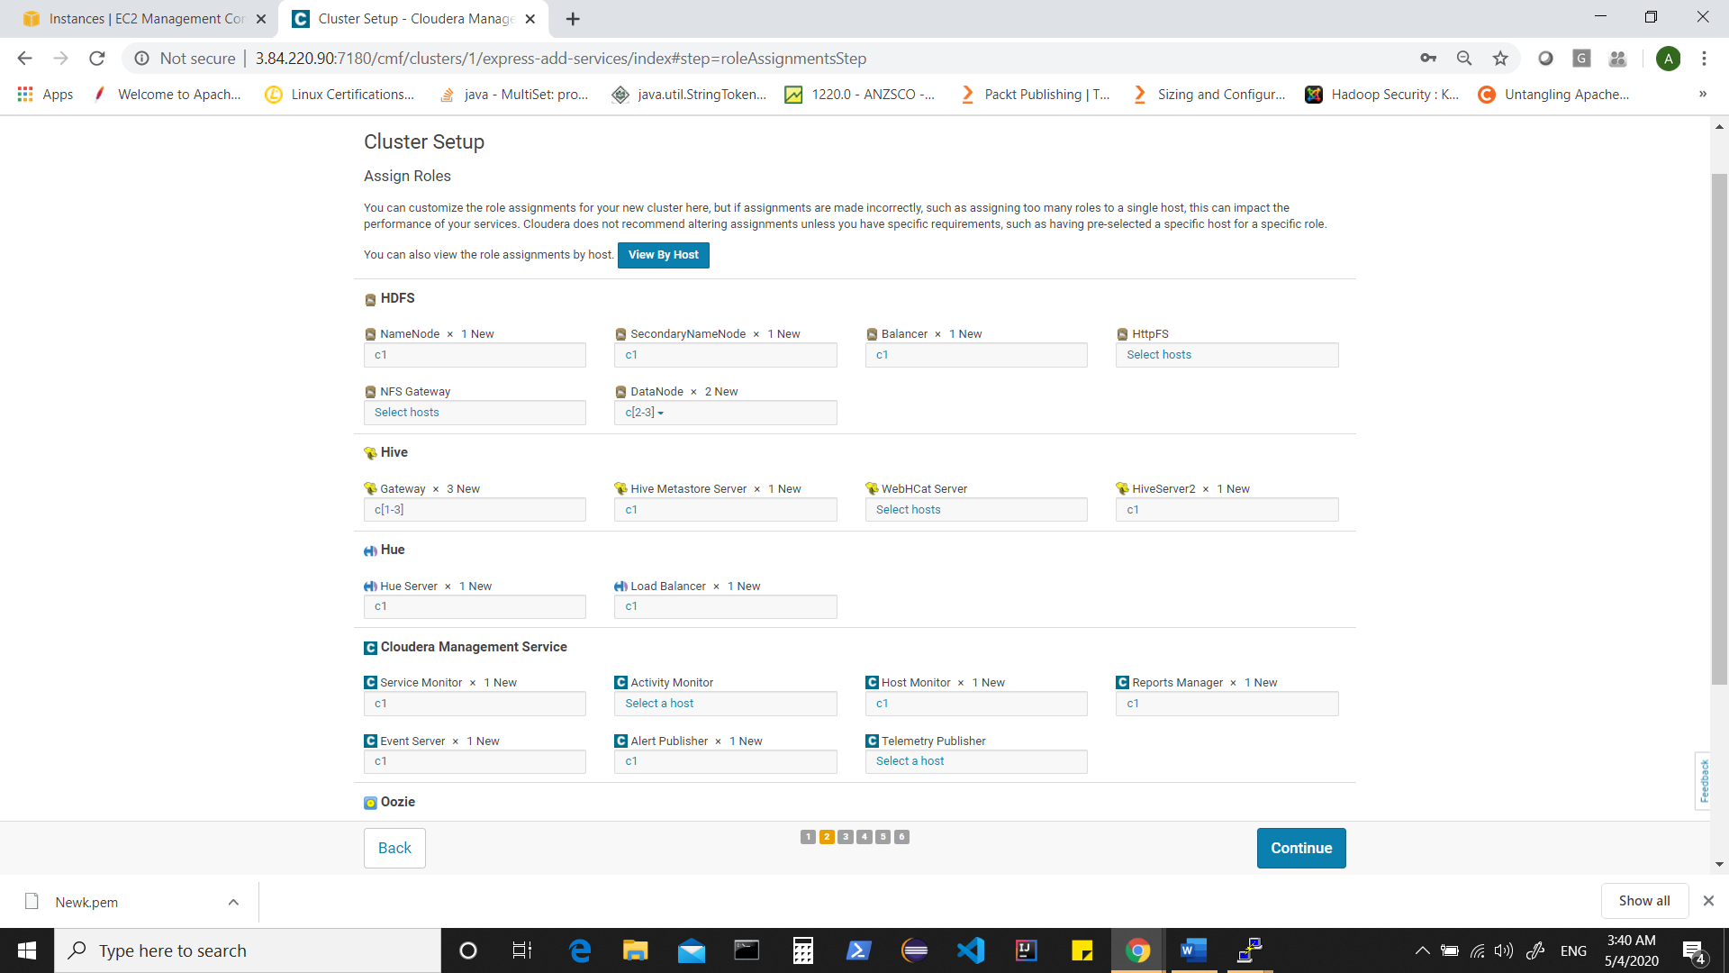

For example , clicking in box for secondarynamenode shows

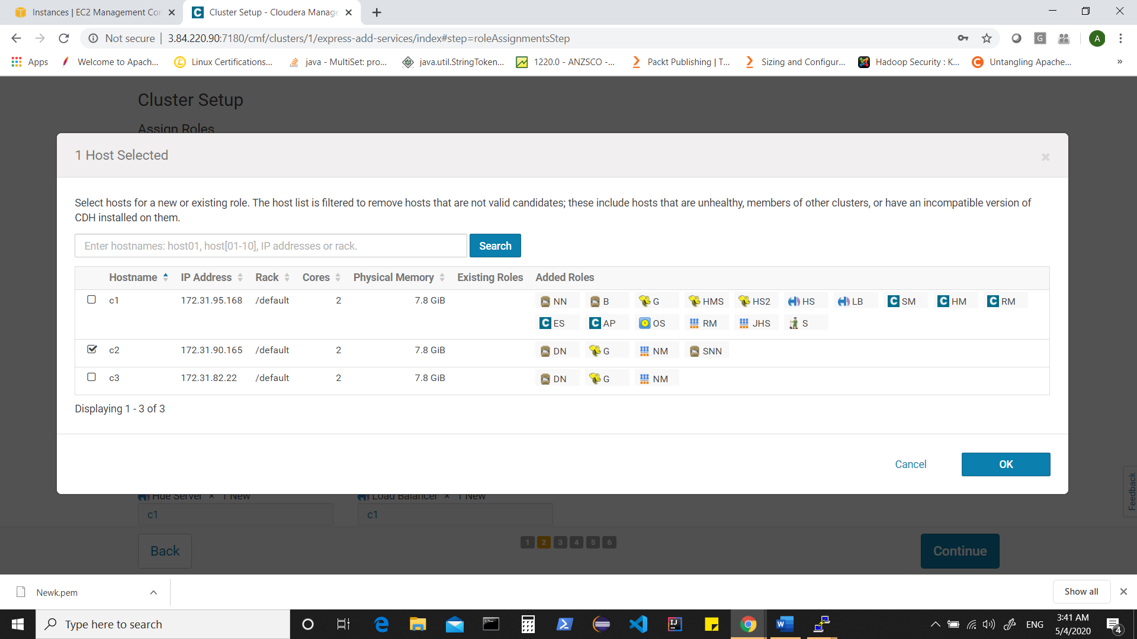

This is how my role assignment looks

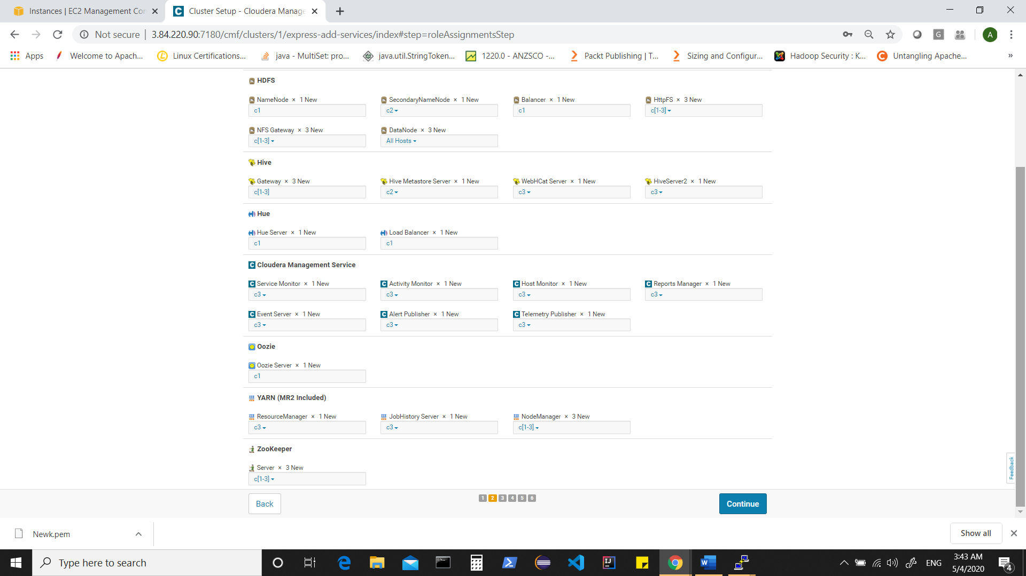

Click on continue , this takes you to “Setup Database”. Here by default “postgres” is chosen. We can find these settings (username/passwds) from instances too.

Click on Test connection

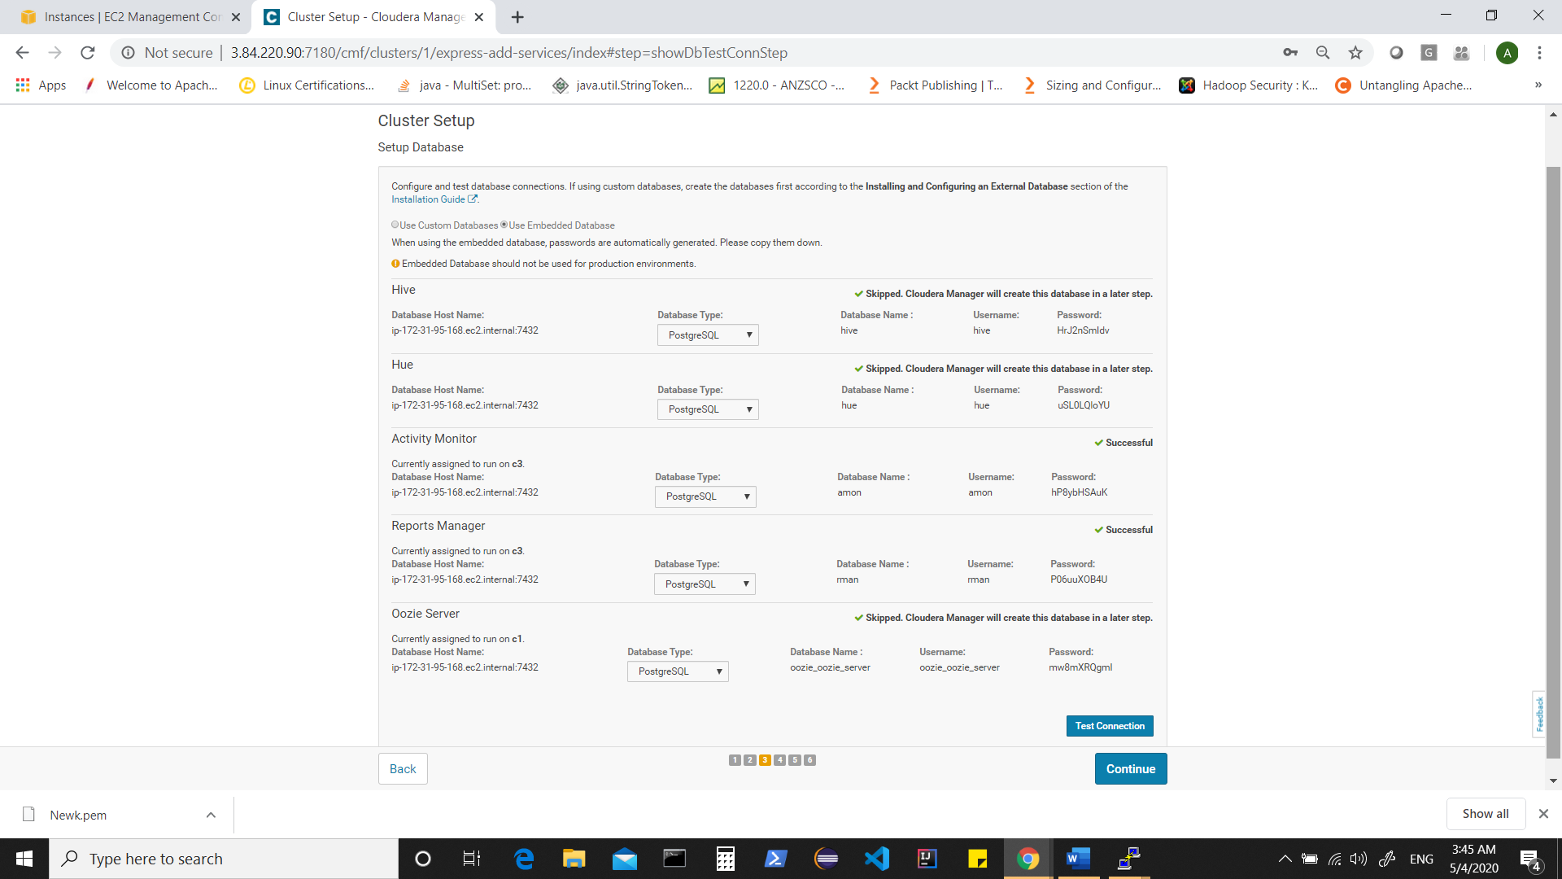

Click on continue

Meanwhile connect to your first instance i.e. C1 ( where cloudera-scm-server is running)

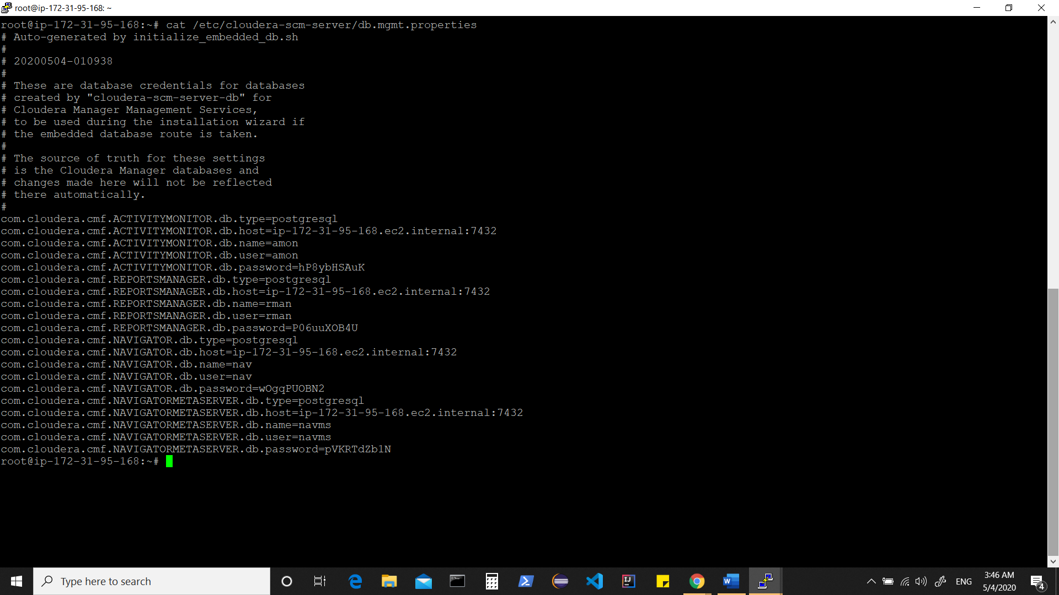

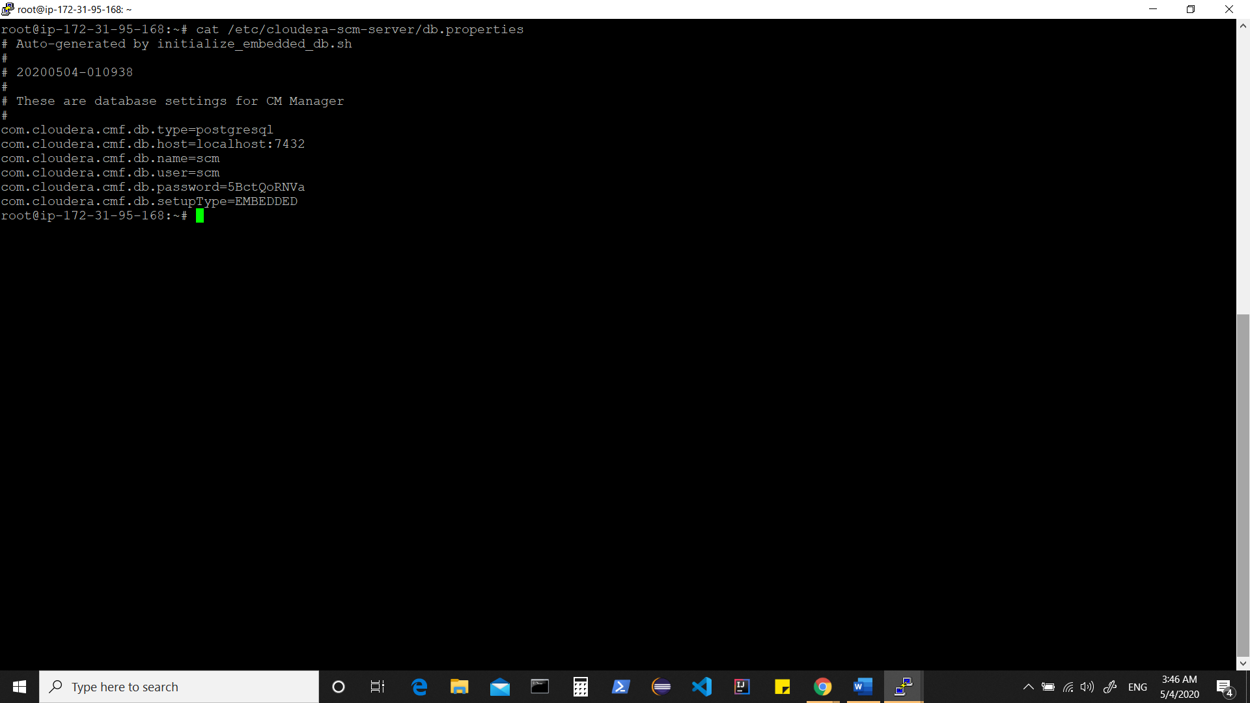

Back to admin console

Shows you default configurations for your services. You can review them or edit at this point of time.

As of now , let them be default and click on continue

Your cluster setup begins

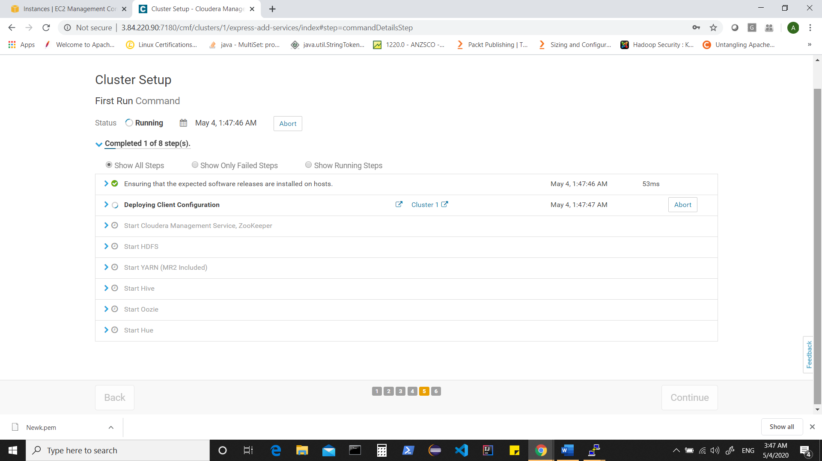

This will configure settings, do the needful and start your services and thus your overall cluster.

Note** There might be various issues in cluster such as “heap settings”, “node offsets” etc and those issues can be resolved once cluster is up and running.

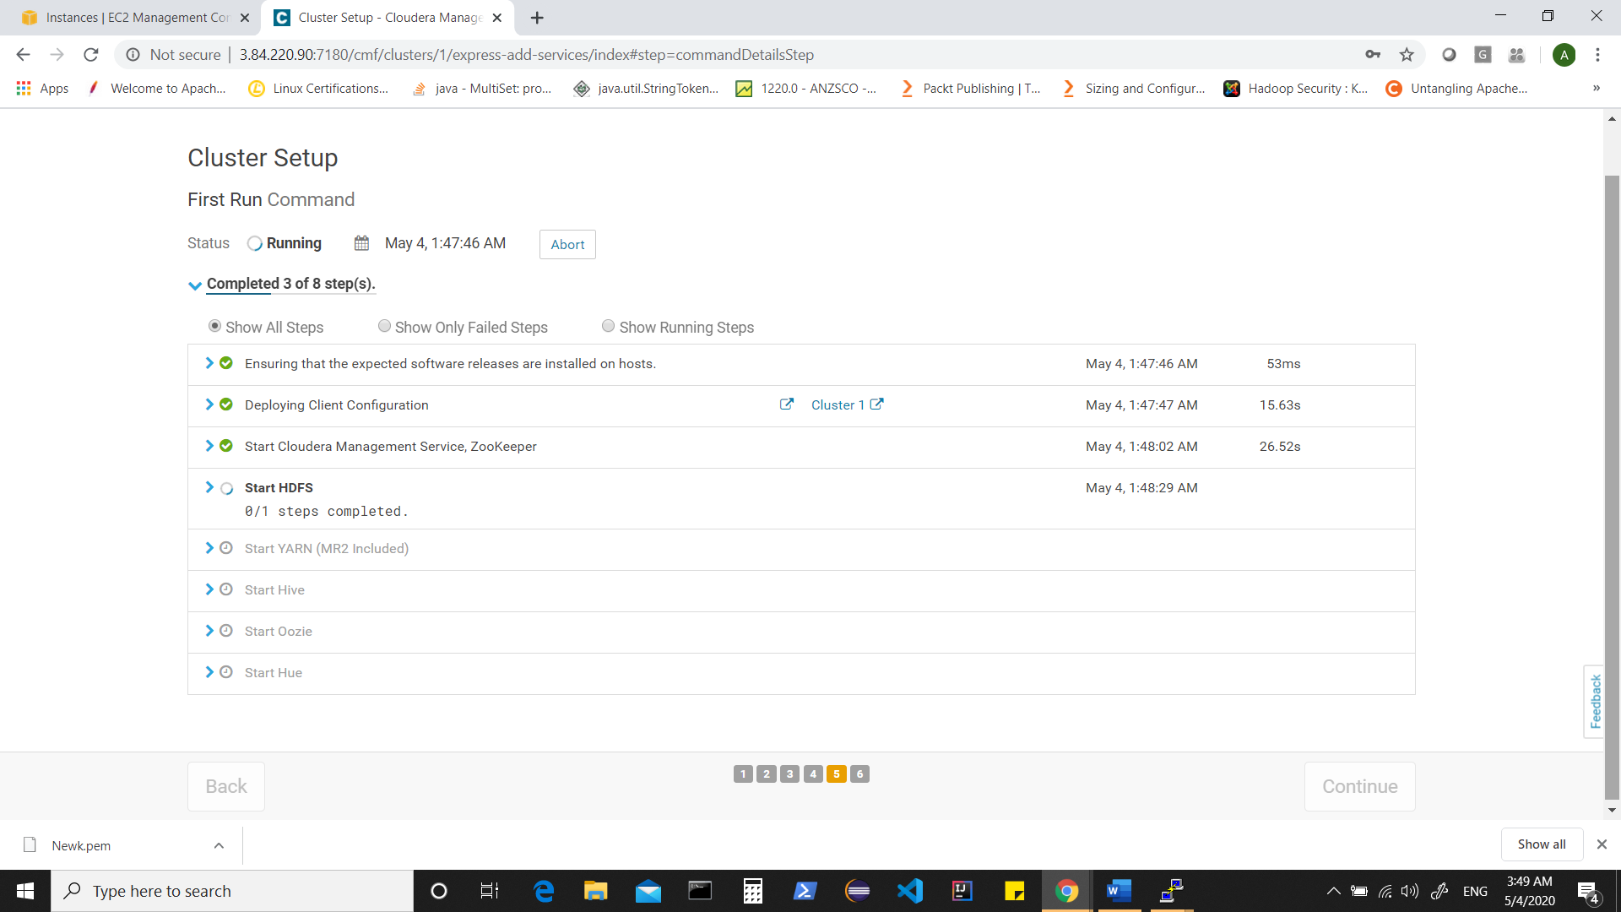

You can expand any section to see what is happening

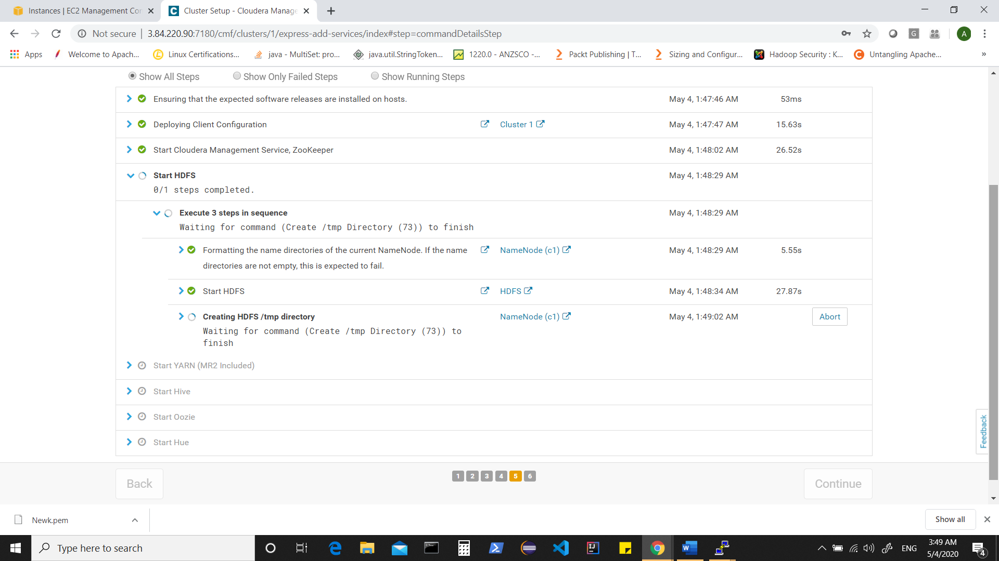

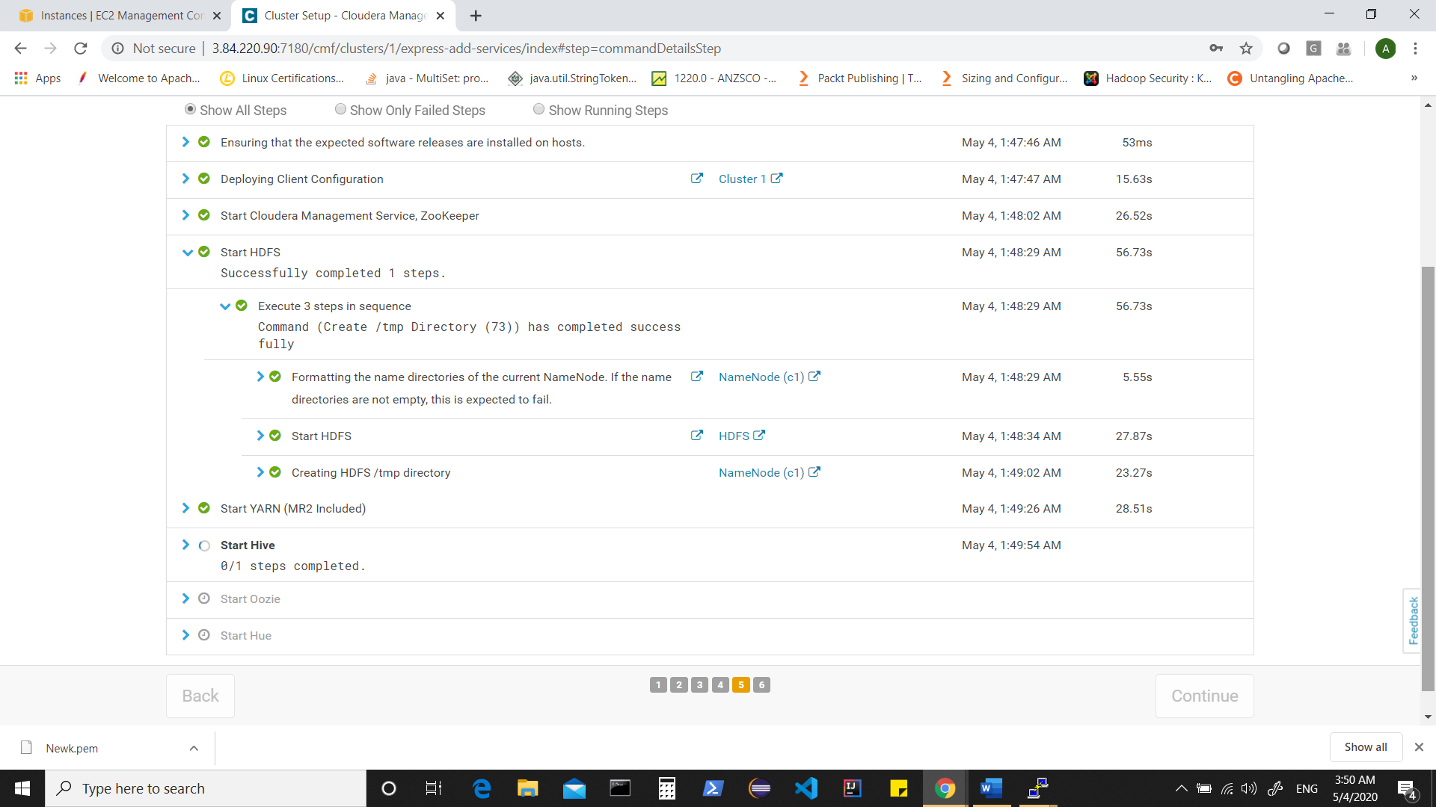

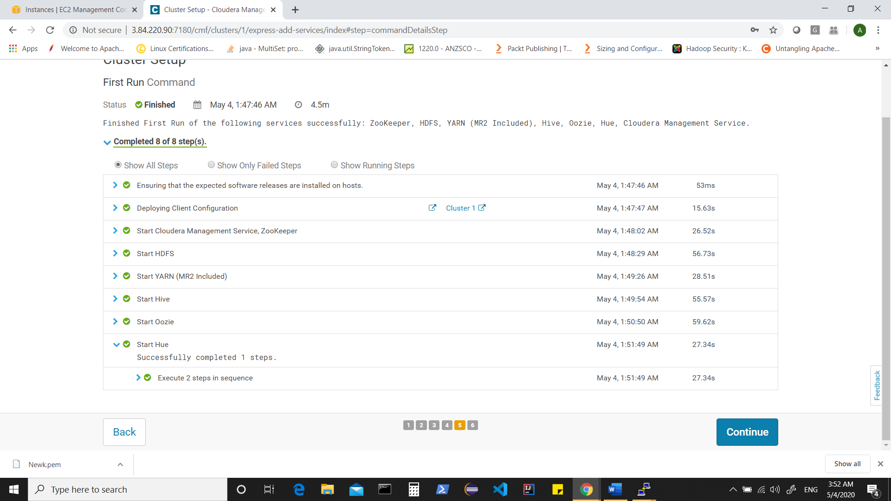

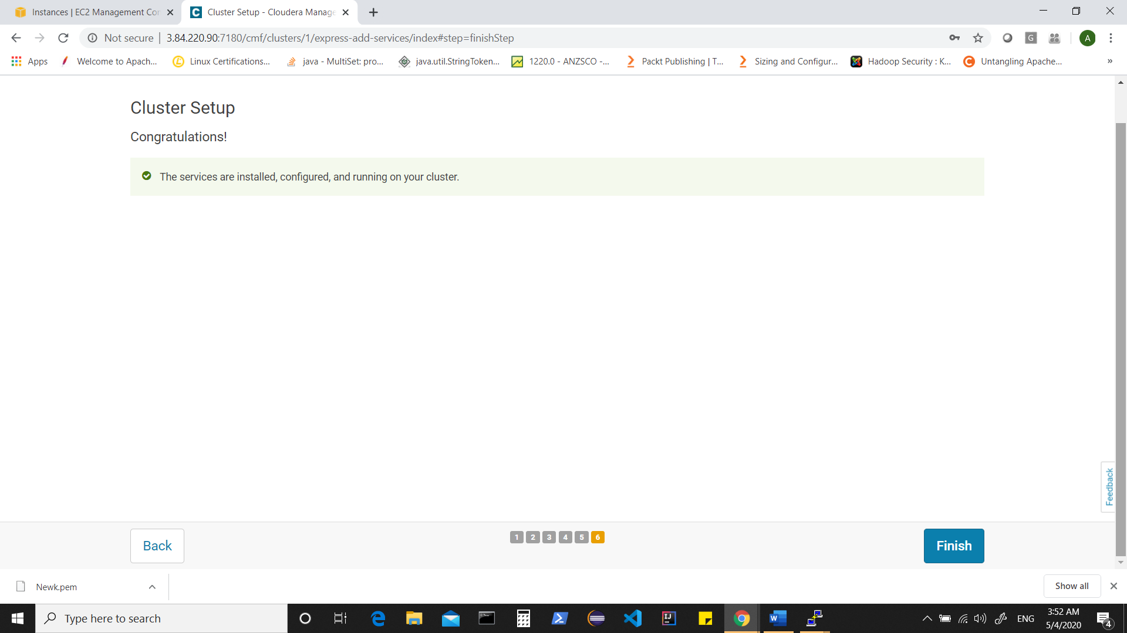

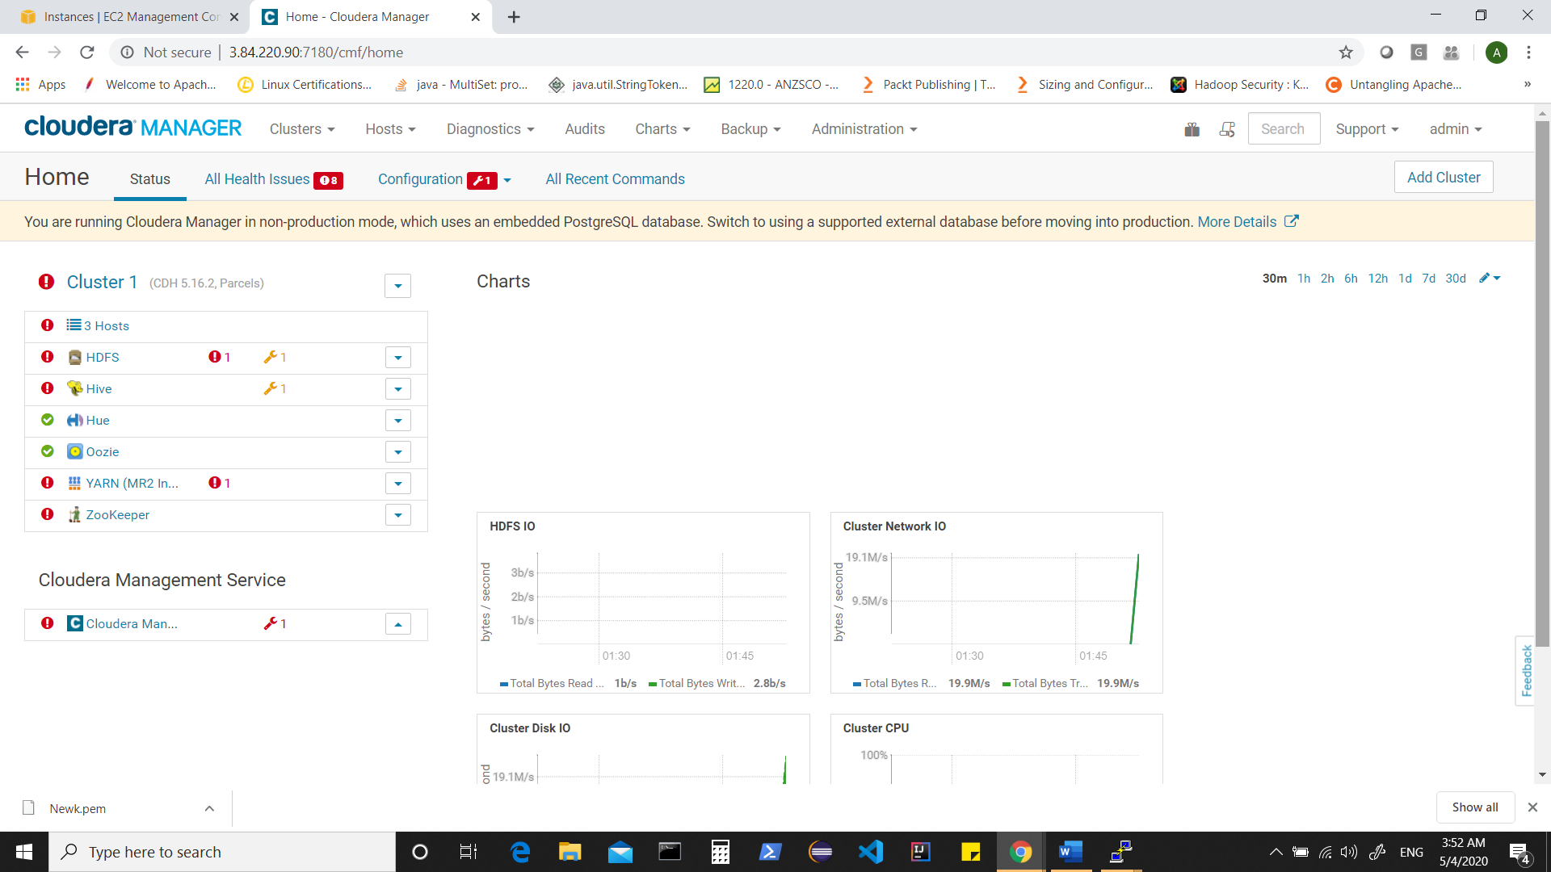

Your cluster is setup. Now we can resolve issues seen one by one.